Applecroft School

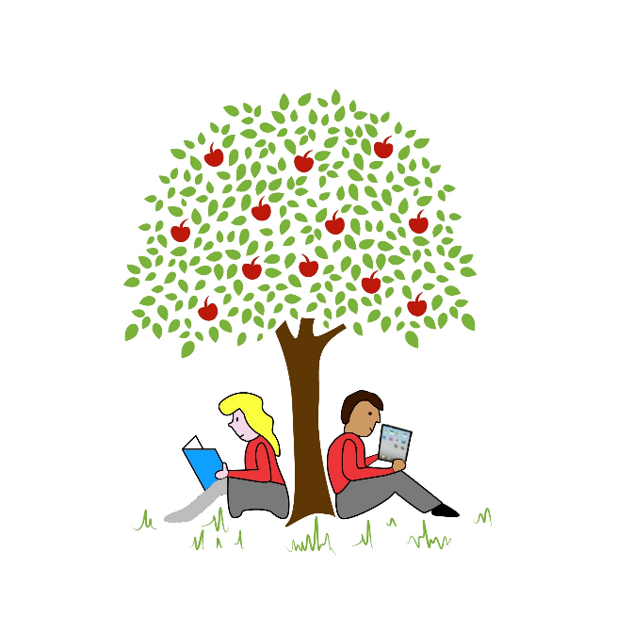

Design Technology (DT)
Policy

Review Cycle: | Annual
Committee to Review: | Curriculum
Date of Issue: | January 2024
Review Date: | January 2025

Design Technology (DT) Policy

- Introduction:

School Vision:
‘To create a positive and inspiring community that empowers everyone to discover their passion, develop their individual talents, realise their potential and aspire to become the very best they can be’.

School Mission Statement:
‘Nurturing Potential, Inspiring Minds, Changing Lives’

School Values:
- Ambition and Leadership
- Kindness and Supportiveness
- Respect and Honesty
- Determination and Resilience

- Our aims and objectives including breadth of study:
Using the objectives from the National Curriculum and Early Years Foundation Stage as our base, it is our aim to:
- develop the creative, technical and practical expertise needed to perform everyday tasks confidently and to participate successfully in an increasingly technological world
- build and apply a repertoire of knowledge, understanding and skills in order to design and make high-quality prototypes and products for a wide range of users
- critique, evaluate and test their ideas and products and the work of others
- understand and apply the principles of nutrition and learn how to cook.

- DT Curriculum Intent:

Design Technology aims to provide pupils with a well-rounded understanding and application of design, creativity, problem-solving, and technological literacy. Our intent is to cultivate a curiosity for innovation, develop practical skills, and foster an appreciation for the importance of design in everyday life. Through DT education, pupils should become independent, confident, and resourceful learners who understand the value of taking calculated risks and learn from their mistakes.

We aim for all pupils to:
- To develop pupils' imaginative thinking, creativity, and critical analysis skills through engaging in design and making activities.
- To provide pupils with opportunities to apply knowledge and skills from other subjects, such as mathematics, science, and computing, to solve real-life problems.
- To foster pupils' resilience, resourcefulness, and risk-taking abilities in a safe and supportive environment.
- To encourage pupils to evaluate and reflect on their own design decisions, processes, and outcomes, promoting a sense of pride and ownership.
- To develop an understanding of ethical, social, and environmental factors related to design and technology, including sustainability and the impact of choices made.

- DT Curriculum Implementation:

Design Technology is included as a standalone subject within Applecroft School’s curriculum, with clear learning objectives and a progressive scheme of work provided by CUSP. It is designed to include a range of DT experiences, covering various materials, tools and techniques, ensuring breadth and depth of learning. Cross-curricular links with subjects such as Mathematics, Science, Art, Computing and Geography are made, enriching the overall learning experience. DT is taught through six topics; mechanisms, structures, food and nutrition, understanding materials, textiles and systems including electrical systems. Each topic is split into three lessons that are taught in a modular approach to allow the children to dive deep into the learning and become immersed in the topic being taught.

Children in EYFS are taught DT through their adult-initiated learning tasks following the CUSP curriculum while following the statutory framework for the EYFS.

CUSP provides regular opportunities for teachers and leaders to receive professional development support to enhance their subject knowledge and teaching pedagogy. Teaching staff effectively use questioning techniques, discussions, and demonstrations to facilitate pupils' learning, thinking, and problem-solving.

Pupils actively engage in practical design and making activities, using a range of materials, tools, and equipment. Design projects are authentic, relevant, and purposeful, encouraging pupils to apply their knowledge and skills to solve real-life problems. Pupils are given opportunities to design and create across different contexts, including individual and group projects, and are encouraged to reflect on their work and make iterative improvements. Teachers actively model and reinforce health and safety practices, ensuring a culture of safety is embedded within DT education.

Applecroft provides a well-equipped stock of resources with access to a wide variety of tools, materials, technologies, and resources. Resources and facilities are regularly maintained, enabling pupils to explore and experiment with different materials and techniques in a safe and effective manner.

Provision is inclusive, tailored to meet the needs and abilities of all pupils. Differentiation strategies are employed to challenge and support pupils effectively, allowing them to make progress irrespective of their starting points. Pupils are provided with equal opportunities to access and engage with DT activities, regardless of their gender, ethnicity, or backgrounds.

- DT Curriculum Impact:

The impact of our curriculum at Applecroft shows that pupils' creativity and problem-solving skills are nurtured, fostering their ability to think critically, generate ideas, and take risks. The children exhibit confidence and resilience as they design and create, displaying perseverance and determination when facing challenges. Pupil engagement and motivation significantly increase as they develop an enthusiasm for the subject and apply their skills to solve real-world challenges. Children work collaboratively, resulting in their communication skills improving, enabling them to work effectively in teams, share ideas, and consider different perspectives. They develop a deeper understanding of the design process and the principles of good design, leading to an appreciation of aesthetics and functionality in everyday life. Pupils' technological literacy improves, as they develop skills in using a range of tools, materials, and technologies. Their understanding of health and safety practices increases, enabling them to work confidently and responsibly with tools and materials. Through DT education, pupils become more aware of the impact of Design Technology on individuals, communities, and the environment. Pupils develop an interest in related careers, understanding the diverse opportunities available in the design and technology industry.

- Learning and Teaching Styles (include approaches for disadvantaged children including SEND):

We use a range of learning and teaching styles in our Design Technology lessons to ensure all children are able to access the curriculum. Teachers are encouraged to adapt their teaching to meet the needs of the children in their class to ensure all children have the opportunity of developing their skills and knowledge in each key discipline taught in DT. Our CUSP curriculum provides SEND support and guidance of how to adapt the lessons to meet all needs. Teachers are given support from leaders to effectively scaffold for disadvantaged children, including SEND. Resources and materials used will be adapted depending on the class needs and learning will be scaffolded for those who need it.

Teachers employ a range of teaching and learning strategies in Design Technology, including:
- Practical activities with hands-on experience.
- Investigation and experimentation.
- Researching and designing prototypes.
- Using a variety of tools, equipment, and materials.
- Collaborative work to enhance teamwork and communication skills.
- Encouraging students to evaluate and improve their own work and that of others.

- How do we plan and organise our lessons?

Planning is completed in year groups and is delivered through 2 hour sessions in an afternoon. DT is taught in a modular sequence across the school to fully immerse the children into the curriculum. A DT topic will be taught within a week and teachers will dive deep into the learning to give pupils all the knowledge and skills they need in order to design, make and evaluate the product associated with the learning question. Some lessons may require the children to be grouped and taught in separate sessions to ensure all children have equal experiences with resources and materials. Food and Nutrition topics are mostly taught in groups to ensure all children are supervised when handling cooking equipment. CUSP lessons are structured to follow 6 key phases; connect what they have learnt previously, explain todays learning, provide an example for the children to follow, give children time to attempt the task set before applying the new skills that have been taught, challenge the children by providing opportunities for deeper thinking.

- How do we make DT inclusive?

At Applecroft School, we believe that every child has the right to an excellent education, to develop a love of learning and to feel successful, no matter their starting point or any ‘barriers to learning’ they may have. To enable this, we adopt a personalised approach to the curriculum, with different support and scaffolds being provided to children to enable them to be successful. Teachers will make appropriate modifications based on student ability, ensuring that every student can access the curriculum and make progress. Resources and materials will be adapted to cater to the diverse needs of students, including those with special educational needs and disabilities (SEND).

- Contribution of the DT to teaching in other curriculum areas:

Children are encouraged to problem solve and think innovatively in their DT lessons to design, make and evaluate products for different uses. These problem solving skills and questioning are developing across many areas of the curriculum. Opportunities will be provided to integrate DT with other subjects, such as science, maths, art, and computing, to encourage interdisciplinary learning. Children will need to use their English skills to understand the criteria of a design and to use written English to evaluate a product. Children will use Maths to measure and draw accurate designs of their product using geometric shapes. Computing is frequently linked to DT when using technology to design and make a product as well as Science when learning about various electrical systems in years 4 and 6. Children are constantly encouraged to draw and edit a design which links well to their Art and Design drawing topic when learning specific techniques for different drawing purposes.

- What is our approach to equal opportunities (considering disadvantaged)? How do we ensure equal opportunities in DT?

We believe it is the right of all children, regardless of their ability, cultural background, ethnicity, gender, disability, home or linguistic background, to have access to high quality learning experiences in a stimulating and supportive environment where prejudices and stereotypes are challenged. All pupils have equal access to the DT curriculum regardless of any protected characteristic including gender, race, cultural background, ability or any additional needs. Teaching in DT is organised to enable children of all abilities to access the curriculum and any activities will be adapted in order to support all pupils in the class.

- How do children record their work?

EYFS use Tapestry to record the DT work that is carried out in their learning environment. As DT is taught through adult initiated learning in Early Years, there is no need for individual portfolios like in the upper years.

Each child from Year 1 – Year 6 has a DT portfolio which is carried through with them throughout their Applecroft journey. These portfolios will hold every piece of work from each topic that the children complete in their DT lessons. Each plastic wallet within the portfolio will hold one topic’s worth of work including, where possible, photographs of the process of learning and final products.

- How do we use feedback to support children’s progress?

In DT, children are very much encouraged to evaluate their own designs and products to form an opinion as to whether they believe they have met the criteria set out at the beginning of the topic of learning. Teachers ensure children have time to reflect on their designs with the support of a peer or an adult to discuss whether they believe they have been successful. Teachers will use questioning against the criteria to support the children and ensure they progress with their learning by solving problems against their products and designs.

- How do we assess and report children’s progress and attainment in DT?

DT is assessed against the end points located on our DT curriculum map. Teachers used formative and summative assessment strategies. These may include teacher observations, self-assessment, peer assessment, and project evaluations. Feedback will be provided to students to support their development and identify areas for improvement. Teachers will use these observations to help support and plan the next lesson. At the end of a topic, teachers make judgements against the end points about attainment which informs the teacher’s annual assessment of progress for each child. This is reported to parents/carers as part of the child’s annual report.

- How do we set home learning (if any)?

Home learning is not usually set for Design Technology, however children may be asked to bring in resources/materials from home to aid the making process.

- How do we monitor DT across the school?

The monitoring of the standards of children’s work and of the quality of teaching in Design Technology is the responsibility of the subject leader. The DT subject leader’s responsibility is to monitor the implementation and impact of this policy through regular planning checks, work scrutiny, pupil and staff voice interviews and the collection of photographs of learning throughout the year. This feedback will be used to refine and improve teaching strategies, resources, and assessment methods.

- How is DT resourced?

There is a range of resources to support the teaching of Design Technology across the school. All equipment is bought or agreed by the DT subject leader and kept in the DT cupboard. All children are taught the safe and appropriate use of equipment and resources. Children are also given the opportunity to bring in materials and resources of their own choice to use for their design.

- How do we develop the CPD of staff?

CUSP provide high-quality professional development opportunities aimed to enhance teachers subject knowledge, pedagogy and assessment strategies. CPD videos are used to support the implementation and delivery of each unit of work. Staff meetings can be used for DT training or for sharing best practice and the DT leader is available to help individuals who are less confident in their DT teaching or who need help with the use of tools and equipment.

- How do we involve parents in DT learning?

We believe that parental engagement plays a crucial role in supporting students' learning. We aim to involve parents as much as possible in Design Technology by requesting for parents or other adults to come into school to support the teaching and learning of the lessons as well as share experience, skills and enthusiasm, where appropriate. We will actively involve parents and carers in Design Technology activities and provide regular updates on the curriculum content and learning outcomes. Opportunities will be created for parental involvement in events such as open afternoons, where students can display their design projects.
- How are the governing board involved (include curriculum committee, faculty and lead governors?

The governing board are kept up to date with the school’s Design Technology curriculum via the curriculum committee, through presentations to the governors either at curriculum committee level or STEM faculty meetings. The STEM faculty consists of the subject leaders for Design Technology, Computing, Science, Maths and two governors from the curriculum committee. The faculty has responsibility for overseeing the provision of the all subjects within the STEM faculty at Applecroft and meet once a term to discuss the subjects. The agenda of meetings could include: Subject Leader Action Plan feedback, quality of learning and teaching, pupil outcomes etc.

