
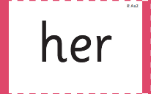
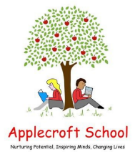
What are we learning in Reception this week?
Tricky words of the week:
Remembrance Day – Monday 11th November
Week 2
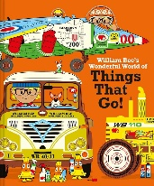
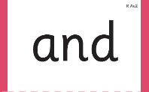
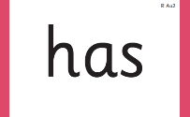
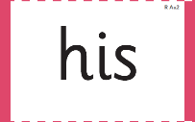
Our structured story:

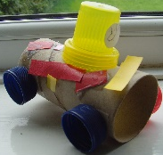
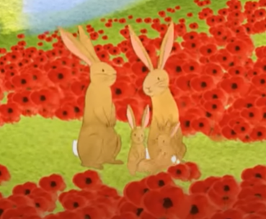
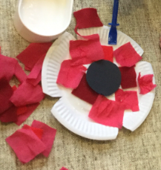

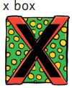
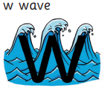

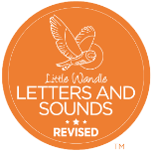
William Bee's Wonderful World of Things That Go!
Understanding the World
Do you know what fuel is? Do you know what an amphibian is? Have you ever seen a building site or builders working on putting buildings up? Do you know any different tools that builders might use? Have you ever seen or been to a food truck?
Communication, Language and Literacy
We will be developing our vocabulary and oracy skills by learning new language such as:
useful, fuel, soot , perfect, amphibious, crane, rescue, spare, vehicle
Phonics
We will be learning:

Read at least 3 x per week with your child - log on Boom Reader!
Personal, Social & Emotional
We will be learning about Remembrance Day and its importance. We will learn how to be thoughtful and reflective as well as how to take time to appreciate others.
Physical Development
We are developing our finger dexterity and hand strength.
HOME LEARNING:
rip, tear, scrunch and stick red and black materials to collage your own poppy!
Mathematics
We will be learning to develop our precision and language when describing attributes of sets of objects.
The children will use given attributes to classify different objects into groups.
The children will develop their understanding that objects may have multiple attributes.

Expressive Art & Design
We will make a truck out of large loose parts and use the junk modelling to make your favourite truck from the book.


