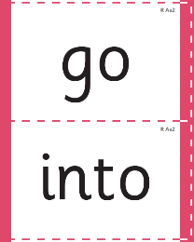
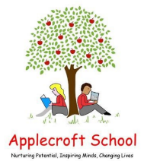
What are we learning in Reception this week?
Reception Nativity: Tuesday 17th Dec - 2.30pm
Tricky words of the week:
Week 3
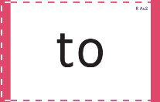
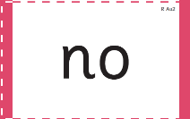
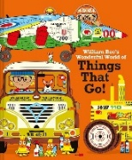
Our structured story:
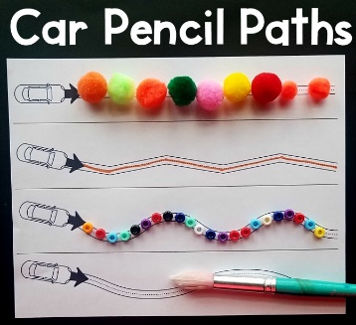
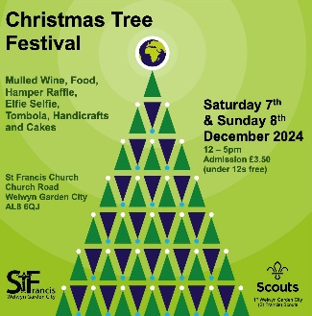


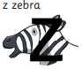
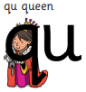


William Bee's Wonderful World of Things That Go!
Physical Development
We are developing our finger dexterity and hand strength.
HOME LEARNING:
Be creative and make your own car pencil paths!
Expressive Art & Design
We will making salt dough decorations for the St Francis’ Christmas Tree Festival. The theme is: ‘Our beautiful planet’
Understanding the World
Do you know what fuel is? Do you know what an amphibian is? Have you ever seen a building site or builders working on putting buildings up? Do you know any different tools that builders might use? Have you ever seen or been to a food truck?
Communication, Language and Literacy
We will be developing our vocabulary and oracy skills by learning new language such as:
useful, fuel, soot, perfect, amphibious, crane, rescue, spare, vehicle
Phonics
We will be learning:

Read at least 3 x per week with your child - log on Boom Reader!
Personal, Social & Emotional
Become confident with our speaking parts for our Nativity.
Show independence, resilience and perseverance when rehearsing and performing on the stage.
Mathematics
We will be learning to develop our precision and language when describing attributes of sets of objects.
The children will use given attributes to classify different objects into groups.
The children will develop their understanding that objects may have multiple attributes.



