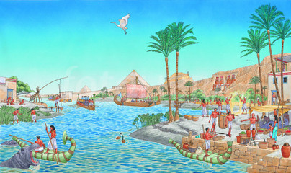
Y6 Geography and History Summer 2020
The River Nile
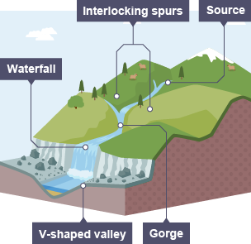
Over the next half term, you are going to conduct an enquiry about the River Nile in Egypt. In recent months you have learnt a number of geography skills and these will be used in your project. We would like you to think of questions you could ask and answer about the River Nile. For example:
Where is the source/mouth?
Through which countries does it travel and in which direction?
What is the surrounding landscape like?
What was it like in Ancient times?
Can you identify the key features of the upper, middle and lower course?
How is the river used today (by humans/wildlife)?
How does this differ from the way it was used in the Ancient Egyptian era?
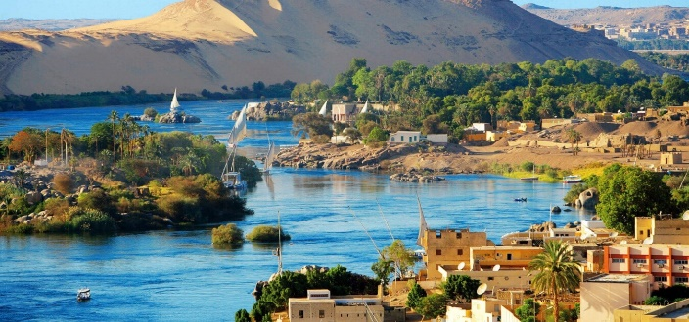
How did the Ancient Egyptians use the Nile in the construction of their pyramids and other buildings?
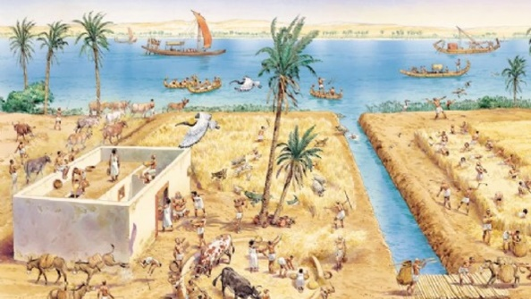

Consider the following skills list to make your enquiry more interesting:
- Collect statistics (length/width/position/climate/time zone etc. using points of the compass, 4 or 6 figure grid references and terms such as latitude, longitude, equator, northern and southern hemisphere)
- Compare with a river in the UK
- Describe how the physical features of the river affect human activity
- Give detailed descriptions of the characteristics of the river
- Locate the names of some of the countries/cities of the world (through which the river travels)
- Identify how land-use patterns have changed over time
- Create maps of the location
- Identify settlements and land-use in the surrounding area

Use research, as well as the knowledge you have gained in lessons, to help answer some of these and other questions for your enquiry. Present your work in a variety of ways including some of the following: handwritten explanations, diagrams, maps, graphs/tables, pictures etc. The final project needs to be handed in by email at the end of this half term. We look forward to reading them.

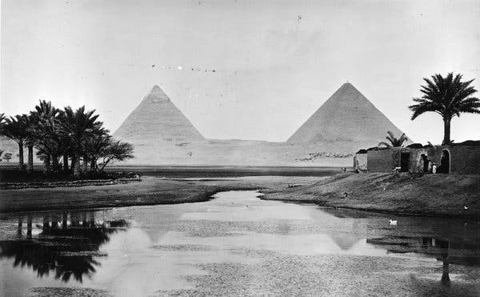

Below are some links that might be useful. Always use the internet safely by being specific in your searches and remember to verify information you find online by checking on multiple sites.
https://www.bbc.co.uk/iplayer/episode/b04l90zl/sacred-rivers-with-simon-reeve-1-the-nile
https://www.bbc.co.uk/bitesize/topics/zg87xnb
https://www.bbc.co.uk/bitesize/topics/z849q6f/articles/z7w8pg8
http://www.primaryhomeworkhelp.co.uk/egypt/nile.htm

