Egyptian Number System

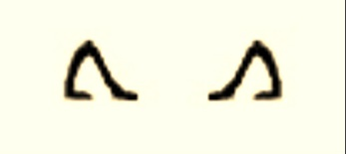
Add Subtract

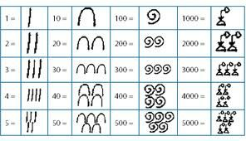

Using these symbols, can you write some Egyptian calculations?
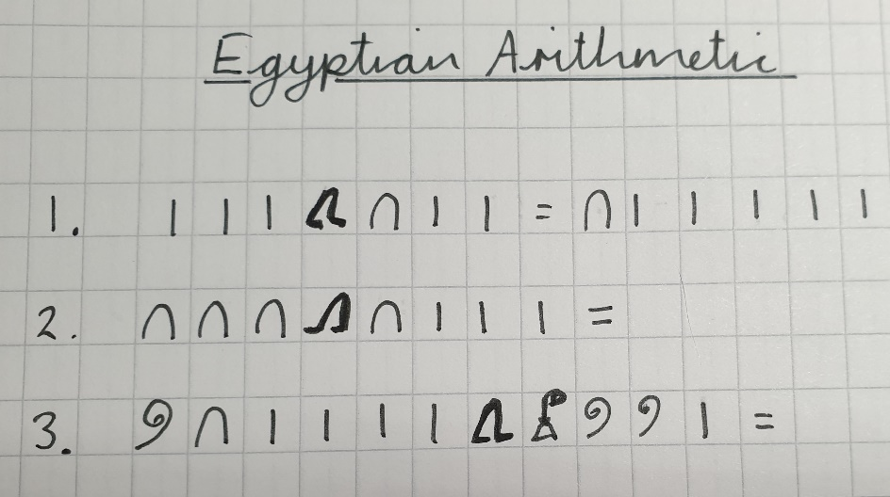
Don’t include the answers - we will put your questions on the website for others to solve, so send us a photo. Here is an example. The first one has the answer, but can you solve the other two?

