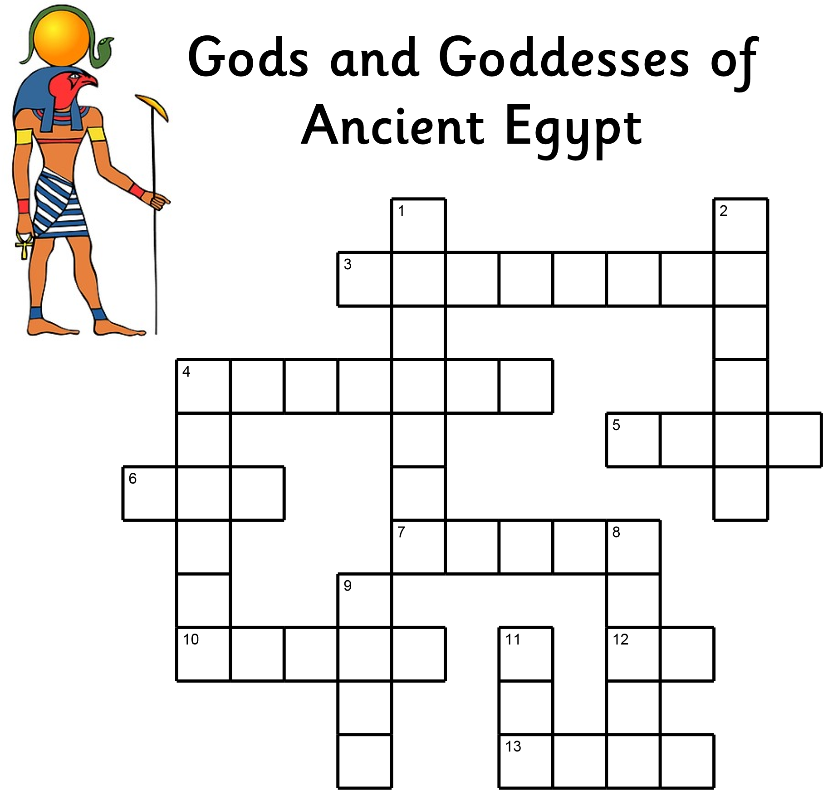
Across | Down
3 The river goddess | 1 The vulture goddess
4 The snake god of chaos | 2 God of the Underworld
5 Healing goddess, wife of Osiris | 4 God of funerals
6 The goddess of the sky | 8 Falcon headed king of the Gods
7 God of wisdom | 9 God of chaos, brother of Osiris
10 God of crocodiles and  alligators  12 The sun god | 11 The god of the earth
13 Cat goddess

