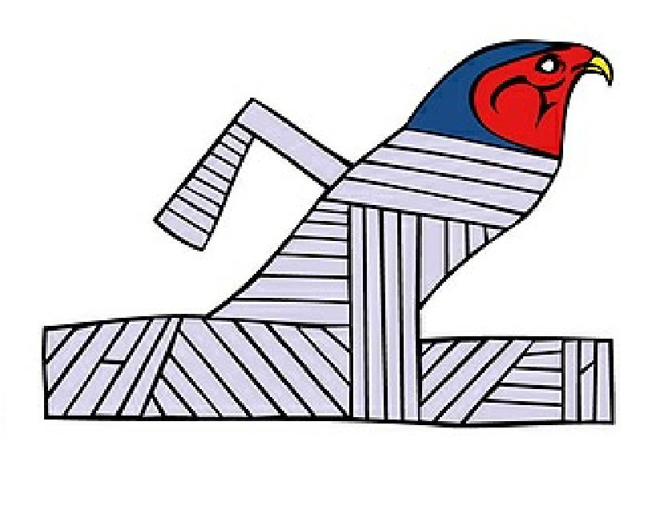Crossword
Egyptian Mummies
1
2
3
4
5
6
7
8
9
10
Across | Down
4. Piece of cloth used to wrap a dead body  - A person's organs were put in these  - God of the dead  - God of funerals  - 'The Devourer', who ate the hearts of sinners | - Process of preserving a body  - Egyptians believed a dead person's heart would be weighed against this  - A decorative coffin  5. The salt used to preserve bodies
10. A preserved dead body, usually wrapped in linen

