Egyptian gods and goddesses

Anubis
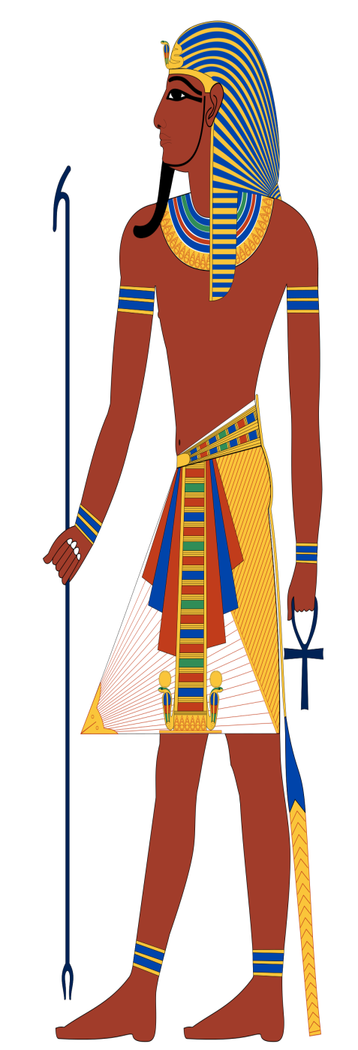
Anubis is the god and inventor
of embalming and mummification.
Anubis is used to weigh the hearts
of the dead souls in the underworld
which is called Duat. However, if
your heart weighed more than
Ma’at’s feather, the god, Ammit
would eat your heart. If your
heart was lighter you would
live forever. Anubis is
represented by a jackal or a the
body of a man and a jackal head. It is
said that Anubis created the first mummy:
Osiris. His wife is called Anput who has
the body of a woman and a jackal head.
They have a daughter called Kebechet,
the goddess of purification.
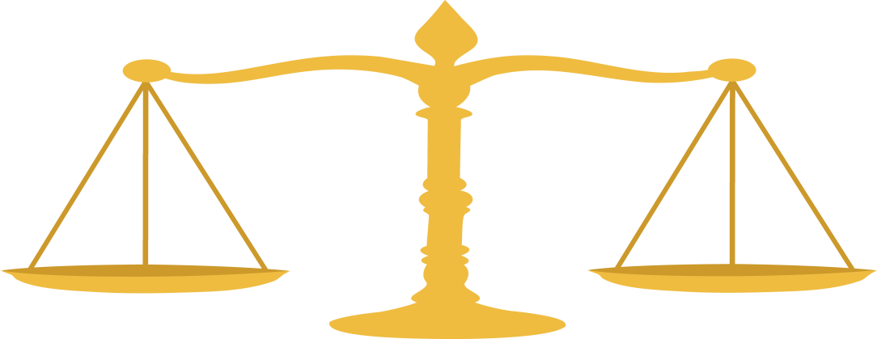
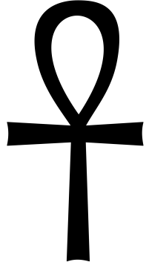

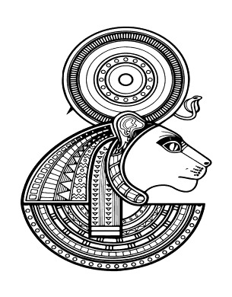
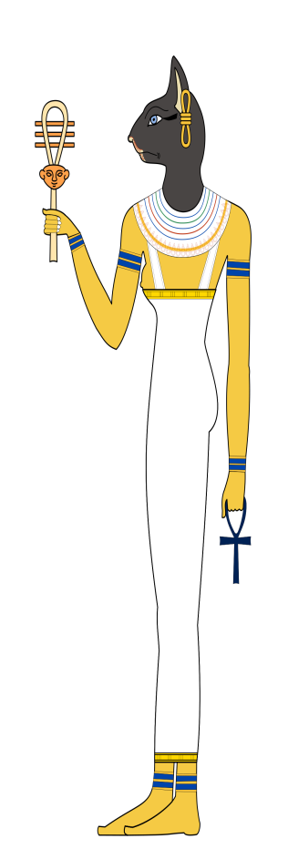
Sekhmet
Sekhmet is the goddess of sun,
war, destruction, plagues and healing.
She is one of the oldest gods and one of
the most powerful. She has a husband called
Ptah who is the god of craftsmen and
architecture and a son called Nefertem,
the god of perfume and god of the lotus flower.
She is said to be the daughter of the sun god Ra.
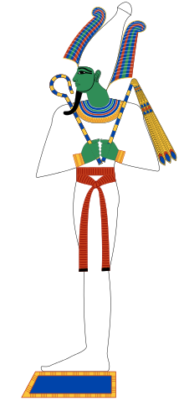

Osiris
Osiris was the god of the dead and
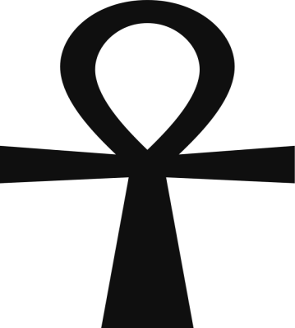
ruler of the underworld. Osiris had
a wife/sister called Isis. Isis was the goddess
of magic, fertility, motherhood, death and
rebirth. He is shown to be wearing
white linen wrapping from a mummy. He wears a
white crown with large feathers. Even though
he was the god of the dead, people still liked
and thanked him for passing them on to their next life.

Chloe Janaway

