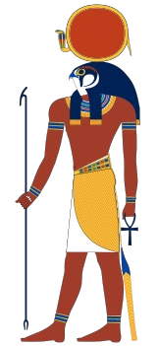

RA.

Ra is the sun god who carries the
sun on the top of his head.

He has the head of a Hawk and the
body of a man.

When Ra got old, he left earth to
dwell in the sky. Before he left
earth, he ruled on earth.

Ra knew that any children of Nut
the sky god would over come him
as king, so he commanded for Nut
not to have any children.

Ra was right because Nut child
Osiris became king because he
married his sister who had great wisdom.

By Innes

