The Easter Challenges
- The Most Delicious Chocolate Something

Easter eggs and other chocolate delights may be on your mind at the moment. You can have fun in the kitchen and share photographs or recipes of your chocolate creations.
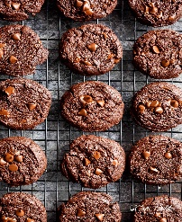
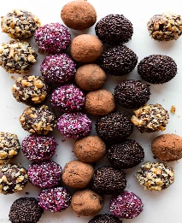
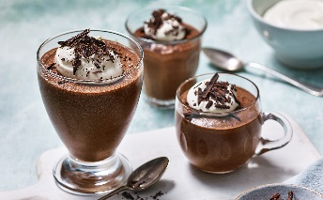
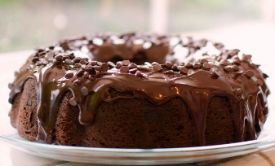

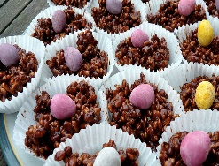
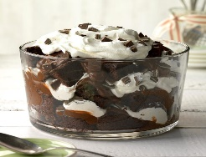
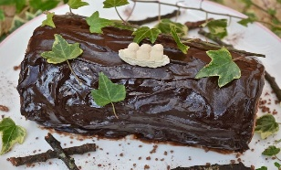
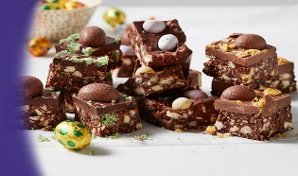

- The Most Beautifully Decorated Egg

Many of you may have had a go at decorating an egg before and you will know it is not as easy as it looks. You can use dyes, inks, felt tips or paints.

Tip: Mix paint with a little PVA glue to make it ‘stick and shine’ or use acrylics.
Tip: Make your own dye with vegetables


- The Most Unusual Egg Hunt
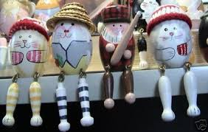
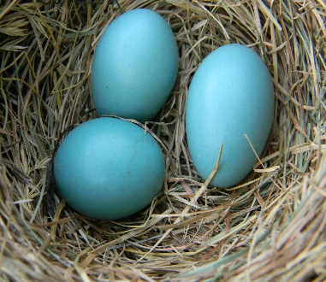

This hunt could take you anywhere – use the internet to search the globe for unusual eggs. These could be living eggs, built eggs or decorated eggs – in fact any unusual egg you can hunt down. Share the photo and a short explanation or description and we will post them all on the website.

