Skellig by David Almond Who or what is Skellig?
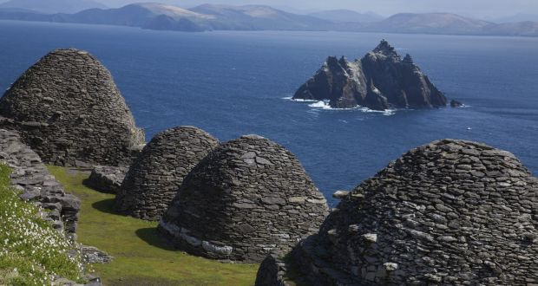
Skellig is named after the islands off the Irish coast in County Kerry? Find out about the islands.
Why do you think the author chose the name?
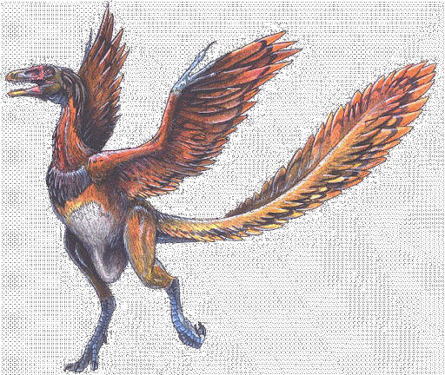

Mina teaches Michael about the archaeopteryx, a prehistoric bird from the dinosaur age.
What can you find out about the archaeopteryx?
You could try drawing your own impression of this creature.
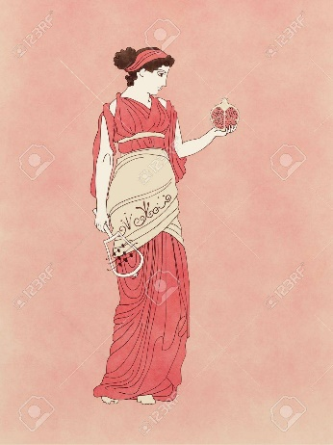
They learn about Persephone and the pomegranate tree.
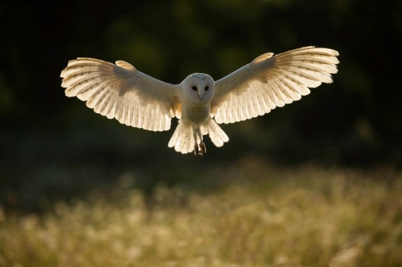
Read the story of Persephone.
Skellig produces owl pellets, suggesting that he is some kind of owl.
Owls are fascinating and beautiful. What can you find out about them?
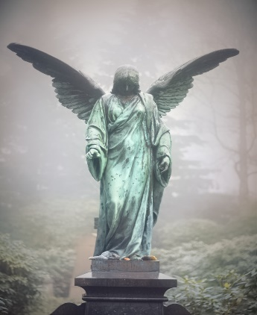
‘I heard an angel singing
When the world was springing
Mercy, Pity, Peace
Is the world’s release’ William Blake
Is Skellig an Angel? What are angels?
So, who is Skellig?

