Eco - Design Challenge
‘We want you to imagine and design an outdoor learning centre of the future. The centre must include an eco-building using energy saving technology to heat and power the building. The building must sit in an outdoor space including an outdoor play area, which children can use to spend time in nature, and to learn about ecology and sustainable living’
You can work remotely in a team if this is possible or you may prefer to do this on your own.
What do you need to do?
- Decide if you are going to do this on your own, with a friend or in a small team.
- Look carefully at the task and read the whole booklet for clues about what they are looking for – see the parts of the task in bold above.
- Do your research – Look at other outdoor learning centres; find out what energy saving technology you could use; find out what makes a good play area; think about what the outdoor space will need to help children learn about ecology and sustainable living?
- Draw a plan and make sure it is well- annotated. You may need an overall site plan and separate plan to look in more detail at the learning centre.
- Write a short explanation of your plan. Explain how the centre and different parts will work and be used by children. Explain why you have chosen different materials, technology and other aspects of your plan.
- Send your finished designs to your class teacher by June 15th 2020 with your team’s names so we can forward the final design to the competition.
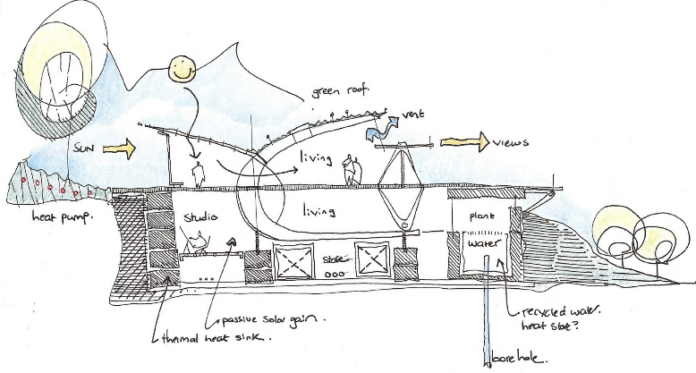

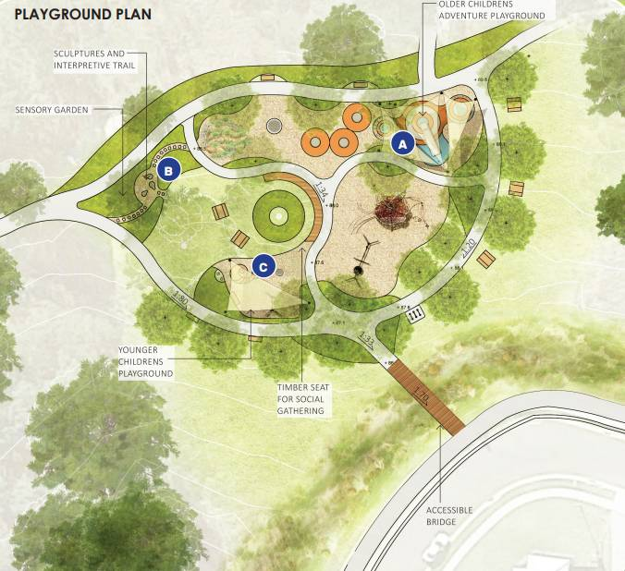
Here are a few websites which may help you in your research and some ideas about what a finished plan could look like.

https://www.bbc.co.uk/teach/class-clips-video/pshe-ks1-ks2-proud-to-be-an-architect/zbf76v4
http://tinyhouseblog.com/earthcob/simonshouse/
https://www.green-modular.com/blog/make-your-school-a-green-school-with-our-top-10-tips

https://inhabitat.com/6-exceptional-eco-schools/

https://b4ed.com/Article/five-essential-building-materials-for-green-schools


