The River Nile

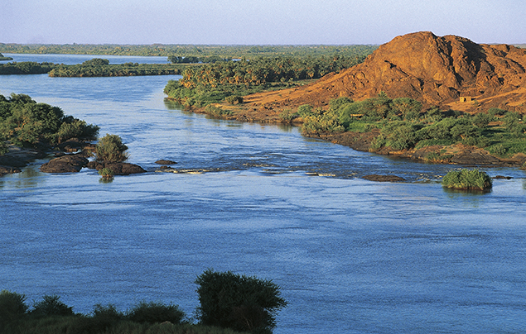

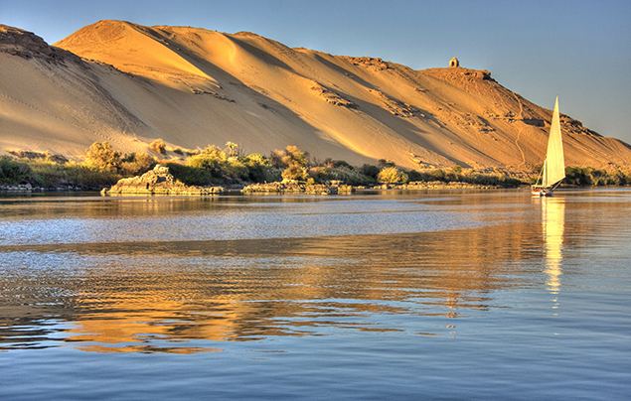

By Hannah Jewell

The River Nile

The Nile is a north flowing river found in Africa. It is the longest river in the world and is well known for being a vital source for one of the oldest civilisations in the World: The Ancient Egyptians. The length of the river is 6,650km. It is 7.5km wide at its widest point. The basin (the area around it) forms part of 11 countries. These countries are: Egypt, Sudan, South Sudan, Ethiopia, Eritrea, Uganda, Rwanda, Tanzania, Burundi, the Democratic Republic of the Congo and Kenya. The two main tributaries of the river are the Blue Nile and the White Nile rivers. The confluence of the Nile (where the Blue Nile and White Nile rivers join) is located in Sudan.

In ancient times the river in Egypt used to flood every year from June to October. The river no longer floods because in 1970 the Aswan Dam was completed. The river flows into the Mediterranean Sea.

Why did the Ancient Egyptians rely on this great river so much?
The Ancient Egyptians relied on the Nile because the landscape around it was a desert and there was no source of water. When the river flooded each year, it left behind tiny particles of silt. The silt contained minerals that made the soil fertile. They used this fertile soil for farming. The three most important crops were wheat, flax and papyrus. Wheat was the main staple food of the Ancient Egyptians and they would also use it to feed their livestock. The Ancient Egyptians used flax to make linen for clothes. Papyrus was used to make paper, baskets, rope and boats.

The Nile was also a source of transport; they would travel along the river in boats made of papyrus. The Ancient Egyptians also used the Nile to bring the bricks for their pyramids, temples and other structures. The bricks were transported in boats to the building sights. The pyramids were built near the Nile so they could be transported this way.
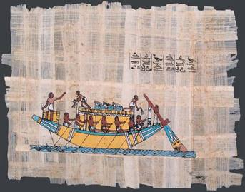
(Picture taken from “Ancient Egypt 101” by Aditis Paul and Taylor Wang)
This papyrus painting, a primary source, shows Egyptians rowing a boat over the Nile.
In ancient times, the river met its delta in a city called Giza. The map below shows where some of the Ancient Egyptian cities were built.

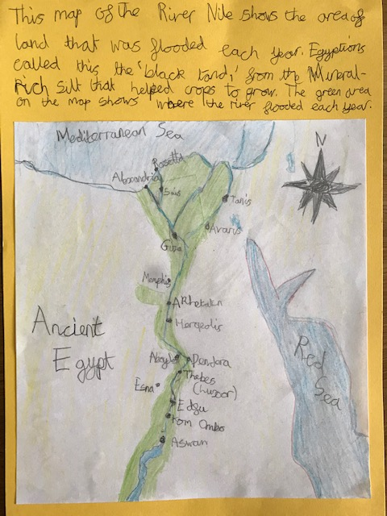
How is the river used today?

The surrounding area of River Nile is home to about 95% of the Egyptian population. The Nile is still an essential part of their lives because they need the water to drink, farm and fish. They still use some of the Ancient Egyptian’s inventions today. One of their inventions is a Sakia; it is used to transport water into canals to water crops. Water wheels are powered by the river and move water from the Nile into canals. Many dams have now been built such as the Aswan High Dam. These dams help tame the river and are a source of hydro-electric power. They are one of main the reasons that the Nile no longer floods in Egypt. The river is still used to transport people and goods. The river is still an important trade route.

The river and its banks are a home to many species of animals. Some of these animals include rhinoceros, hippopotamuses, baboons, frogs, turtles, tortoises and over 300 species of birds. Many water birds spend their winter in the Nile delta. Another well-known animal that lives in the river is the Nile crocodile. On average the Nile crocodile is between four and five metres long. It is one of the most dangerous species of crocodile and is responsible for hundreds of human deaths every year.

Current and future problems for the River Nile

The silt and sediment that used to flow north, enriching the soil and building the delta is now building up behind the Aswan dam instead. The water is becoming more polluted due to agricultural, industrial and human waste. Also, because routine annual flooding no longer occurs along parts of the river, it is not being flushed and cleaned of this waste.
Many of the countries relying on the Nile are fighting for rights over the river. They all claim to own the Nile’s water. Ethiopians claim that the water should belong to them because the river is generated in the highlands of their country. Some countries are building dams to control the water and hold it back so they can use it for planting. In Ethiopia, engineers are currently building a dam named The Grand Renaissance Dam to generate hydro-electric power and also for a water source. The Egyptians are worried about this dam being built because they fear that the new dam will stop the River Nile from adequately filling Lake Nassar and will therefore affect the Aswan’s Dam’s ability to produce electricity. They believe that Ethiopia will now be able to turn off or reduce the flow of the river. This would prevent the precious water from reaching their population who rely on it.

This image shows The Grand Renaissance Dam under construction.
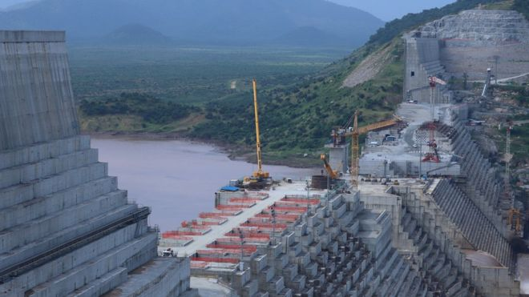

(Picture taken from “Egypt-Ethiopia row: The trouble over a giant Nile dam”, BBC Website)

