Countries the Nile flows through and information about them.

The Nile runs through ten countries in all,
Sudan 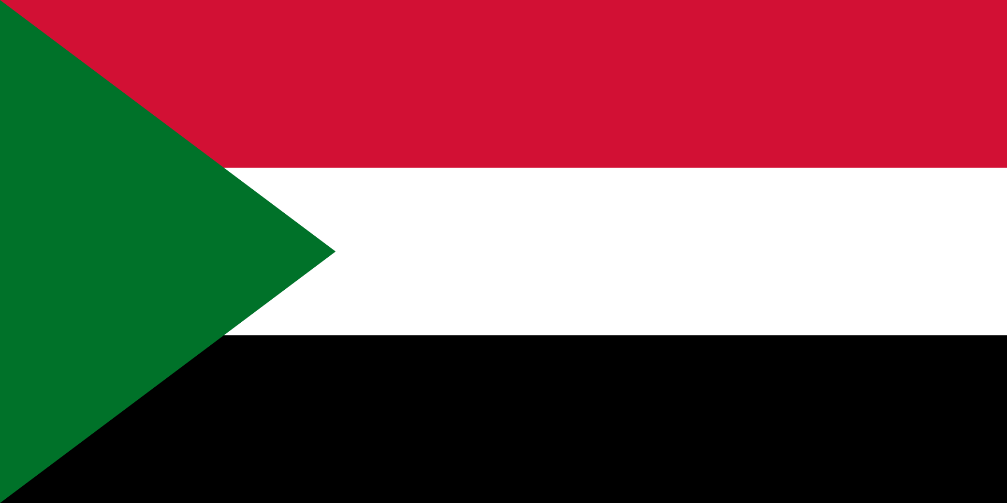 Egypt 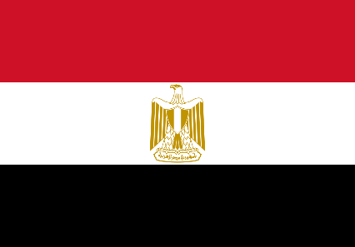
This Photo by Unknown Author is licensed under CC BY-SA
Ethiopia 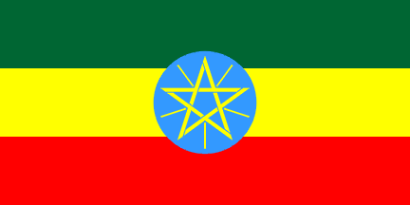 Rwanda 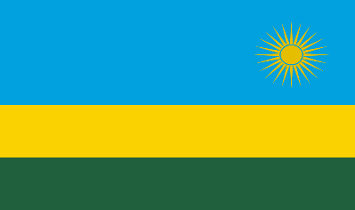
This Photo by Unknown Author is licensed under CC BY-SA
Tanzania 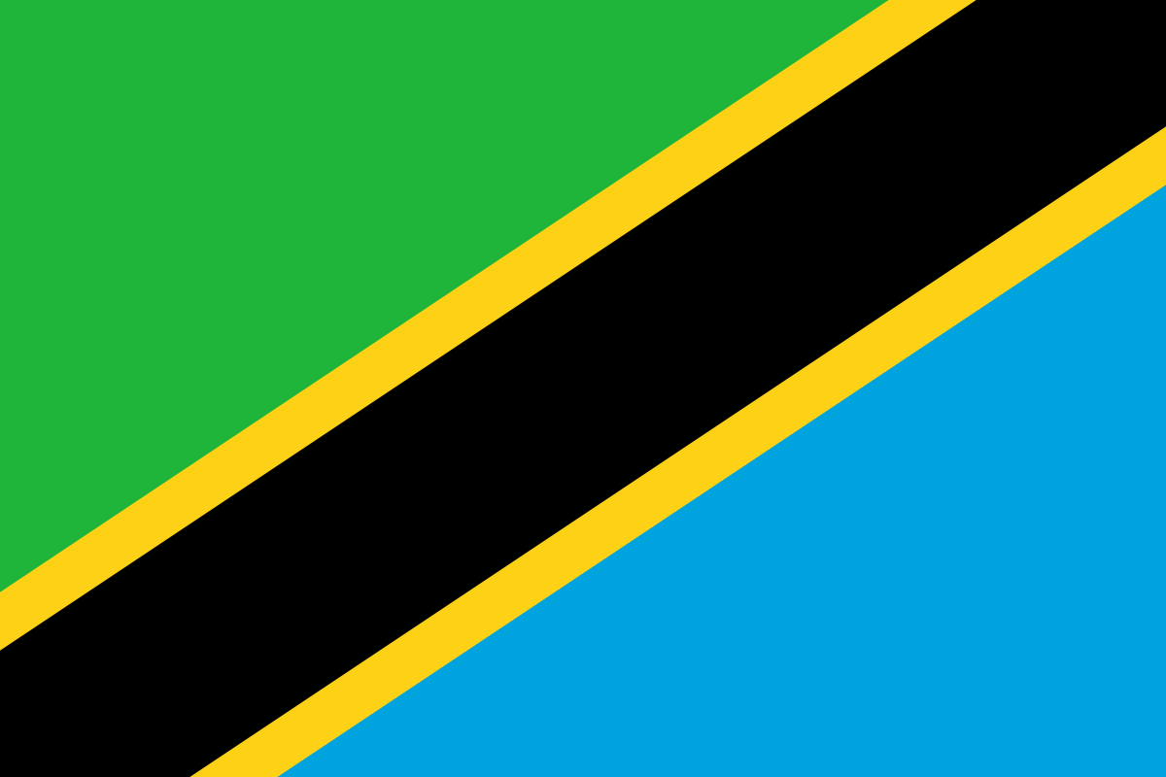 Uganda 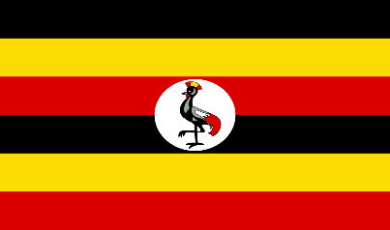
This Photo by Unknown Author is licensed under CC BY-SA
This Photo by Unknown Author is licensed under CC BY-SA
Burundi 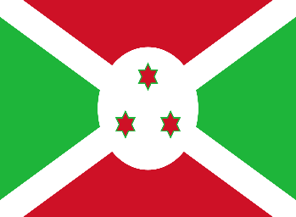 Congo 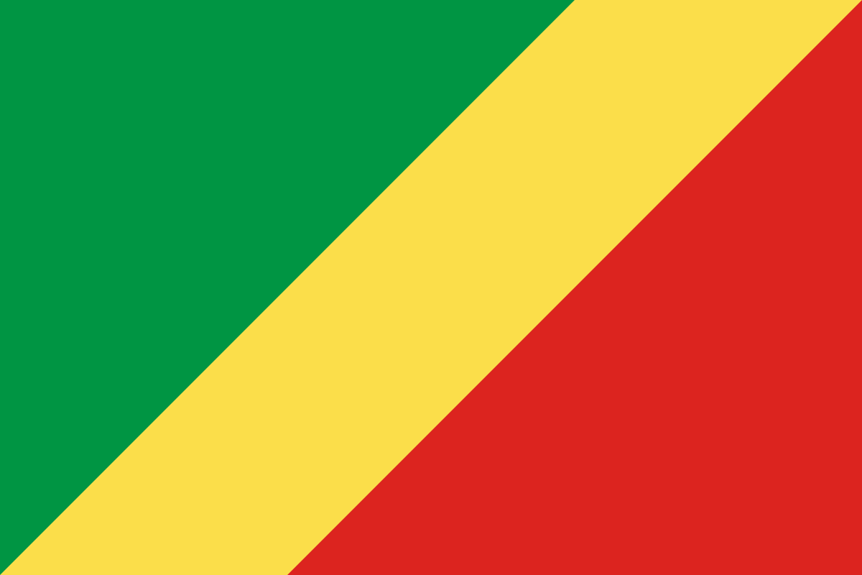
This Photo by Unknown Author is licensed under CC BY-SA
This Photo by Unknown Author is licensed under CC BY-SA
Kenya 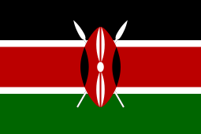 Eritrea 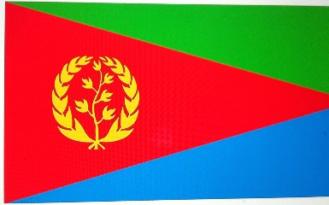
This Photo by Unknown Author is licensed under CC BY-SA
country | population
Sudan | 40 million
Egypt | 88 million
Ethiopia | 105 million
Rwanda | 13 million
Tanzania | 59 million
Uganda | 37 million
Burundi | 10 million
Congo | 79 million
Kenya | 48 million
Eritrea | 3 million

The Nile starts in Eritrea flowing into Kenya, Tanzania and then Uganda. In Uganda it splits, and a little tributary breaks off flowing through Congo and Burundi while the main channel flows into South Sudan and then into Sudan itself where it splits. The Blue Nile flows into Ethiopia and stops while the White Nile flows into Egypt and meets the sea.

