The river Nile
The river Nile is the longest river in the world, and it is about 6650 km long. It flows in the north east of Africa, from south to north ending in the Mediterranean Sea.
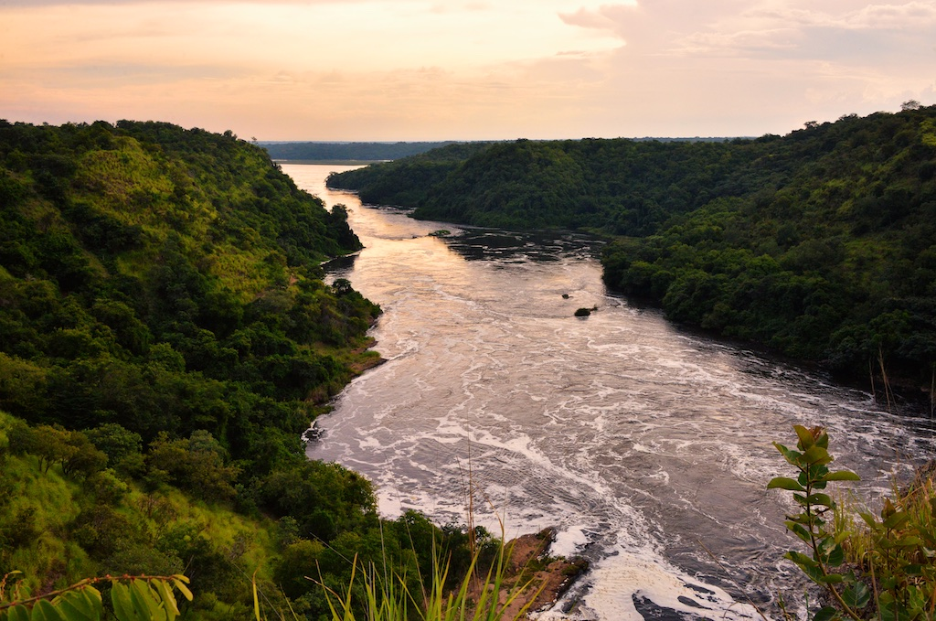

The source of the Nile
For several decades, scientific teams, amateurs, and adventurers tried to find out the source of River Nile, till it was finally discovered by a group of British explorers in the middle of the 19th century. They had to face lots of challenges, including diseases, wounds and fatigue. It seemed such a challenge to find the source of the Nile that people even used this expression to describe something incredibly difficult to achieve!
The Nile river has two main branches – the White Nile, which flows 4,230 miles from its central African sources to the Mediterranean, and the Blue Nile, starting in Ethiopia, which flows for 1,450 miles.
In 1856 two explorers called Speke and Burton left together for an expedition to find the source of the Nile. They became the first Europeans to discover Lake Tanganyika. They were told of a second lake in the area, which was found by Burton and named Lake Victoria, which was eventually declared the source of the White Nile, and lake Tana in Ethiopia the source of the Blue Nile. Eventually the Ruvyironza River of Burundi, a tributary of Lake Victoria, was regarded as the true and ultimate source of the Nile. The Ruvyironza is one of the upper branches of the Kagera River, which follows the Rwanda-Tanzania and Uganda-Tanzania borders into Lake Victoria.
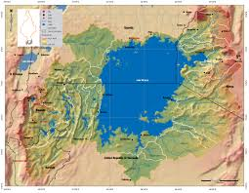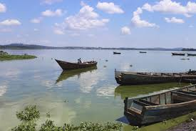
Lake Victoria

Indigenous people believe that the source of the Blue Nile comes straight from heaven and therefore that its waters are holy. They come to the source to pray and they believe the water can heal them and protect them.

Which countries does the Nile flow through?

When people think of the Nile they immediately associate it with Egypt, but in fact, the Nile runs through or along the border of 10 other African countries: Burundi, Tanzania, Rwanda, the Democratic Republic of the Congo, Kenya, Uganda, Sudan, Ethiopia, and South Sudan. With the river running through all these countries, who owns the Nile? Egypt was given ownership of the Nile in 1929 by Great Britain. At that time, Britain's powerful military-controlled Egypt, and wanted to make sure they also had control of the Nile. Britain no longer rules Egypt, but this official agreement still gives Egypt final say over how the river is used today. However, in 2011 Ethiopia started the construction of a huge Dam, called “the Millennium Dam”, at about 15 km east of the border with Sudan. This project will be a huge electric station powered by water (hydroelectric power plant) but has been the reason of many arguments between Ethiopia and Egypt, with even threats of sabotage. Egypt and other countries are worried that the dam will have a negative impact on the river’s water flows, which Ethiopia denies.

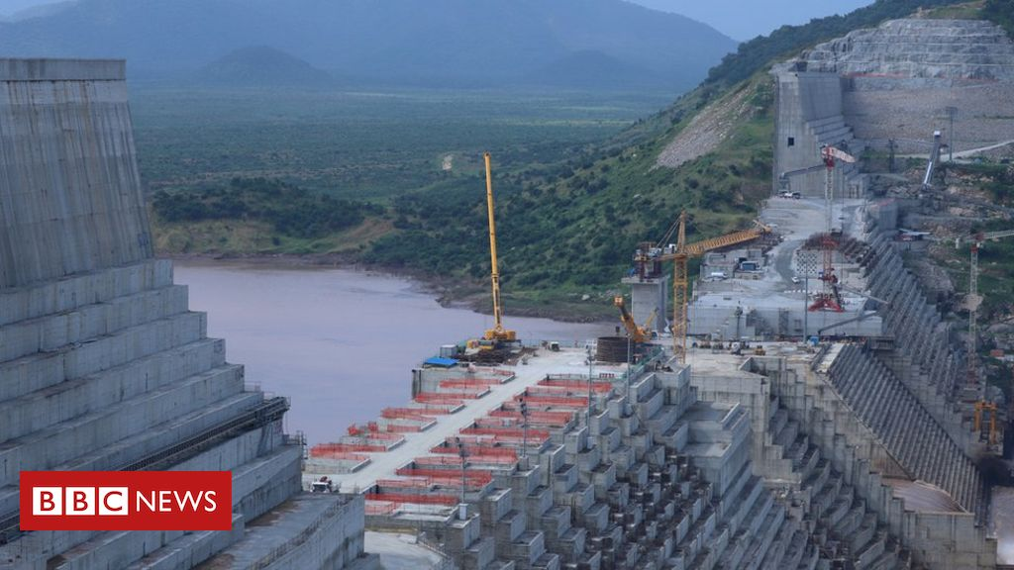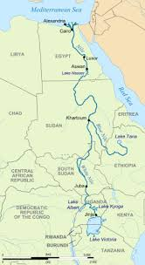
The Millennium Dam.

The stages of the Nile

The Upper Course

After leaving Lake Victoria, the Nile flows into the Sudd (a big swamp of vegetation, such as papyrus, elephant grass and water Hyacinth) in Sudan. Because of this amount of vegetation in this area, the channel often gets blocked (sudd means “block” in Arabic). The river loses a lot of water as he meanders through shallow channels, because the water seeps into the ground and evaporates. Then the river meets the Blue Nile
The Blue Nile starts at 1,785 m above sea level in Lake Tana. Starting southeastward, the river becomes very wide while crossing the Sudan border and changes direction to the northeast. It gets most of its water from heavy rains in summer. After that it drops to the Sudan plateau and joins the White Nile.
Thats where, in Khartoum, the mainstream of the Nile begins. The first series of rapids it encounters is about 120 km downstream. Then there is grassland.

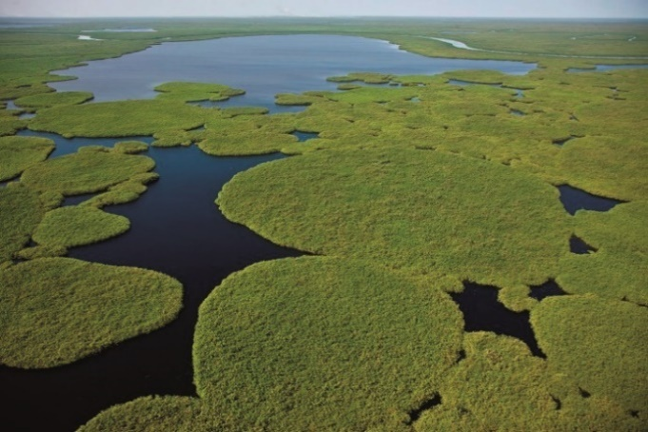
The sudd swamp

The middle course
the Nile now starts its middle course through the desert. Because of the heat and the fact that there are no streams and little rainfall to keep it going, the Nile becomes a lot narrower. The Middle Course is small and is only desert land.

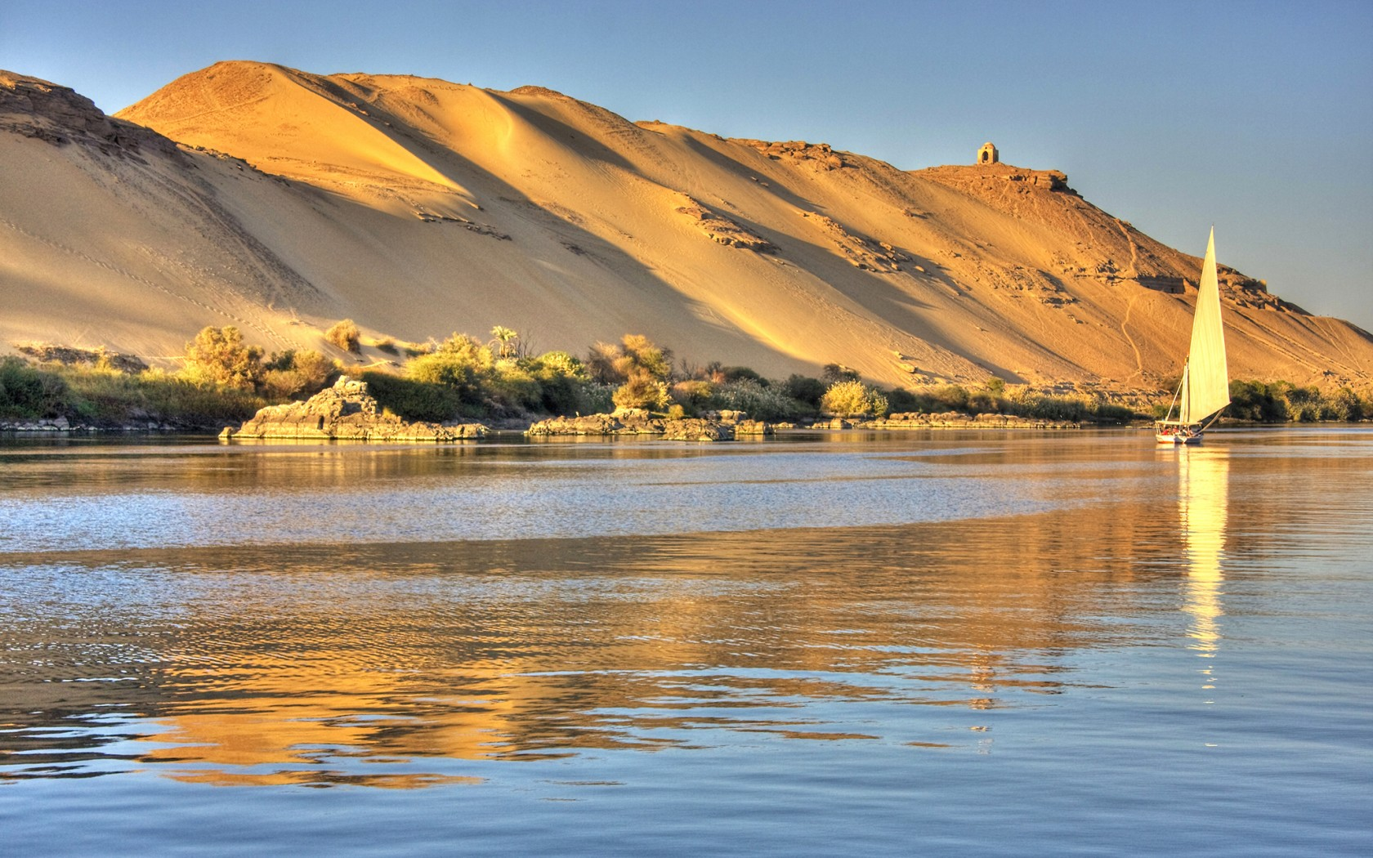

The lower course

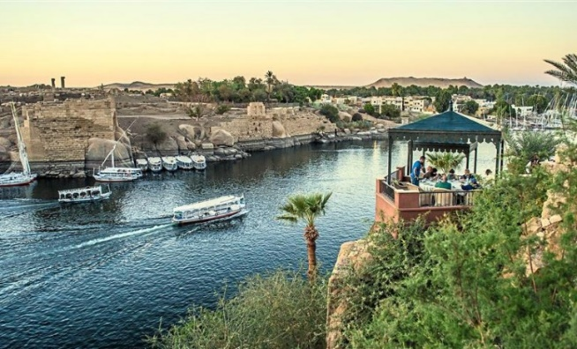
The Nile's lower course starts just before the Nile's desert land finishes and It arrives in Egypt. At Cairo, the Capital, the Nile separates into 3 distributaries which flow across the Wide Delta into the Mediterranean Sea.
the Nile in Egypt

Why is the Nile so important?
Ancient Egypt

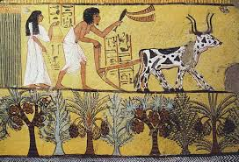
in Ancient Egypt, the country was separated into two regions, Upper Egypt and Lower Egypt because of the flow of the Nile River from south to north into the Mediterranean Sea. the Nilewas very important to ancient Egyptians for many reasons.
Fertile land
Although most of Egypt is made of desert land, around the Nile the soil is very fertile, moist and good for growing crops, such as wheat, flax and papyrus.
Wheat was an important grain for the Egyptians. They used it to make bread and to sell to other countries in the region. Flax was used to make linen for clothes. Papyrus was a plant that grew along the shores of the Nile. The Ancient Egyptians used it in many ways, including to make paper, baskets, rope, and sandals.
In the Autumn, particularly around September of each year Egypt would have a lot of rain causing the River to flood. The Ancient Egyptians believed that the flood was caused by the tears of the goddess Isis as she cried for her dead husband Osiris. These floods were very important because they made the soil fertile, bringing lots of minerals and nutrients to the farmlands. The black soils carried by the river was called “the gift from the Nile” by the Egyptians. They also called the Nile the "Aur", which means "black" and comes from the black soil. The Egyptians measured the height of the annual flood using a Nilometer. This helped them to determine how good the crops would be that year.
Building Material
People used The Nile River to collect building material. For example, they used the mud from the riverbanks to make bricks, which they dried in the sun. These bricks were used for building homes, walls, and other buildings. The Egyptians also used limestone and sandstone from the hills along the side of the Nile.
Transportation
Since most of the major cities of Ancient Egypt were built along the Nile River, the river was used as a big road to connect towns. Boats constantly travelled up and down the Nile carrying people and goods
Seasons of the Nile
The Egyptians even built their calendar around the Nile River. They divided the year up into three seasons. Akhet, or inundation, was considered the first season and was the time of the flooding of the Nile. The other two seasons were Peret, the growing season, and Shemu, the harvest season.
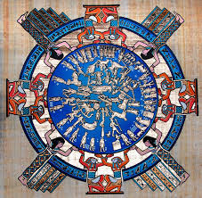

Modern Egypt

More than 95 percent of Egypt's population lives on the banks of the Nile, and the Nile River Valley is one of the most densely populated areas in the world, with an average of 3,820 people per square mile.
The Nile is still a vital resource for the countries through which it flows. Farmers produce a wide variety of crops, including citrus fruits, cotton, wheat, sugarcane, legumes and sorghum. Despite this production, the countries through which the Nile flows remain poor and their populations are getting bigger and bigger. A program called “The Nile Basin Initiative” was started in 1999 to help each of these countries use the Nile and its benefits. The Nile is also being used to generate electricity, and several dams have already been built to control flooding and generate hydroelectric power (electricity from water).
Agriculture isn't the only industry thriving on the banks of the Nile: tourism also greatly benefits from the river. Many guides and companies take tourists on desert treks, tours of the Great Pyramids, scuba diving expeditions and much more. Visitors to the area can also enjoy tours of the Nile from the comfort of riverboats.
The Nile River has also been used in many television programs and films, including "The Jewel of the Nile" (1985) and "The Simpsons."
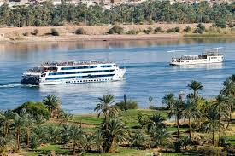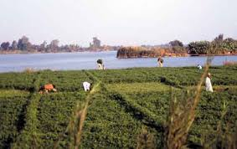
Cruise on the Nile Crops on the Nile

