THE RIVER NILE

1.Geography

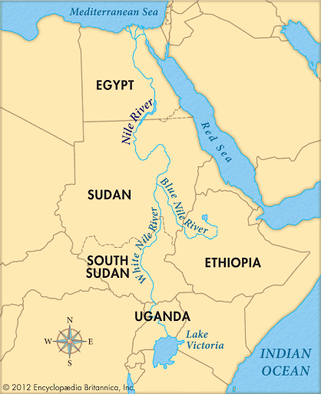

Continent: Africa

Length: 6650 km

Mouth: Mediterranean Sea

Source: lake Tana (in Ethiopia)

2nd Source: lake No (in South Sudan)

Basin: 3400000 km squared

The average width of the river Nile is 2.8km but can reach up to 7.5km.
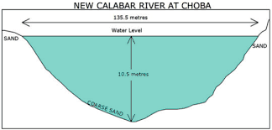
The river basin average temperature is 30 C.

The river Nile can reach 8-11 meters deep.

The Nile is the longest river in the world. It flows 4132 miles toward Mediterranean Sea and has two parts: The White Nile and The Blue Nile.

The river basin covers eleven countries: Tanzania, Uganda, Rwanda, Burundi, the Democratic Republic of the Congo, Kenya, Ethiopia, Eritrea, South Sudan, Republic of the Sudan, and Egypt.
The river Nile is north flowing and is one of the world’s largest waterways.

The river Nile provides people with a supply of water. In Ethiopia only the priests can go to the source, as Ethiopians believe that the Nile is a gift from God.

The river Nile is home to many animals that build their homes by or in the river such as: the Nile crocodile, Nile monitor, African tiger fish, Nile river snakes, Nile soft shelled turtle, Nile perch and hippopotamus.

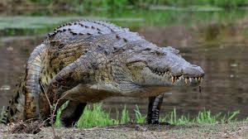

The river Nile is home to the great pyramids in Egypt.

2. History

The river Nile is over 30 million yeas old and its name comes from a Greek God called “Neilos” meaning valley.

In ancient Egypt times the river Nile flooded annually every year between June and September. The Egyptians knew when the annual floods were coming so they controlled the water to use in their crops.

The Egyptians called the flood plains around the river the “black land” for when the seasonal floods came and they called the dry land around the banks of the Nile the “red land.”

Most Egyptians lived near the Nile as it provided water, food, transportation and excellent soil.
They used the river Nile for washing, water for crops, animals and as a source of water for humans especially when the floods came.
They also used the Nile in the construction of the pyramids by using boats to
carry the stones right up to the pyramids.

3. The River Nile Today

Today the river Nile is still used for crops, washing and as a source of water for living things but is also used for, trade, irrigation and leisure. Majority of Egyptians today still live within a kilometer from the Nile.

Many people around the river Nile still depend on it for the food and jobs like fishing or transportation.

The river Nile is also tourist attraction and is a holy river for the villagers who live nearby.

As the river Nile is important source for growing crops and animals, the lives of people who live beside it would be a lot harder without access to its water. That is why they believe that the Nile is a gift from god.

Nowadays the river Nile does not flood. This is because of the dam, which was build between Ethiopia and Egypt, which is 1800 feet. It was build to protect crops from flooding.

However because the dam is blocking the sediment that used to flow north enriching the soil the delta is now shrinking.

As the dam is stopping the floods, which used to flush and clean the river water from waste, the Nile is becoming more and more polluted.



