Lily Jackson Presents:
Nile news
May 2020
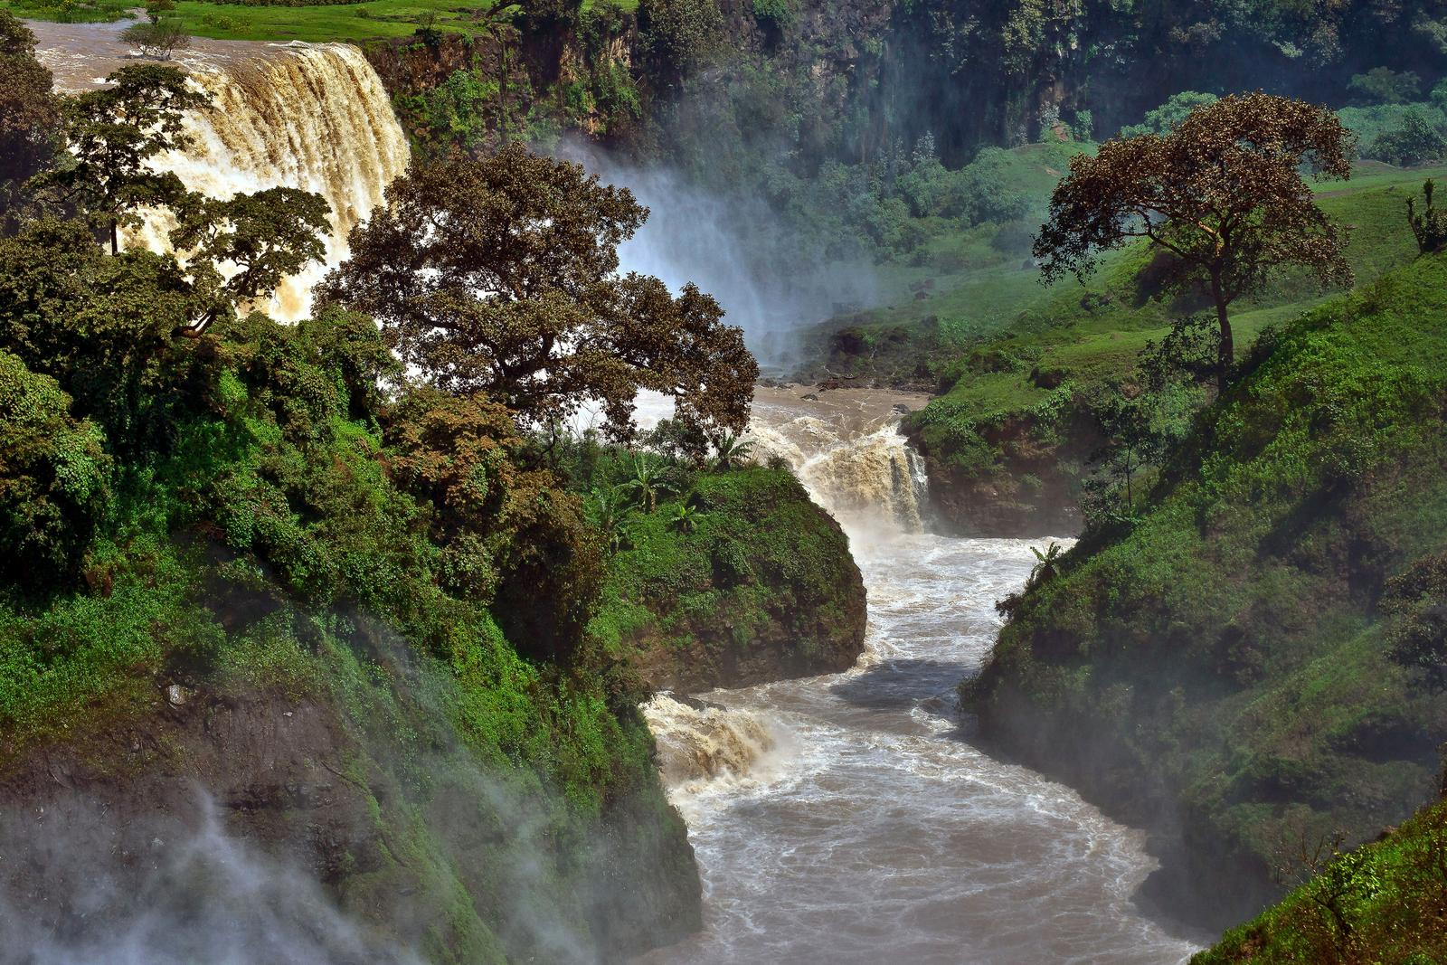  Enquiry into the River Nile  The Nile in action.  This Photo by River Mouth is licensed under LI-LY-DO-JA |  |  |  |  |  |  | Have you ever imagined standing next to the River Nile? Here’s your chance to bring it to life.
The River Nile is the longest river in the world. It has two main tributaries. With its lakes and tributaries, the Nile connects to 11 different countries in Africa flowing from Burundi north to Egypt. Millions of people depend on the water for food, crop, water, transport and drink. Even today half of Egypt’s population, which is 40 million people live on the Nile delta part of the Nile. |  |  | The Nile is 6,648km long and ends at the Mediterranean Sea, but it took thousands of years to find where the river started. The British explorer John Hanning Speke discovered Lake Victoria in 1858 and correctly guessed that this was where the Nile began. |  |  | In modern times the Nile does not flood every summer. The Aswan High Dam was built in 1970. This dam controls the flow of the river while using the water’s power to generate electricity for Egypt. It is 111m high and the lake that formed behind it Lake Nasser is one of the largest human-made lakes in the world.
The 11 Nile Countries
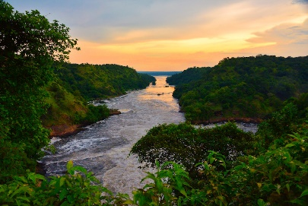
Tanzania, Uganda, Rwanda, Burundi, the Democratic Republic of the Congo, Kenya, Ethiopia, Eritrea, South Sudan, Republic of the Sudan, and Egypt
Read more on p2
Ancient times Around the Nile  Written by Lily Jackson  Ancient Egypt could not have existed without the river Nile. Since rainfall never happens in Egypt, the floods provided the only source of moisture to sustain crops. Most Egyptians lived near the Nile as it provided water, food, transportation and excellent soil for growing food. The ancient Egyptians could grow crops only in the mud left behind when the Nile flooded so they all had fields all along the River Nile. The Nile also gave the ancient Egyptians food. They used spears and nets to catch fish. They would also use the nets to catch birds that flew close to the surface of the water. The Nile helped the ancient Egyptians was in trade. The Nile was the quickest and easiest way to travel from place to place. |  |  |  | The River Nile flooded every year between June and September, in a season the Egyptians called akhet - the inundation. The flooding left behind fertile soil that was helpful for farming. The river also gave them protection from enemies. Egyptians bathed in the Nile River. In Ancient Egypt the Nile River held a very important place in the society. Not only did it bring water and life to the desert, it was also a symbol of the ancient Egyptian spiritual life. In fact, the ancient Egyptians believed that the Nile river was actually a passageway between life and death. | 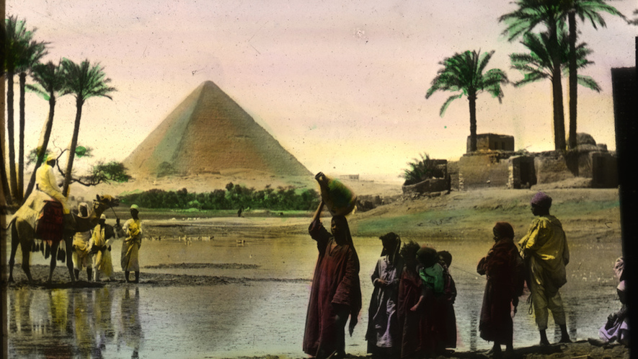  The Nile River was the centre of Ancient Egypt.  Ancient Egypt, one of history’s first civilizations arose around the Nile River about 5,000 years ago. It lasted for over 2,000 years.  The Ancient Egyptians called the rich black soil from the floods the "Gift of the Nile". Today, the Aswan Dam keeps the Nile from flooding modern cities. The Ancient Egyptians called the Nile the "Aur”, which means "black" and comes from the black soil.

 | Did you know that the Nile is home to over 15 million habitats.
THE ANIMALS OF THE RIVER NILE |  |  |  |  |  |  |  | There are also Triggerfish that live in the Nile. Triggerfish are found in the lower Nile River system. It has daggerlike teeth that protrude when its mouth is closed, and it is known for being fierce, whether it is predator or prey.  The softshell turtle, named after its flattened shell, can be found in the Nile River. The flattened shell helps the turtle to swim rapidly.  The Triggerfish is a freshwater fish found throughout much of Africa including the Nile River. It has a silvery colour with narrow black strips running across its skin. It has sharp teeth that allow it to cut into prey after tightly grasping it. African triggerfish are extremely important to the local people in the Nile.  The Nile Crocodile is one of the most scary animals of the Nile River. It is the second biggest reptile in the world after the saltwater crocodile. This species is found in Africa and lives in lakes, rivers, and even marshlands. A male Nile crocodile has a length ranging from 3.5 to 5 m while females are about 30% smaller than males. Nile crocodiles are feared for their aggressive nature. |  |  | 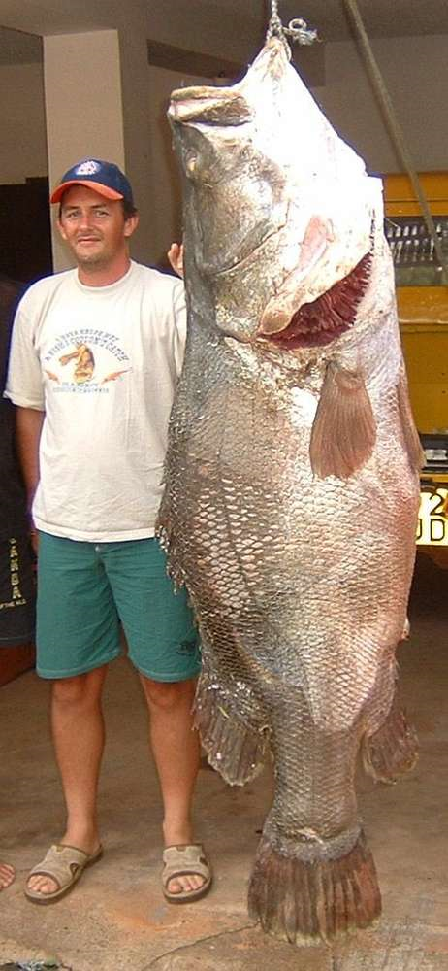  Picture of the giant Nile Perch
One of the animals of the River Nile is a hippopotamus. Hippopotamuses are now found only in the swampy Al-Sud region of South Sudan and farther south. A male hippopotamus is typically about 3.5 meters long,1.5 metres tall, and 3,200 kg. |  |  |  |  | Another one of the animals is The Nile perch which is found in the lower Nile River system. This freshwater fish can grow to be quite large, some weighing as much as 200 kg and measuring 2 meters (6.6 feet) in length.
Did you know that there are over 100 species of fish in the River Nile?
Several species of snakes, both venomous and non-venomous, live in the Nile River. Some of the deadliest snakes living along the river are the Egyptian banded cobra, red spitting cobra, black mamba. Water snakes that live almost in the Nile’s waters are also found in the river. These snakes feed on fish, invertebrates, and amphibians in the water. |  |  |  |  | The Nile Monitor is found across Africa. This large monitor also lives in the Nile River. It can grow to around 120 to 220 cm in length and has strong jaws, legs, and muscular bodies. Nile monitors feed on a variety of animals like fish, eggs from crocodiles, frogs, snakes, birds and small mammals.

Characteristics of The Nile
Characteristics and Geographical Features of the Nile River |  |  | 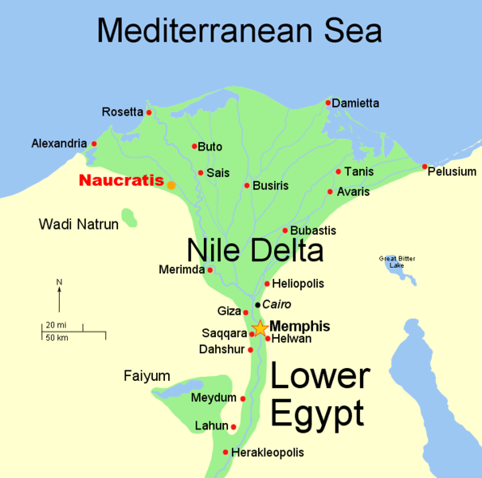 |  |  | One of the unique features about the Nile River is the fact that it flows north, which is opposite to the direction most rivers go. The Nile River, one of the longest river systems in the world, begins with six cataracts (also known as rapids) that flow into a narrow valley-river section, then spreads out into the marshy Nile Delta near the Mediterranean Sea.  The Nile begins in the country of Burundi, which is in the middle of Africa, and flows towards the northeastern part of the continent. It flows all the way through Egypt and eventually empties out into the Mediterranean Sea.  The Nile Delta in Northern Egypt is where the Nile River drains into the Mediterranean Sea. It is around 160 kilometres (100 miles) in length and spreads out over 240 kilometres (149 miles) of coastline. |  |  |  |  |  | Around 40 million people (half of Egypt’s population) live in the Nile Delta region. The Nile Delta is formed in Lower Egypt where the Nile River spreads out and flows into the Mediterranean Sea. It is one of the world's largest river deltas—from Alexandria in the west to Port Said in the east, it covers 240 km of Mediterranean coast is rich. From north to south the delta is approximately 160 km in length. The Delta begins slightly down-river from Cairo. The characteristics of a society include: food supply includes farming, the Nile river, and what they ate. Social levels and classes includes the social levels of Ancient Egypt and the wealthy and the poor. Specialization of labor includes trade, the domestication of animals, and jobs.

10 facts about the river nile

The Southern Stretches of the River are Home to Nile Crocodiles.
Written By Lily Jackson
 |  |  |  |  |  |  |  |  |  |  | 1.Why is the River Nile referred to as the Forgotten River?  This river only contributes 1% of the total |  |  | water volume that flows through the Nile, it is sometimes  Continues on P3
Nile Sunset in Action
Written by Lily Jackson

The Nile in Egypt at night
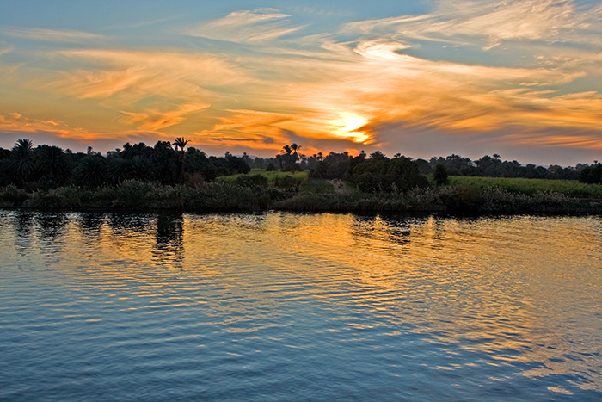
referred to as the Forgotten River. It empties into the Mediterranean Sea. Most of the year, this river could hardly be classified as a raging body of water.  2.How deep is the Nile?  The deepest point in The Nile is found in the Blue Nile which is about 6000 feet deep which is equivalent to the Grand Canyon in USA. Throughout Egypt, the Nile has worn a deep, wide gorge in the plateau region.  3. How old is the Nile?  The Nile river is at least 30 million years old. THE source of the Nile river remained a mystery to Europeans for thousands of years.  4. When was the Nile dam built?  The British began construction of the first dam across the Nile in 1898. Construction lasted until 1902, and the dam was opened on 10 December 1902.  5. What direction does the tide flow on the Nile?  Africa's Nile River flows northward, emptying into the Mediterranean Sea. |  |  |  | 6. Where is the Nile located?  The Nile River is located on the continent of Africa. It begins in the country of Burundi, which is in the middle of Africa, and flows towards the northeastern part of the continent.  7. Why do people live by the Nile?  Because it offered water, food, transportation and excellent soil for growing tasty food most Egyptians lived near the Nile Ancient Egypt couldn’t have existed without the Nile River. Since rainfall is almost non-existent in Egypt, the Nile River provided the only source of moisture to be able to sustain crops. The dry, sandy deserts both east and west of the Nile provided protection from their enemies, allowing the people to enjoy a peaceful lifestyle. |  |  | 8. What direction does the Nile sunset?  Sun sets to the northwest for the Northern Hemisphere, but to the southwest for the Southern Hemisphere.  9. How the Nile shaped Egypt?  The Nile River shaped ancient Egypt in that it provided a waterway for trading, a means of defending against enemies, and a water source for agriculture. Each year, the river flooded the land around it. This caused silt deposits to develop and made the land fertile for agriculture.  10. What does the Nile mean?  The meaning of the name “Nile” is: “River; light or shine”. ... The name Nile is of African, Celtic - Gaelic origins, which means it has more than one root.
The Nile is sometimes called The Forgotten River.
Lily Jackson, Chief Editor, Applecroft News
 |  |  |  | No other region in our world is so dependent on a single water system, especially as it is located in one of our world's most extensive and severe deserts. |  |  | More than 90% of the population of Egypt today lives adjacent to and relies directly on the Nile and its delta.
 |  | The ancient Egyptians relied on the Nile as their source for reliable or at least predictable water supplies to allow their agricultural and then commercial settlements to develop. |  |  |  |  |  |  |  | The Nile at night has beautiful views and sunsets. The River is calm and slow moving. |  |  | The Nile also has some lovely cloud shapes and patterns which reflect in the serene water.
Pyramids around the Nile |  |  |  |  |  |  |  |  | The reason they built the pyramids next to the Nile River was so it would be easier to get the rocks to the pyramid. The stones could be bought nearer to the pyramid building site by boat. Ancient Egyptians built pyramids to honor, or sometimes pharaohs and other royalty. |  |  |  |  | The pyramids of Egypt are among the world's great treasures; one is among the seven wonders of the ancient world Egypt is largely desert, much of ancient Egyptian arose in the Nile River valley. Many of the best-known pyramids to visit when vacationing in Egypt still cast their shadows over the river.  The pyramids were built by the Nile first and foremost because that’s where the builders were. While we can speak of Egypt, mostly what we mean by that is the banks of the Nile. Where the waters of the Nile valley are available for drinking there are people. Outside of that, there’s desert. If they’d been built much farther away, it would have been impossible to support the builders.  The stone for the pyramids came from quarries which could be many miles away. Transport by water is cheap and easy ,but moving things over land is difficult.
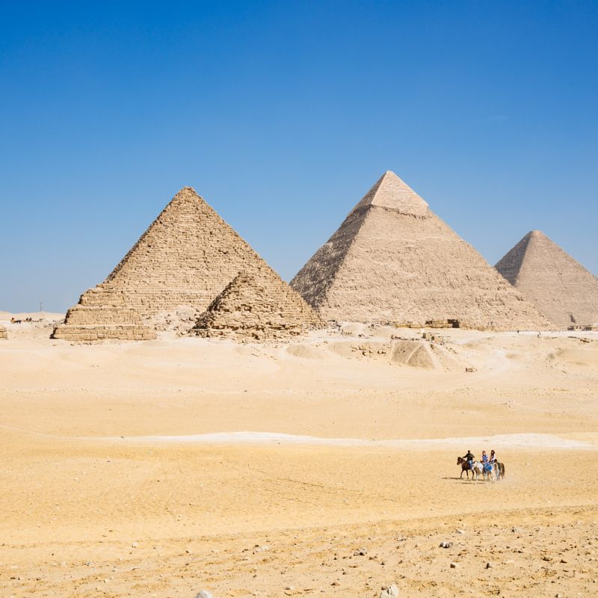
Pyramids of the River Nile

