Who Stole the Sand Hanitizer?
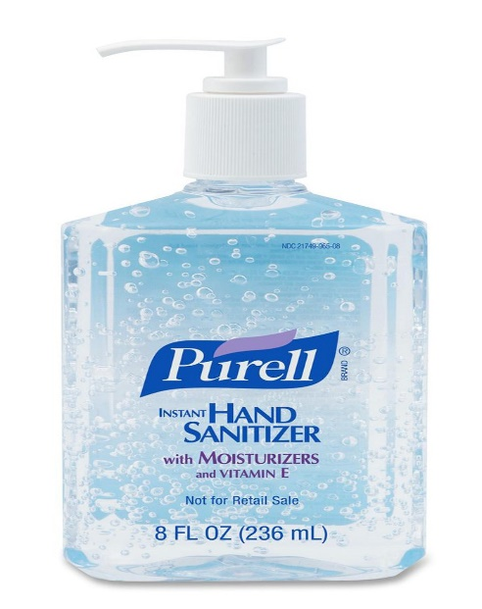

The special Sand Hanitizer has gone missing!
It is your job to find out which NHS worker stole it.
Complete maths problems to find the culprit.

Here are the suspects.
Name | Gender | Hair colour | Colour of clothing | Favourite food | Department
Lottie | Woman | Blonde | Black | Ice cream | Operations
Edward | Man | Black | Orange | Ice cream | Restaurant
Max | Man | Red | Pink | Pot noodles | A&E
Charlotte | Woman | Black | Blue | Pasta | Operations
Emma | Woman | Blonde | Black | Ice Cream | Receptionist
Violet | Woman | Brown | Violet | Custard | Operations
Bill | Man | Black | Orange | Chicken | A&E
Charlie | Man | Black | Red | Ice cream | A&E
Megan | Woman | Blonde | Black | Pot noodles | X-Ray
Chris | Man | Blonde | Blue | Pasta | Receptionist
Melody | Woman | Brown | Black | Chicken | A&E
Nickola | Woman | Blonde | Black | Hot Dogs | Operations
George | Man | Black | Pink | Pot Noodles | X-Ray
Tilly | Woman | Blonde | Black | Ice cream | A&E
Annabeth | Woman | Blonde | Black | Hot Dogs | Restaurant
Bob | Man | Green | Rainbow | Brussels | Snacks
Jeff | Man | Green | Rainbow | Brussels | Snacks
Sarah | Woman | Black | Blue | Ice cream | A&E
Tina | Woman | Blonde | Black | Chicken | Receptionist
Owen | Man | Blonde | Green | Ice Cream | A&E
Sam | Man | Black | Purple | Custard | X-Ray
Matilda | Woman | Blonde | Black | Hot Dogs | A&E
Susie | Woman | Brown | Orange | Pasta | X-Ray

The Sand Hanitizer was stolen by…

Good Luck!!!!
(You’ll need it… )
Fun Fractions
Add, subtract, multiply or divide each of these fractions, then change the numbers into letters using the table and put them on the line at the bottom of the page to determine the culprit’s gender.
(d = divide)
1. 30/15 + 7/14 =
Workings out space:
2. 2/5 – 1/20 =
3. 3/4 d 1/5 =
4. 1/7 x 1/2 =
5. 4/21 d 6/7 =

1/14 | 2/3 | 4/9 | 5/6 | 9/8 | 5/6 | 2/9 | 3/5 | 2/7 | 1/7 | 3/4 | 1/2 | 15/4
= | = | = | = | = | = | = | = | = | = | = | = | =
A | B | C | D | E | F | G | H | I | J | K | L | M

2/9 | 7/20 | 3/5 | 1/1 | 7/19 | 1/6 | 1/2 | 3/7 | 9/5 | 5/2 | 5/6 | 1/4 | 2/3
= | = | = | = | = | = | = | = | = | = | = | = | =
N | O | P | Q | R | S | T | U | V | W | X | Y | Z

The culprit is a…

Marvelous Multiplication and Division
Complete these long multiplication and division questions, turn them into hair colours using the table and write the colour that appears the most on the line at the bottom of the page, and if it was done correctly this will be the culprit’s hair colour. Round decimals up to whole numbers.
(d = divide)
1. 51328 d 14 = 4. 32 x 7756 =

2. 15465 d 45 = 5. 15 x 9157 =

3. 29798 d 23 = 6. 65 x 5463 =

Six-digit number | Four-digit number | Five- digit number | Three-digit number
Blonde | Red | Black | Brown

The culprit’s hair colour is…

Annoying Algebra
On the hygiene secretary’s desk (Where the Sand Hanitizer was kept) there was a thread off someone’s clothing that wasn’t the secretary’s clothes. Complete these algebra questions to find out what colour it is, then check the table and write the answer on the line.
1. 15 x 21 + a = 317 a =
Workings out space:

2. 6 x 5 – b = 18 b =

3. 124 x 308 - c = 38191 c =

4. 34 x 60 + d = 2043 d =

5. 12 x 14 – e = 157 e =

1 | 2 | 3 | 4 | 5 | 6 | 7 | 8 | 9 | 10 | 11 | 12 | 13
A | B | C | D | E | F | G | H | I | J | K | L | M
14 | 15 | 16 | 17 | 18 | 19 | 20 | 21 | 22 | 23 | 24 | 25 | 26
N | O | P | Q | R | S | T | U | V | W | X | Y | Z

The colour of the thread is…

Nice Nets
A piece of food was found on the hygiene secretary’s desk. Draw lines to join the shape name to its net and consult the table to find out what type of food it is. (Hint: if your combination isn’t on the table, it probably isn’t right)
1. Tetrahedron 2. Cube 3. Cuboid 4. Triangular Prism

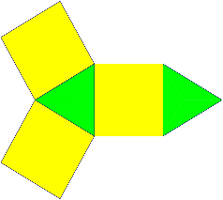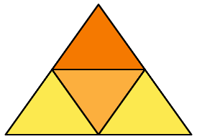

This Photo by Unknown Author is licensed under CC BY-SA

5. 6. 7. 8.

1 2 3 4  5 6 7 8 | 1 2 3 4  5 6 7 8 | 1 2 3 4  5 6 7 8 | 1 2 3 4  5 6 7 8
Ice cream | Chicken | Hot Dogs | Pot Noodles

The food was…

Repetitive Rounding
A cleaner found traces of the Sand Hanitizer in a department. But to identify which one, you must complete these questions. When you’re done, count the total number of 0s on the end of each number, then the 00s, and finally the 000s. The category with the biggest total is your answer, then check the table to turn it into a department.
Round to the nearest:
10 100 1000
1203 = 12674 = 395465 =
3456 = 45738 = 917427 =
4683 = 31292 = 304751 =
7805 = 32893 = 489986 =
1301 = 12054 = 974382 =
4178 = 54904 = 398463 =
2306 = 14650 = 297565 =
1276 = 39765 = 723258 =
4163 = 32478 = 423979 =
8946 = 98365 = 223781 =
0 | 00 | 000
A&E | Operations | Restaurant
The culprit’s department was…

Hope You Enjoyed!!!!

