What Makes Welwyn Garden City Special?
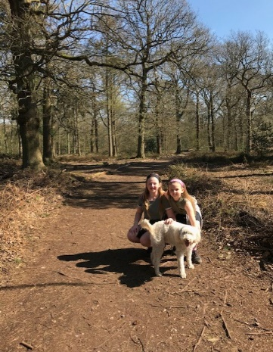
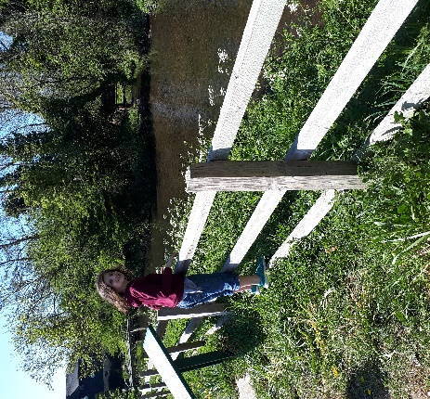

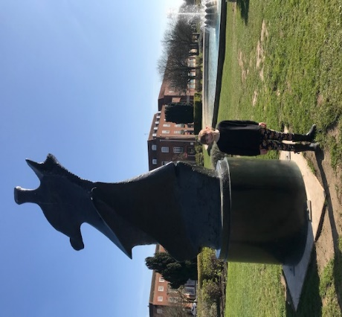
We have seen lots of pictures of you enjoying your daily exercise and walks around Welwyn Garden City. This year is our centenary year and although some of the celebrations have been postponed for a while, we can still appreciate and celebrate the things we enjoy and are proud of in our town.
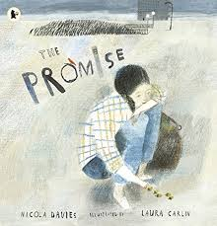
At the beginning of the year we read ‘The Promise’ as part of our introduction to learning more about this garden city which is our home. ‘The Promise’ starts in a harsh, grey, lifeless city but this place is transformed by a girl who plants trees; she changes not only the living environment but also the hearts and minds of the people who live there.

We want to continue that work by asking you to write about what it is that you love about Welwyn Garden. Maybe there is some place that is particularly special to you or your family; maybe it is something about the history or the garden city; maybe it is something more general about the spaces and surroundings that you enjoy. You could decorate your writing with illustrations or designs to echo your writing.
We would like to send some of your writing to the Centenary organising committee. We think they would appreciate knowing that even though we have paused our celebrations we are still thinking about what it means to live here.
What makes you grateful to live in Welwyn Garden City?

