There were more than 2000 gods in ancient Egypt. Most took human form but some had the heads of animals. Here is a selection of the more important gods that Egyptians would have worshipped.

- Ra: Ra was god of the Sun and the lord of the gods. He is shown to have the body of a human and the head of a falcon. Above his head sits a sun disc with a sacred cobra twisted round it. It is said that Ra sailed the heavens in a boat called ‘Barque of Millions of Years’. At the end of every day many thought Ra had died as he sailed through the night in the Underworld leaving the Moon to light the night sky until he was born again at dawn.

- Amun: Amun was an important god because it is said that he created all things. However, there are not many stories or pictures of him as he was invisible. Many of the pictures of him come from when he mixes with another god like Ra, when he becomes Amun-Ra. Amun is usually in human form but sometimes has a ram’s head.

- Horus: Horus has the head a hawk which makes him look similar to Ra but Horus has a crown made to look like the two parts of Egypt, the red and the white to show that he ruled all of the land. Horus was the god of the sky and it was believed that the pharaohs were a living version of Horus making them godlike.

- Thoth: Thoth was the god of wisdom, writing, time and the moon. The ancient Egyptians believed that Thoth created hieroglyphics and kept a record of all knowledge. He has the head of an ibis bird, a long beaked bird common in Egypt.
- Ma’at: Ma’at was the goddess of truth, justice and harmony and the wife of Thoth. A pharaoh had to promise to follow Ma’at and be a fair and honest leader.

- Isis: Isis is the mother of Horus and the queen of the goddesses. Sometimes she is shown to have a throne on her head and other times she has a sun disk similar to Hathor.

- Osiris: Osiris is the god of the dead and husband of Isis. He is shown wearing the white linen wrapping from a mummy. He wears a white crown with large feathers. Although he was the god of the Underworld, Egyptians still liked him for helping people pass on to the next life.

- Hathor: Hathor was the goddess of love, music and dance. She looked after all women in life and death. Hathor sometimes took the form of a cow with a sun disk above her head.

- Anubis: Anubis was the god of embalming, the mummiﬁcation ritual.It is believed he made the ﬁrst mummy, Osiris. Anubis was the guide of the dead, he helped them pass to the next life. It was said that Anubis would wait for you in the hall of the dead to weigh your heart. If your heart was lighter than Ma’at’s feather, you would live forever. If it was heavier, your heart would be eaten by the demon Ammit. Anubis had the head of a jackal.

- Sekhmet: Sekhmet was goddess of war, ﬁre and medicine. She has a head of a lion, the best hunter known to the Egyptians and her breath is said to have created the desert.

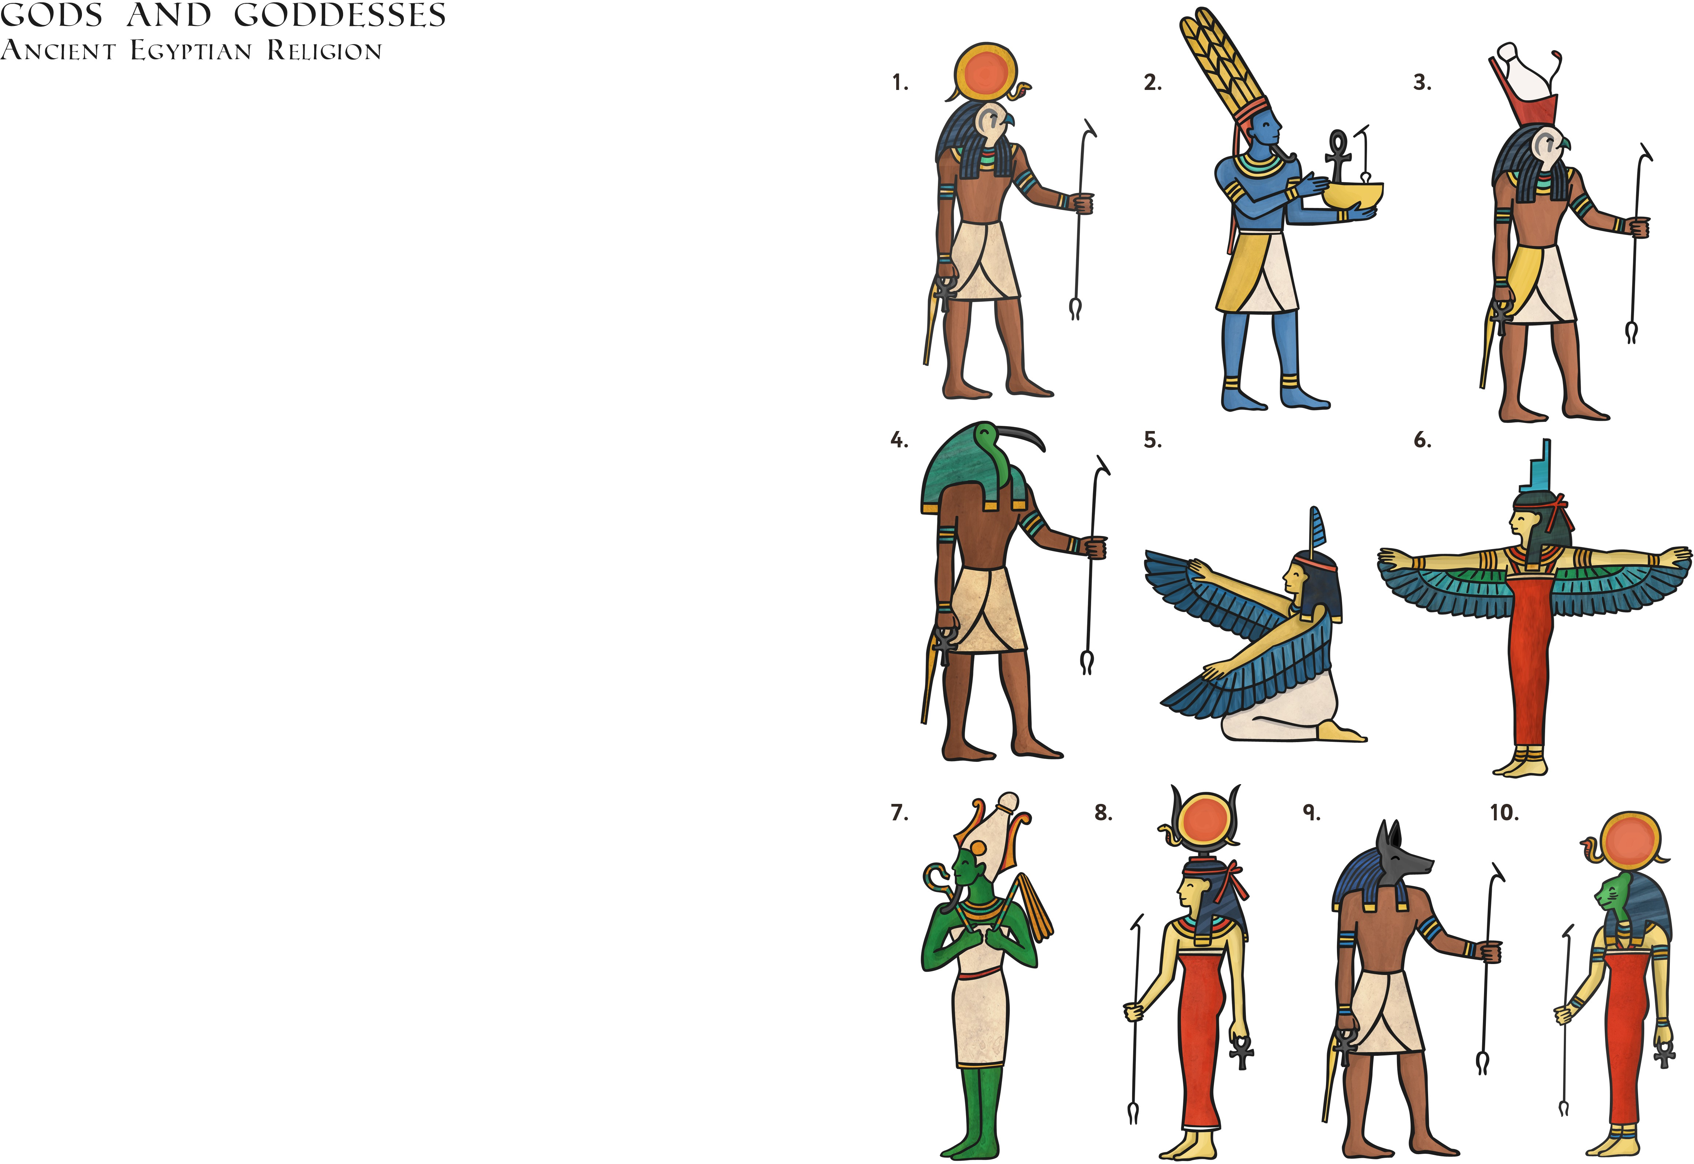

twinkl.co.uk


- How many gods were there in ancient Egypt?

- Why are the names of the gods in bold?

- What was special about Amun?

- Who created hieroglyphics?

- Who was married to Thoth?

- What was the name of the first mummy?

- Why do you think pictures were included in the text?

- In which kind of book would you expect to find an information sheet like this?


- How do you think the author selected these ten gods from a list of 2000?

- What does the author mean by the word ‘mummification’?

- Find a word in section nine that means the same as a religious act.

- If you could choose the head of a bird for yourself, which bird would you choose and why?

- What do you think the Egyptians meant by a ‘heavy heart’?

- Why do you think the Egyptians had so many gods?

- Why is it important to know about ancient Egyptian gods?

- How does the layout of this text help you to understand the information better?

- Pupils may give several responses, but anticipate the following: the gods and goddesses are considered the most important; they are considered the most interesting; they are likely to be the most well-known.
- ‘Mummification’ means to preserve a body after death by wrapping it up.
- Ritual
- Pupil’s own response.
- ‘Heavy heart’ is a metaphor for sadness. It suggests the heart feels heavy because a person is affected by lots of emotion.
- Pupils may give several reasons, but anticipate the following: every god and goddess needed their own role; it gave all Egyptians something to believe in; it helped people to understand natural events (such as the weather) better.
- Pupils may give a variation of the following: it is important to know about these gods because it helps us to understand how the people of ancient Egypt thought about the world and how our lives today differ.
- The bold text, numbering and paragraphing allows the reader to find parts of the text more quickly and may help them to remember it easy.

MA Answers
- There were more than 2000 gods in ancient Egypt.
- The names are in bold so that they stand out from the rest of the text and can be found easily.
- It is said that Amun created all things, so he is special.
- It is believed that Thoth, the god of wisdom, invented hieroglyphics.
- Ma’at was married to Thoth.
- Osiris is believed to be the first mummy.
- Pictures were included to show how each of the gods and goddesses looked.
- I would expect to find this information in a non-fiction text, such as a non-chronological report.

- There were more than 2000 gods in ancient Egypt.
- A sacred cobra sat on Ra’s head.
- Isis is the mother of Horus and the queen of the goddesses.
- Osiris is believed to be the first mummy.
- Pupil’s own response. They should include the name of the god/goddesses and identify at least one further detail.

