The Ancient Egyptian Gods.
Find out about the gods and goddesses who the Ancient Egyptians worshipped and whose stories helped to explain their world. The links below could be a starting point:

BBC Ancient Egyptian Gods
https://www.bbc.co.uk/bitesize/topics/zg87xnb/articles/z4m8pg8
The Myth of Osiris
https://www.youtube.com/watch?v=TiNLx8h5jVE
Create fact files for the gods. These can be recorded by hand or on the computer. Include their name, what they are famous for and any five facts you have found out about them. Here is an example:

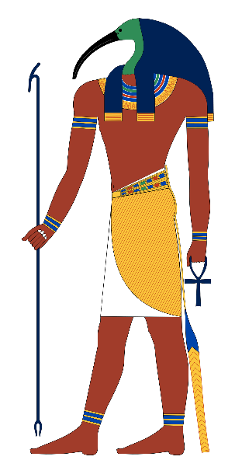
Thoth.

Thoth is the Egyptian god of writing, magic, wisdom, and the moon.
He has the head of an ibis and the body of a man
He was one of the most important gods of ancient Egypt
He was the Sun God Ra’s messenger
Ancient Egyptians believed he gave them the gift of hieroglyphs

