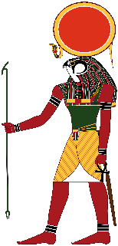
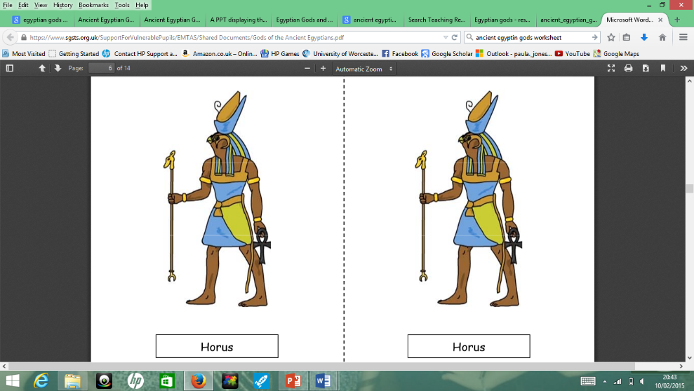
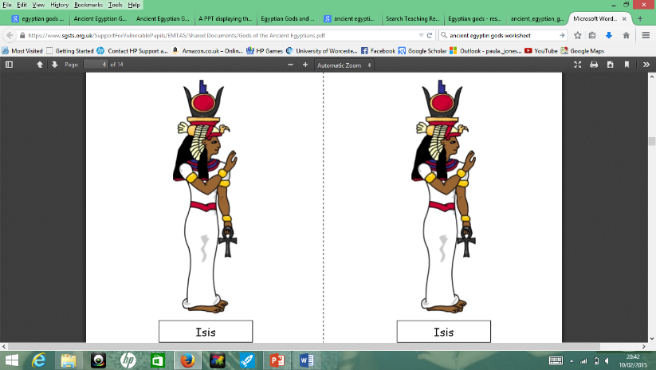
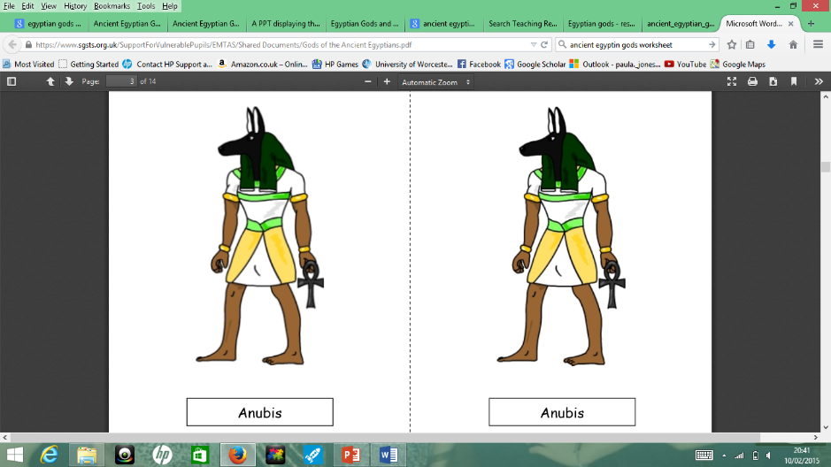
LO: I can describe Ancient Egyptian Gods
Can you recognise and name each of these gods? What are they responsible for e.g. wisdom, war or writing.
…………………………………….…………………………………….…………………………………….…………………………………….…………………………………………………………………………………………

………………………………………………………………………………………………………………………………………………………………………………………………………………………………………………

………………………………………………………………………………………………………………………………………………………………………………………………………………………………………………

………………………………………………………………………………………………………………………………………………………………………………………………………………………………………………………………………………………………
You can find out more about one of these gods or choose a different one.
Use this space to write notes to help you create your own fact file for your chosen god.
………………………………………………………………………………………………………………………………………………………………………………………………………………………………………………………………………………………………………………………………………………………………………………………………………………………………………………………………………………………………………………………………………………………………………………………………………………………………………………………………………………………………………………………………………………………………………………………………………………………………………………………………………………………………………………………………………………………………………………………………

