What I Love About Welwyn Garden City

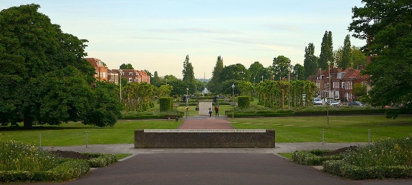
One of the things I like most about Welwyn Garden City is all the greenery (the flowers trees and grass) and just all the wildlife. The reason I like all the greenery and wildlife here is it really brightens up this garden city.

I also think that there is a lovely balance between shops, restaurants, green outside places for the children and houses. I believe this balance is perfect as our garden city is not crowded with shops or houses; there are still plenty of outside places for the children to play and for the adults to relax in.

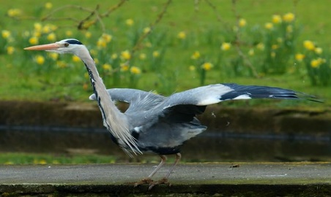
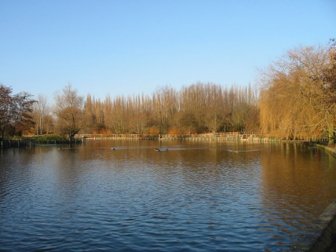
Another thing I really like are the two lakes on opposite sides of the road out of Welwyn Garden City. I love the grounds the lakes are on and the lakes themselves which are filled with wildlife, birds, fish and rabbits - just a few examples of the creatures that live there. On these lakes you could learn to sail or bird watch or learn to row or have a lovely picnic in the heat of summer on the bank of one of the lakes. Graceful and beautiful creatures and birds live at Stanborough Lakes, including kites, rabbits, blackbird and plenty of varieties of fish.

Andrew

