What Makes Welwyn Garden City Special?
When I think of Welwyn Garden City, I immediately see the beautiful nature and gardens that surround me. When I was younger, I used to be fascinated by a patch of grass in Handside Lane, which in springtime shows a display of different daffodils, with golden shades of yellow and orange, swaying in the gentle spring breeze. I could hear bees buzzing collecting the pollen and I could see butterflies fluttering around me. As a toddler, I used to get lost in the tall stems. When I walked past after nursery, I would shout: “Look it’s the daffodil garden!”
Another place which is special to me is a little circular maze made of red-leaved small bushes, in the gardens near the fountain in town. I used to pretend it was my home and I would hide inside from my mum, even though she knew where in was! I used to pretend that the first circle was the kitchen, the second was the lounge and the third was my bedroom.
Now, when I walk past these two places I smile and remember how much fun I used to have. Sometimes I even wish I still were that little carefree girl.
By Clara
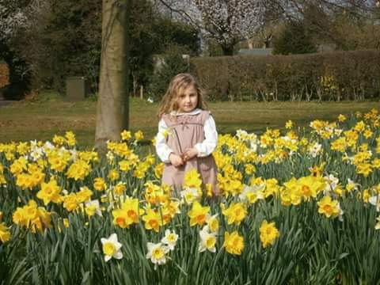

Me aged 3 in the “Daffodil Garden”

