Wonderful Welwyn Garden City
Our Motto: A Marriage of Town and Country.

I like WGC because it's the perfect place to live, the grass is lush and we have lots of gardens and flowers and plants, it's full of beautiful nature. We have lots of outdoor spaces to go to like parks and woods to walk, run or cycle in. It's a magical place to live in or just to visit, there are lots of areas to walk our dogs in as well.

We have a lovely town centre with our history still intact like the Howard Centre. We also have a beautiful fountain that marks Queen Elizebeth II coronation on the 6th February 1952. Our town is now 100 years old since it was built in 1920 but it has grown, and we have too. We have built train stations which provides easy access to London and to the North of the country. We also have transport links by roads like the A1.

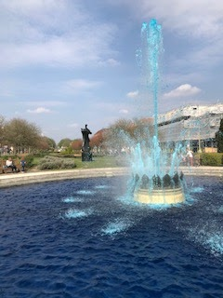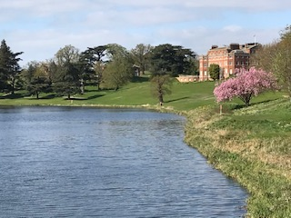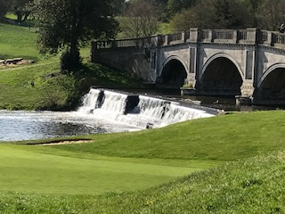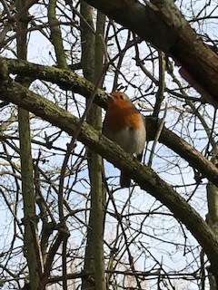

Our City feels very green and open and full of spaces to explore. We learn a lot at school like geography, maths and English. I can also walk to school which is good for the environment. There are lots of sports activities in and out of school that we can do like football, netball, basketball and rugby.

We all try to look after the ‘City’ because it's an extraordinary place to live; it's full of animals and wildlife. As a ‘City’ we try as hard as we can to help endangered species and to help stop killing our planet and all the creatures that live on it including us. Every day, without even knowing its happening, our forests are chopped down and it’s killing habitats and homes. In Welwyn Garden City we care about our environment.

Isabelle

