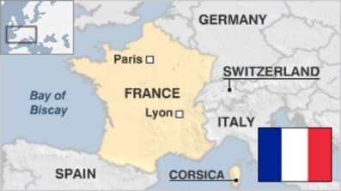
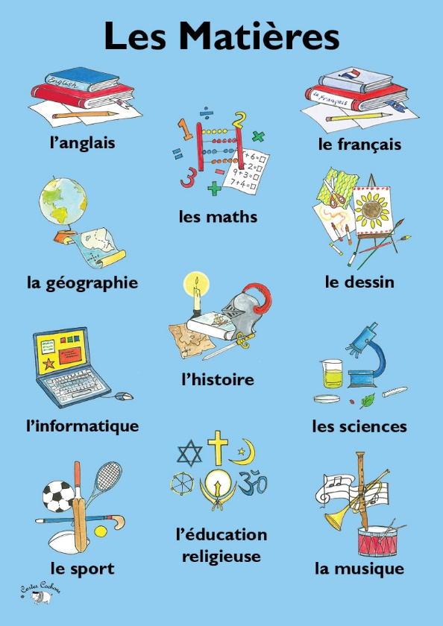
French
Home Learning

Bonjour!

In French this term, we would have been looking at ‘school life’ - subjects and time of lessons etc. These short videos are good for listening to the language used to talk about school, and help you to practise other words and phrases you’ve already learnt such as numbers, greetings and ways of introducing yourself.

Watch this once through, and then watch again being ready to pause it to have a go at repeating phrases about school subjects.

‘Not again Farley!’

https://www.bbc.co.uk/bitesize/clips/zqtjmp3

How many subjects can you recognise and say/repeat in French?
Can you use your knowledge of numbers to work out what time the lessons are?
After watching the video, can you say and then write a sentence about the subjects you like and dislike?
For example:

J’aime La geographie
(I like geography)

J’adore le science.
(I love science)

Je n’aime pas l’histoire.
(I don’t like history)

Je préfère l’art

(I prefer Art)
Ma matière préférée est L’anglais

(My favourite subject is English)

If you have a French dictionary you can check the spelling of any subjects you aren’t sure about. If not, google translate is always quite handy! Google will also tell you how to say the phrase or sentence if you press the speaker button, which is quite fun!

Challenge
https://www.bbc.co.uk/bitesize/clips/zcdg9j6

- Watch this little video and listen out for any vocabulary you learnt in the first one. See if you can pick up any words which describe the subject and why you might like/dislike it. For example ‘C’est difficile’ (it’s difficult)

- Could you make a poster, PowerPoint, or even a video of yourself telling us about your favourite (and not so favourite!) subjects in French? If you want to add phrases to include the reason you like/dislike them, then even better! E.g. J’aime l'histoire parce que c'est fascinant! (I like history because it is fascinating!)
Happy French speaking mes amis!
I look forward to hearing from you (in French of course!)

Au revoir,

Mrs Entwisle

