Year 1 Curriculum Letter - Autumn Term 2026

Welcome to Year 1

English
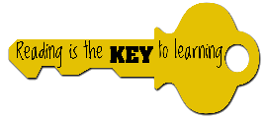  Reading:  In Year 1, we will send home two books each week:  A decodable phonics book, which your child will have already read in school.  A reading for pleasure book, chosen from the school library.  Children will be reading with adult three times a week in reading practise sessions. These sessions follow the sequence decoding, prosody and comprehension. Book change for both books will be on Thursdays.  CUSP reading lessons will be taught five times over a fortnight. In these lessons, we will be looking at the core texts: ‘Beegu’, ‘Where the Wild Things Are’, ‘The Storm Whale’, ‘The Owl and the Pussy Cat’ and ‘The Boy Who Cried Wolf’. In each of these learning modules, we will look at additional supporting texts alongside the core books and practise reading fluency and comprehension skills. | Writing:  This year, we have a new writing curriculum - the ESSENTIALWRITING programme – a carefully sequenced curriculum designed to help children write with purpose and for real audiences.  All the children’s writing will be based on a book, which we will have explored in depth prior to writing. In Autumn Term, we will be look at the core texts, ‘Someone Just Like You’, ‘Puffin Peter’, ‘Gruffalo Crumble’, ‘Purple is…’ and a range of Traditional Tales. In these lessons, the children will learn to write for different purposes, such as, writing to entertain and writing to inform. Our focus this term will be writing sentences with a capital letter, finger spaces and full stop.  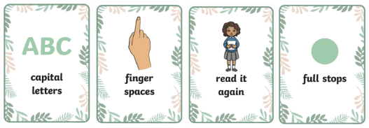
Handwriting:  In Year 1 we continue to teach the Little Wandle handwriting phrases to ensure all children are forming letters correctly. All children will practise lowercase and uppercase letters, and the children will practise writing simple words in their handwriting books. | Phonics:  In Phonics this term, we will begin by reviewing Phase 3 sounds and consolidating the children's learning in Reception. We will then move on to words with two or more digraphs, e.g. queen, thicker. After that, we will move on to teaching phase 5 sounds.
Maths
In Maths, our key focus will be on securing the children’s knowledge of numbers to 10. This will include finding patterns in numbers (including subitising), counting and comparison (more, less, fewer), regrouping the whole, addition and subtraction, solving problems using part or whole, unknown and equality and balance. We will then move on to numbers to 20 and will focus on making 10 and some more, estimating and ordering, 1 more and 1 less, doubling and halving and odd and even numbers.

Art & Design: | Computing:
In Art & Design, the children will be  covering the medium of ‘Drawing’ and  will answer the key question ‘How are  lines and shapes used in drawings?’.    In this module, the children will be exploring a range of shapes and lines using a variety of drawing tools. They will explore the artists Roger Hargreaves and Piet Mondrian and will create a final piece which incorporates lines and shapes.  We will also be celebrating ‘Art & Design Week’ where the children will be exploring printing and collaging techniques. They will be looking at the artists Hannah Rampley, Kurt Schwitters and Karla Reid. | In Computing, we will begin by teaching fundamental computing skills and emphasising ‘staying safe online’. Our first module will be ‘Online Safety’. In this unit, children learn about the potential dangers in the online world and what basic steps we all need to take to have positive digital experiences.  Our next module will be ‘Technology around us’. In this unit, the children will develop their understanding of technology and how it can help them in their everyday lives. They will start to become familiar with the different components of a computer by developing their keyboard and mouse skills. They will also consider how to use technology responsibly.
Design Technology (DT): | Geography:
In DT this term, the children will cover the learning modules ‘Mechanisms’ and ‘Structures’.  In Mechanisms, the children will be answering the key question ‘How can you make a picture move?’. They will be exploring sliders and their applications, experimenting with different slider systems and will design and create their own moving picture.  In Structures, the children will be answering the key question ‘How can you stop a tower from toppling over?’. They will explore different materials to create a tower, understand what makes a structure stable and will create a final tower following a design criteria. | In Geography this term, our learning  module will be ‘Continents, Oceans, UK Countries, Capital Cities and Surrounding  Seas’.    In this module, the children will name and locate the world’s seven continents and five oceans. In addition, they will also be naming, locating and identifying characteristics of the four countries and capital cities of the United Kingdom and its surrounding seas.
History: | Leader in Me & The 8 Habits:
In History this term, the children will cover the learning module ‘Changes within living memory’. To engage children in this learning, the module is closely linked to toys and shops. In the module, children will first learn about stages in their life. Next, they will learn about the shops in our community and compare them to shops in the past. They will then interview a member of our community who has lived here for a long time about what shops used to be like. | This term we will be focusing on Habits 1-4 and how they support learning, personal development and creating a positive classroom culture.  We will be exploring stories related to each of the habits and thinking about how we can use them in our daily lives. We will also be looking at what makes a leader and how every child in Year 1 can be one.  
Religious Education (RE) & Worldviews: | Personal, Social, Health & Economic Education (PSHE)
  In RE this term, the children will be learning about Hindu Dharma. We will be exploring the main beliefs held by Hindus and learning about Hindu celebrations. We are also excited to welcome Bhaktivedanta Manor on Friday 6th November as part of our RE Immersion Day. More information will be sent out soon. | In PSHE this term, we will be covering the units Living in the Wider World, Health and Wellbeing, and Relationship Education.  In the Living in the Wider World and Health and Wellbeing units, we will be exploring the following lesson titles: This Is Me, How We Grow, What Are Feelings?, Feelings and Loss, How We Play and Learn and Staying Safe.  In our Relationship Education unit, we will be covering the following lesson titles:  Respect, Polite Words, Sharing and Taking, Turns, Being Kind and Getting Hurt.
Physical Education (PE): | Music:
In PE this term, the children will be covering gymnastics and locomotion.  In gymnastics, the children will cover the unit ‘Wide, Narrow and Curled’. In this unit, children will move and balance in wide, narrow and curled ways, applying champion gymnastics criteria, on the floor and on apparatus. They will also experiment moving in a variety of wide, narrow and curled ways, understanding the differences between each type of movement.  In our ‘Locomotion’ unit, children will learn to run by applying the correct technique to ensure maximum speed. They will play games that encourage them to think about where to run, why to run there and when and why running fast is important in games. | 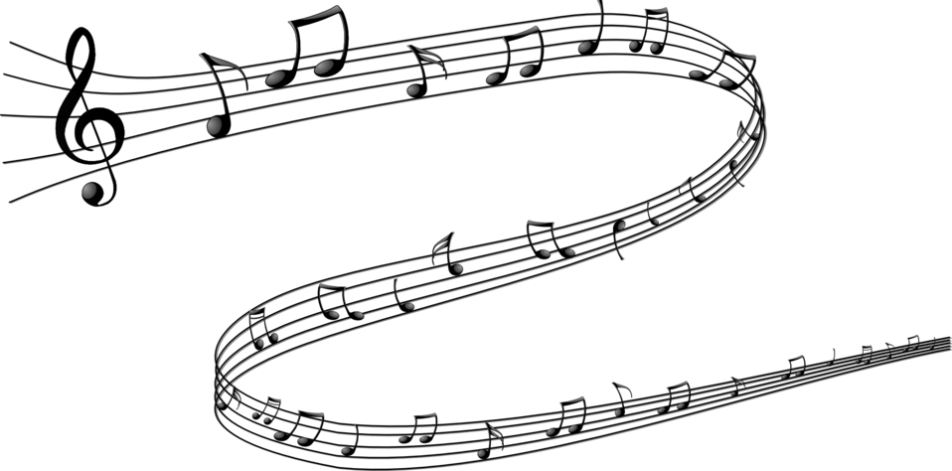  In Music this term, our learning modules will be ‘Being Together in Music’ and ‘Introducing Rhythm and Pulse’. In our ‘Being Together in Music’ module the children will learn to sing a range of simple nursery rhymes. They will be introduced to folk songs and nursery rhymes from other cultures in subsequent units. They will join in with singing and reflect on how this makes them feel. They will be introduced to simple conducting cues and learn the terms melody and lyrics.  In our ‘Introducing Rhythm and Pulse’ module the children will be introduced to the simple terms, ‘rhythm’ and ‘pulse’. They will build on this knowledge by learning to pick out and play the pulse of a familiar song. They will also learn to copy back and join in with simple rhythms, using both body percussion and a range of untuned instruments.
Science

In Science, we will cover the learning modules, ‘Seasons and Weather’, ‘Day and Night’,
‘Plants’ and ‘Animals Including Humans’.
In our Seasons and Weather module, the children will learn about each of the seasons and
identify what the weather is like in each season.
In our Day and Night module, the children will learn how day becomes night and explore what happens to the sun at night-time.
In our Plants module, the children will identify the parts of a flower and tree, and learn about wild plants, garden plants, deciduous trees and evergreen trees.
In our Animals Including Humans module, the children will learn about the different groups: mammals, fish, amphibians, reptiles and birds and the different types of foods that animals eat. We will use the scientific vocabulary of carnivores, herbivores and omnivores.
Attendance & Punctuality:
Doors open: 8:35 am – please aim to arrive at school at this time.
Register closes: 8:45 am
End of the day: 3:15 pm
Good attendance is essential for high achievement and outstanding learning. Please ensure you arrive promptly to drop off and pick up your child. Any child arriving in their classroom after 8:45am will be marked late.
Behaviour & Discipline:
At Applecroft School, we have adopted a therapeutic approach to behaviour management. Our Behaviour & Discipline policy is based on a green triangle that recognises and rewards valued behaviours and a red triangle that recognises and ensures clear consequences for detrimental behaviours. Both triangles have five levels that progress as the behaviours do.
Green Triangle  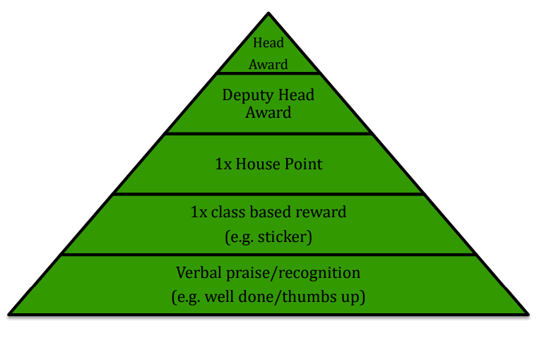 | Red Triangle  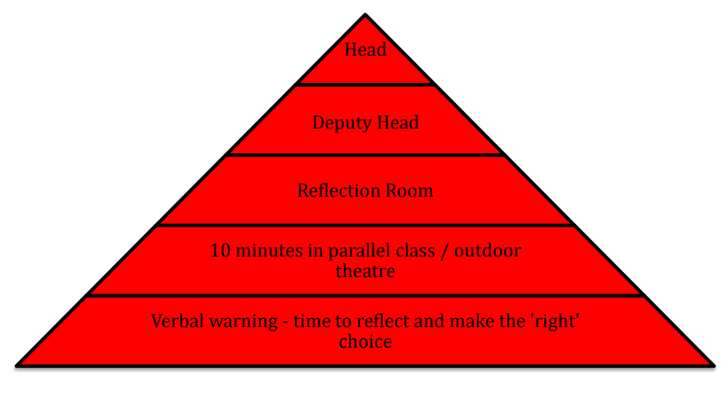
Home Learning:
Please ensure you read with your child at least five times a week. We will be introducing Book Talk every morning, where children will have the opportunity to record at school if they read the previous night. We will also discuss these books together as a class.

Each term, we will provide a Home Learning Grid containing a variety of tasks. Each week, your child can choose one activity from the grid to complete. These activities are linked to what your child has been learning in school, so they will already have some background knowledge of each topic.

The grid will be uploaded to Google Classroom each week, and there will be an option to ‘hand in’ completed work online. Children can either submit their work on Google Classroom or complete written tasks in their Home Learning Book.

Home learning will be set every Friday and will be due in by the following Friday.
Key Dates:
Autumn Term 2026:
Thursday 3rd September - Friday 18th December
Half Term: Monday 26th October - Friday 30th
Inset Day: Friday 27th November – School closed
Occasional Day: Monday 30th November – School closed
Christmas Break: Monday 21st December - Friday 1st January

Other Important Dates:
Friday 18th September – 9:00am / Monday 21st September - 2:30pm - Volunteer Meeting & Safeguarding Training
Wednesday 23rd September - Individual/Sibling School Photos
Monday 28th September-Thursday 1st October - Book Fair after school, under the KS1 playground canopy
Monday 19th – Friday 23rd October - Art & Design Themed Week
Tuesday 22nd October - Parent Consultations – 3:30-6:30pm
Wednesday 4th November - Parent Consultations – 3:30-6:30pm
Tuesday 8th December - Christmas Show Matinee Performance - 1:30pm
Tuesday 8th December - Christmas Show Evening Performance - 5:30pm
Thursday 10th December - Christmas Show Evening Performance - 5:30pm
Wednesday 16th December - Pantomime Day
Thursday 17th December – Christmas Jumper Day
Safeguarding:
Our Designated Safeguarding Leads are:
Ms Ruth Johnson (Lead DSL)
Mrs Lisa Withe
Mr Paul Wyatt
Ms Jale Apicella,
Mrs Natalie Clementson
Mrs Carey O’Connor
Miss Eloise Yates

If you have any urgent concerns regarding safeguarding, please ring the school, if it is not urgent then contact our DSLs via safeguarding@applecroft.herts.sch.uk
Staffing in the Year Group:
Miss Hannah Kenworthy - Year Group Leader and Miro Class Teacher
Mrs Anya McGrath- O'Keeffe Class Teacher
Mrs Debbie King - Learning Support Assistant
Miss Skye Barker - Learning Support Assistant
Mrs Vikki Wake - PPA Lead - RE
Mr Passade - PPA Lead - PE
Mrs Varnals-Scrace – Early Reading Teacher
Communication:
Teachers are available to meet with you if necessary. Please arrange a meeting with us in advance by speaking to a member of the team or emailing the office via admin@applecroft.herts.sch.uk.

Google Classroom will be used for updates throughout the year as well as uploading home learning so please check this weekly.

You can also follow the school on Instagram to see what exciting things we have been up to!


Year 1 Timetable:
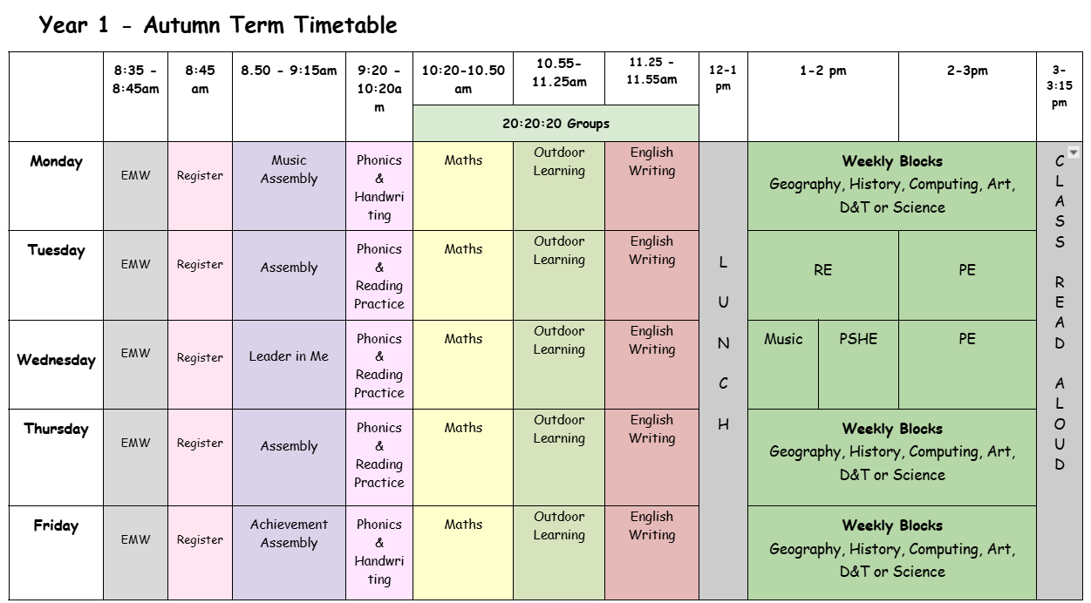
(Timetable is subject to change on occasion)
Uniform Expectations:
School Uniform: Red jumper/cardigan / grey trousers, skirts, shorts or pinafore dress / white polo shirts, shirt/blouse / smart, black shoes / white/grey socks / grey/red tights / red /black hair bands/clips/Alice bands only
Black boots are not permitted – black sturdy school shoes only

PE Uniform: White t-shirt (plain or school logo) / plain black shorts / plain black jogging bottoms / plain black hoodie (or school logo) / trainers

OPAL Outside: Wellies and a waterproof coat and trousers / all in one.

Please ensure all uniform items are labelled with children’s names so items can be returned if lost.

