Year 2 Curriculum Letter - Autumn Term 2026

Welcome to Year 2

English
Reading:  Reading is taught through a flexible module rotation alongside daily Little Wandle phonics practice, where children read in small groups with an adult three times a week. To ensure every child has the book they need for these sessions, it is vital that Little Wandle reading books are brought back to school regularly.  Alongside this phonics practice, pupils will develop their expression, fluency, and comprehension through CUSP whole class guided reading lessons taught five times a fortnight. Please also read aloud to the children daily at home time to foster a love of reading, and our complete CUSP reading spine featuring core texts like, ‘Grandad’s Island’, ‘The Goose that Laid the Golden Eggs’, ‘Mrs. Noah’s Pockets’, ‘Paddington’, and ‘The Christmas Pine’ are available on the school website. | 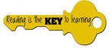  Writing:  Writing is taught daily through the Herts ESSENTIALWRIING scheme on an alternating module rotation with reading, ensuring children actively apply their writing skills across all areas of the curriculum, including during CUSP reading lessons. Every single piece of writing is carefully inspired by rich texts explored in depth beforehand, allowing pupils to understand the purpose behind their work as they write to either entertain or inform.  Throughout the term, children will produce a variety of engaging writing outcomes including narratives, instructions, list poems, letters, and postcards. Lessons will place a strong focus on mastering core punctuation, such as, accurate capital letters, full stops, exclamation marks, and question marks to demarcate sentences while also introducing commas for lists and expanded noun phrases to add rich descriptive detail to their work.
Handwriting:  During our handwriting lessons, children are taught to use pre-cursive writing to form their lower-case letters. We start with mastering the basic shape of different letter families. Focus will be on letter size and ensuring that they are consistent with one another. We will practice individual letters that are formed in a similar way and will look at lower case and capital letters. We will then move on to practicing our letters within words.  Towards the end of Year 2 we will move on to joining our handwriting once we have mastered letter formation and sizing. | Spelling:  All children will be continuing with daily ‘Little Wandle’ phonics up until October half term. We will be refreshing the children’s Phase 5 phonic knowledge by reviewing vowel digraphs and a range of suffixes which will lead into spelling patterns and rules. After half term, we will be using the ‘Bridge to Spelling’ units provided by Little Wandle and teach spelling three times a week. The children will learn to use and spell prefixes and suffixes as well as master many spelling rules.  Spellings will be uploaded onto Google Classroom weekly for children to practice at home.
Maths
We teach Maths through the Herts ESSENTIALMATHS scheme. We will begin each step of learning by reactivating children's prior learning and addressing misconceptions before any new content is taught. This term we will focus on securing the children’s fluency to twenty and their understanding of place value. We will practice counting on and back in ones and tens, calculation skills (including exploring strategies to add and subtract mentally), and estimation. We will then move onto measuring using different scales and using money, including giving change. Maths will be uploaded on to Google Classroom weekly for children to practice the concepts at home.
Art & Design: | Computing:
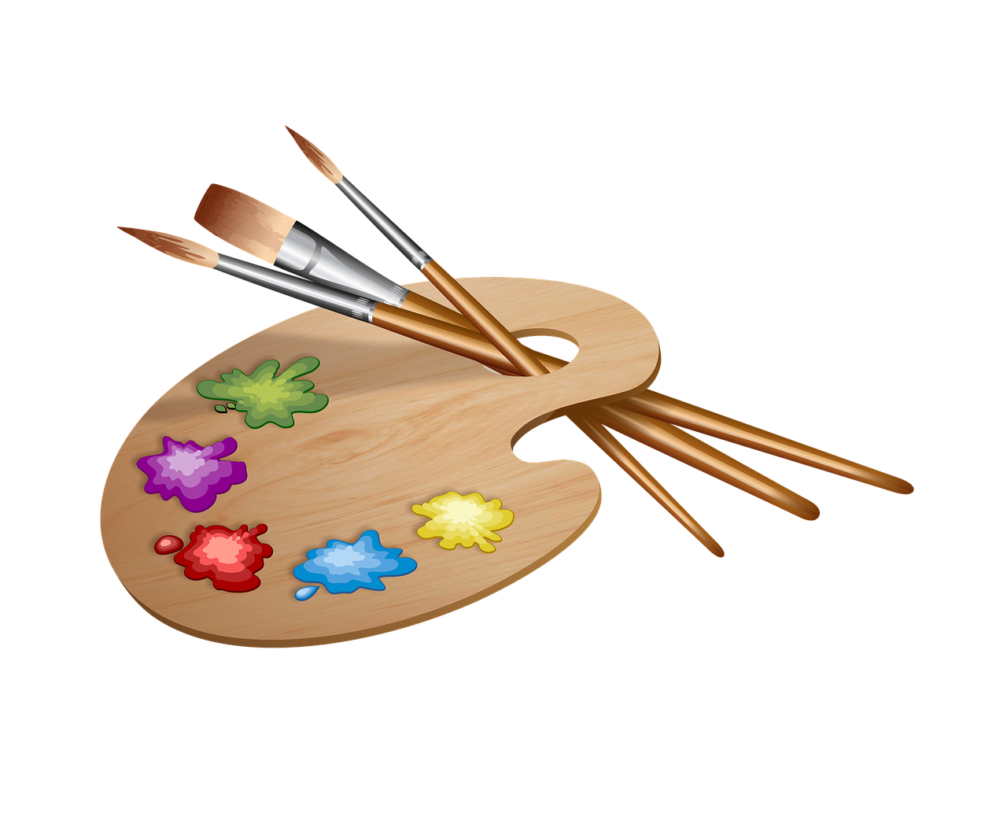  This term we will focus on painting. We will be exploring different types of paint and how artists create effects. We will create tints and tones and examine and explore these paints; how they can be used to create different effects such as blocking, washes and thickened paint. This term we will also enjoy our ‘Arts Themed Week’. During this week, we will focus on collage and printing. In collage, we will be ‘painting with paper’ and will create collages using torn pieces of paper. In printing, we will be exploring negative and positive space and create a final print using polystyrene boards. | In Computing, we will begin by teaching fundamental computing skills and emphasising ‘staying safe online’.  Our focus will be:  - always asking the pupils to take care when they are using the internet;  - to keep themselves safe and  - always asking an adult to check anything they do not feel comfortable with or are unsure about.  Later in the term, the children will be learning about photography in our Creating Media unit. We will use iPads to take pictures in portrait and landscape. We will learn about how to take the best photos and how to add effects to these.
Design Technology (DT): | Geography:
In Design and Technology this Autumn term, Year 2 pupils will explore exciting hands-on projects across two main focus areas: Food and Nutrition and Mechanisms. Under the Food and Nutrition module, children will answer the key question "What does healthy mean?" by learning about processed foods, discovering how to make healthy snacks taste delicious, and making their own pitta crisps. In the Mechanisms module, pupils will investigate how wheels and axles work together by building simple wheel mechanisms and exploring the key learning question "Are bigger wheels always better?" to see how wheel size and axle position affect vehicle movement. |   In Geography, we will be learning about human and physical features in our local area. We will be using world maps, atlases and globes to identify the  United Kingdom and its countries, continents and oceans. We will learn simple compass directions and use locational and directional language to describe the location and features and routes on a map. We will use aerial photographs to recognise landmarks. We will use simple fieldwork and observational skills to study the geography of our school and its grounds.
History: | Leader in Me & The 8 Habits:
In History, our topic is ‘The Great Fire of London’. We will learn about how the community of London came together to put the fire out and how others came to support. We will discuss how some people fled the community. We will learn about the people in power and how they made decisions about the rebuilding of the city and finally we will learn about the changes to London as a result of the fire. | This term, we have scaled down our Leader in Me modules to focus solely on behaviour, aligning closely with our new behaviour curriculum. Behaviour will be explicitly taught once a week during dedicated sessions, with personal targets set and reviewed every Monday and Friday to help children reflect on their choices, establish a positive working environment, and celebrate their progress in our weekly assemblies.
Music:
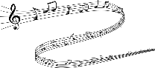
This term in music, our focus will be ‘Experimenting with Sounds.’ Pupils will learn about the origins of samba music; they will have the opportunity to play a range of untuned percussion with a greater degree of control. Pupils will play simple ostinato call and response rhythms and compose their own basic rhythms. They will learn to follow simple conducting directions and will rehearse and perform as an ensemble.
In the second half term we will be focusing on singing and how to control our voices. We will be doing lots of singing practice in preparation for our Christmas production!
Physical Education (PE): | Personal, Social, Health & Economic Education (PSHE):
We will begin the year with ‘Dance’ and ‘Locomotion’. In Dance, the children will become explorers and will develop small and large shapes to create a motif using water as inspiration. In locomotion, the children will focus on dodging. They will learn to develop a strong understanding of how, where and why to dodge and apply this understanding in game situations. We will then focus on team building and ball skills using our hands.  Please remember to send your children to school wearing PE kit every Monday & Friday. | In PSHE our first topic will be ‘Living in the Wider World.’ In this unit we will explore money, including how this has changed from the past, how we can save and spend our money and the difference between wants and needs.  In the second half term we will look at ‘Health and Wellbeing.’ This unit will cover; developing healthy habits, looking after our teeth, the importance of sleep and we will also look at medicines. At the end of this unit, we will explore feelings and how we can identify and manage big feelings.
Religious Education (RE) & Worldviews: | Science
In the Autumn term, we will carry on our Christianity learning from Year 1, this term exploring the Old Testament. We will discover how Christians believe the world was created. We will then be discussing the idea of rules and exploring stories such as Adam and Eve, Noah's Ark and Jonah and the Whale. We will then focus on Christmas and learn about Advent and the Nativity with a visit from St Francis Church. |   In Science, we will be learning to become scientists. We will begin with our ‘Living Things and their Habitats’ Unit.’ We will look at the differences between things that are living, dead, and things that have never been alive. Also, what animals and humans need to survive and how both animals and plants are suited to their habitats. We will also describe how animals obtain their food from plants and other animals, using the idea of a simple food chain, and identify and name different sources of food.
Attendance & Punctuality:
As ever, attendance is vitally important. If your child is unable to attend school, we request that all parents/carers contact the school office (email or phone) to report their child’s absence by 8:15am at the latest.
Year 2 drop-off/collection times: Soft start from: 8:35am
Lessons begin: 8:45am, register closes at 8:45am and your child will be marked late if arrival is past this time. Please note, children need to be in their classrooms by 8:45am.
End of day collection: 3:15pm.
A reminder that 96%+ equals good attendance, anything below is unsatisfactory.
Behaviour & Discipline:
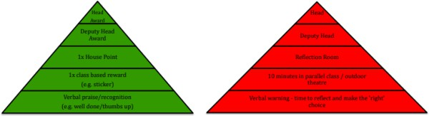
In Year 2, the use of the green and red triangle is continued. If your child makes valued choices at school, they will earn their way onto the green triangle, however if they decide to make detrimental choices, they will proceed to the consequences of the red triangle (see images below).

Home Learning:
Home learning will be set on Friday afternoons and is expected to be handed in by the following Friday. Please ensure you check Google Classroom at least once a week for home learning as well as any further updates. Home learning will consist of Spellings and Maths to support any tricky concepts taught in school.

In addition, it is the expectation that all children read every day for at least 10 minutes.

Key Dates:
Monday 14th September - Year 2 Welcome Meeting – 2:30pm
Wednesday 23rd September - Individual/Sibling School Photos
Monday 28th September to 1st October - Book Fair at 3:15pm under the KS1 playground canopy
Monday 19th October - Arts Themed Week
Monday 26th to Friday 30th October - Half Term
Monday 2nd November - Return to school
Friday 6th November - PTA Fireworks
Friday 13th November - Year 2 ‘Stay & Read’ session for parents and carers - 2:15-3:00pm
Friday 27th November - INSET day – School Closed
Monday 30th November - Occasional day – School Closed
Monday 7th December - Christmas Show dress rehearsal
Tuesday 8th December - 1:30pm – Y1-6 Christmas Show Matinee Performance
Tuesday 8th December - 5:30pm - Y1-6 Christmas Show Performance
Thursday 10th December - 5:30pm - Y1-6 Christmas Show Performance
December 15th December - Christianity immersion day
Wednesday 16th December - Whole School Panto
Thursday 17th December - Christmas lunch and jumper day
Friday 18th December - Last day of term 2:00pm finish

Safeguarding:
Our Designated Safeguarding Leads are:
Ms Ruth Johnson (Lead DSL), Mrs Lisa Withe, Mr Paul Wyatt, Ms Jale Apicella, Mrs Natalie Clementson, Mrs Carey O’Connor and Miss Eloise Yates.

If you have any urgent concerns regarding safeguarding, please ring the school, if it is not urgent then contact our DSLs via safeguarding@applecroft.herts.sch.uk
Staffing in the Year Group:
Miss Brooks – Year 2 Goldsworthy Class Teacher and Year Group Leader
Miss Wood – Year 2 Monet Class Teacher (Maternity Cover for Mrs Smart)
Miss Edlin – Year Group LSA
Mrs Russouw - Year Group LSA
Mrs Varnals-Scrace - Reading Teacher
Mrs Vikki Wake – PPA Lead - RE
Mr Bradley Passade – PPA Lead - PE
Timetables:
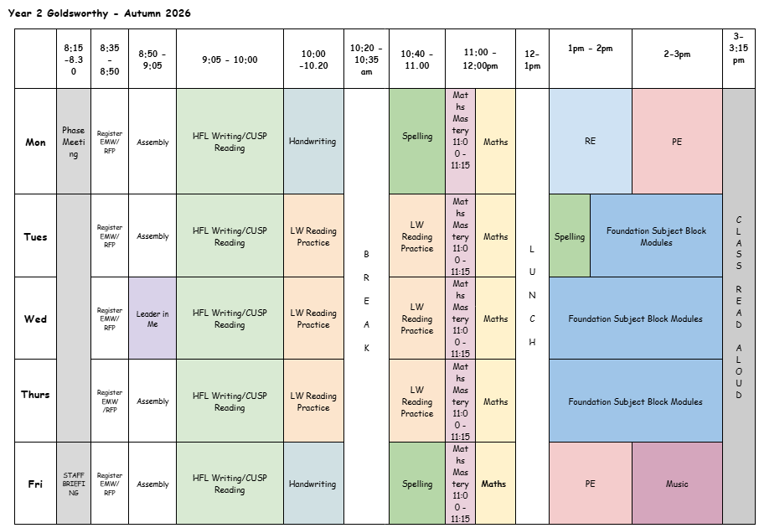
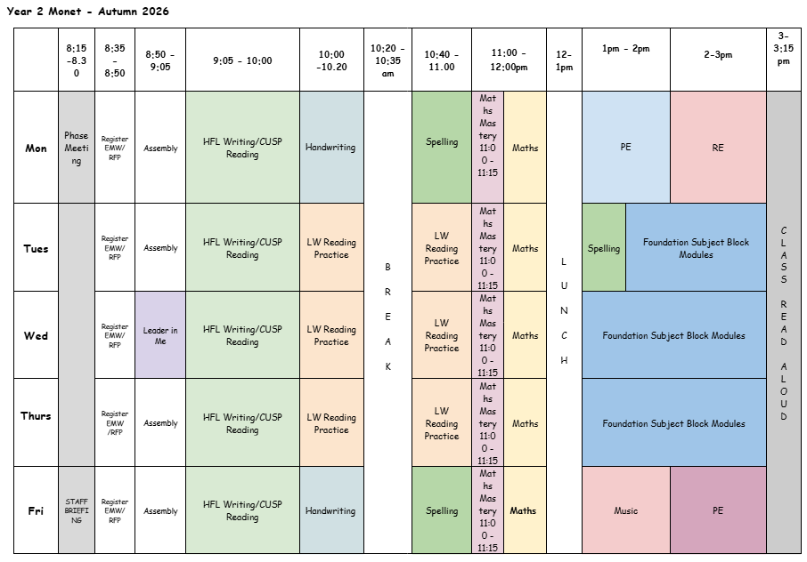

Uniform Expectations:
School Uniform: Red jumper/cardigan / grey trousers, skirts, shorts or pinafore dress / white polo shirts, shirt/blouse / smart, black shoes / white/grey socks / grey/red tights / red /black hair bands/clips/Alice bands only
Black boots are not permitted
PE Uniform: White T-shirt / black shorts / plain black jogging bottoms / plain black hoodie / trainers
OPAL Outside: Wellies and a waterproof coat and trousers / all in one.

Please ensure all uniform items are labelled with children’s names
Communication:
Teachers are available to meet with you if necessary. Please arrange a meeting or a phone call with us in advance by speaking to a member of the team or emailing the office via admin@applecroft.herts.sch.uk

Google Classroom will be used for updates throughout the year as well as uploading home learning so please check this weekly.
You can also follow the school on Instagram to see what exciting things we have been up to!

