Year 3 Curriculum Letter - Autumn Term 2026
Welcome to Year 3
Below is an outline of our plans and expectations for this term.
English:
  Reading:  Following the CUSP scheme of work, we  will be using four fantastic texts to support us in building our comprehension skills. We will develop our retrieval and inference skills, as well as our abilities to make reasonable predictions and summarise texts.  Our texts for this term are:  - ‘Greta and the Giants’,  - ‘The Pebble in my Pocket’,  - ‘Leon and the Place Between’ and  - ‘The Night Before Christmas’.  Children will continue to partake in reading practice sessions three times a week.  They will be reading in small groups, with texts suited to their current skill to support progress. | Writing:  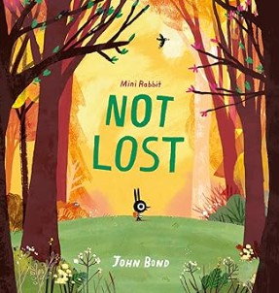  This term, our writing lessons will follow Herts ESSENTIAL WRITING scheme, designed to strengthen core skills and inspire creativity.  We’ll revise sentence structure before moving on to a range of exciting writing styles.  Children will write stories inspired by ‘Mini Rabbit Not Lost’, explore poetry about emotions, (including performance poetry), and produce non-fiction pieces such as a formal letter and a report. They will build their vocabulary, develop editing skills, and share their finished work with others!
Handwriting:  We will begin with a reminder on individual pre-cursive letters with lead and exit strokes.  As the year progresses, children will be taught to begin to join their letters to write in a fully cursive manner.   | Spelling:  We follow the Herts ESSENTIAL SPELLING scheme for spelling practice. In the first term, we will be reviewing the vowel digraphs the children will have learnt in KS1.  In the second term, we will be looking at adding suffixes to words, which may cause letters within the root word to change.  Finally, we will look at homophones and near homophones.
Maths:
During this term, we will be consolidating our understanding of number and place value. This will include, regrouping 1s into 10s and 10s into 100s; counting on, and back, in 1s, 10s and 100s; estimating, comparing and rounding numbers, including ordering numbers in a sequence.
Our second topic is all about addition and subtraction. Firstly, we will develop mental arithmetic strategies before moving onto learning written methods of addition and subtraction. Finally, we will apply these skills to solve word problems. Our last topic of the term is geometry and statistics where we will interpret bar charts and tables; learn about different types of angles; explore different types of lines including vertical, horizontal, perpendicular and parallel.

Art & Design: | Computing:
Our focus this term is Painting.  We will look at colour combinations and explore which colours are complementary. We will examine the life and work of Vincent Van Gogh in our painting unit, as art appreciation is an important aspect of our curriculum. We will produce a final painting, inspired by Van Gogh, that uses complementary colours and different hues, using our knowledge of the colour wheel. This term will see all the children participating in our annual ‘Art & Design’ Themed Week. During which, we will focus on collage and printing. For collage, we will be practicing weaving skills, and in printing, we will be using collagraph printing to produce a final piece. | In Computing, we will begin by teaching fundamental computing skills and emphasising online safety. This will include identifying cyberbullying, not sharing personal information across the internet, and always asking a  grown-up to check anything you do not feel comfortable with or are unsure about.  Later in the term, the children will be learning to make animations and tell a story by adding effects, sounds and backgrounds.  
Design Technology (DT): | Geography:
For DT we follow the CUSP Curriculum. The first learning module in DT will be textiles. We will explore materials through the question ‘How can you make a box out of cloth?’ The children will learn about nets, joining techniques, and material for purpose.  The second learning module will be our Food and Nutrition topic. We will learn about having a balanced diet and make 3 different dishes, each with a particular culinary skill focus. The children will make a fruit yoghurt bowl, popcorn and homemade chips. It should be a tasty unit! | Geography is taught following the CUSP Curriculum. This term, our learning module is titled ‘Fieldwork & Map Skills’. We will learn about the 8-points of a compass and explore using these around the school grounds. We will learn the difference between physical and human features and identify examples of these in the UK. Finally, we will use digital mapping software to compare different terrains.  
History: | Leader in Me & The 8 Habits:
History is taught following the CUSP Curriculum.  Firstly, we will study ‘Changes in Britain from the Stone Age to the Iron Age’. We will learn about the different parts of the Stone Age - the Palaeolithic, Mesolithic & Neolithic periods  - and what these times were like. We will then move on to the Bronze age and finally the Iron Age, before making comparisons between the ages by looking at the different types of artefacts, burials and monuments. We will also study the chronology of this era. | At Applecroft School, we develop the children’s leadership skills through the ‘Leader in Me & 8 Habits’ of an effective leader.  Across the first term, we will reintroduce the children to each of the ‘8 Habits’ and describe how they can support both learning and personal development.    We will then spend the rest of the term applying these habits in a leadership capacity, looking into self-leadership before learning about leading others.

Modern Foreign Languages (MFL): | Music:
In KS2, children will begin to learn French, following the ‘Language Angels’ curriculum. Throughout this term, we will be learning about ‘Les Salutations’, or greetings. We will look at saying hello and goodbye; introducing yourself; and finally, asking how someone is feeling and responding.    We will listen to, and practice, the correct pronunciations - linking the words to their English equivalents. We will then move on to writing simple sentences. | In Music, our first learning module, following the CUSP Curriculum is focused on untuned percussion. We will explore rhythm and pulse through songs, rhymes and chants. We will be introduced to the term ‘time signature’ and learn that music is written in bars. We will be introduced to the standard musical notations used to represent rhythms. We will learn and perform rhythms and use body and untuned percussion instruments.  Our second learning module will be focused on singing, in particular singing in unison and for performance, which will be showcased in our Christmas Shows!
Physical Education (PE): | Personal, Social, Health & Economic Education (PSHE):
We will begin the year focusing on Gymnastics and Netball.  In Gymnastics, the children will be learning about symmetry and group performance.  In Netball, the children will learn fundamentals of the game, such as passing and shooting. Later in the term, we will move to Handball where children will build on their learning of Netball.  Finally, they will learn communication and tactics with a focus on leadership. Please remember to send your children to school wearing P.E. kit on Mondays and Wednesdays. | At Applecroft we follow the PSHE scheme from EC Publishing. This term, we will be focusing on ‘Health and Wellbeing’.  Year 3 children will explore key themes including; emotions and self-esteem, developing resilience, understanding the benefits of exercise, coping with grief and loss, and discovering personal identity.  Through class discussions, collaborative tasks, and moments for reflection, they will build confidence and deepen their knowledge of caring for both their mental and physical  well-being.
Religious Education (RE) & Worldviews: | Science
This term we will be learning about Sikhi. We will be learning about the lives and teachings of the 10 human Gurus and discovering what the Guru Granth Sahib is and what happens at the Gurdwara.  We will also be exploring rites of passage within the Sikh community.  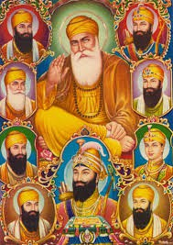 | In Science, we follow the CUSP Curriculum for this subject.  Our first learning module is titled ‘Rocks’. We will investigate how rocks are formed and the different types of rock there are. We will work scientifically to test the hardness of different rocks and find out how fossils are formed.  Our second learning module is ‘Animals including Humans’, where we will learn about the effects food has on our bodies, what our skeleton is for including the names of different bones, and what muscles do and where we find them.

Attendance & Punctuality:
Doors open: 8:35 am – please aim to arrive at school at this time.
Register closes: 8:45 am End of the day: 3:15 pm
Good attendance is essential for high achievement and outstanding learning. Please ensure you arrive promptly to drop off and pick up your child. Any child arriving in their classroom after 8:45am will be marked late.

Remember 96+% = good attendance.
Behaviour & Discipline:
At Applecroft School, we have adopted a therapeutic approach to behaviour management. Our Behaviour & Discipline policy is based on a green triangle that recognises and rewards valued behaviours, and a red triangle that recognises and ensures clear consequences for detrimental behaviours. Both triangles have five levels that progress as the behaviours do.
Green Triangle  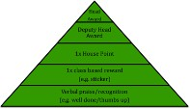 | Red Triangle  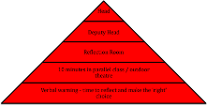
Communication:
If you wish to speak with us in person regarding your child, we are available on Thursdays between 3:20-3:40pm. Please email admin@applecroft.herts.sch.uk to book an appointment or catch us at the end of the day at pick-up.

You can also follow the school on Instagram to see what exciting things we have been up to!


Home Learning:
Home Learning tasks will be set as Google Classroom assignments, where appropriate. Children are expected to spend between 30-45 minutes on most tasks.
All home learning will be set on a Friday and will be due the following Friday.
Key Dates:
Autumn Term Dates 2025
Thursday 3rd September - Friday 18th December I INSET Day: Friday 27th November – School Closed
Occasional Day: Monday 30th November – School Closed
Half Term: Monday 26th October - Friday 30th October Christmas Break: Monday 21st December - Friday 1st January

Other Important dates:
- Volunteer Safeguarding Meeting (small hall) - Friday 18th September at 8:50am or Monday 21st at 2:10pm
- Individual School Photos - Wednesday 23rd September

- Y3 Fun Run - Tuesday 20th October
- Christmas Shows - Tuesday 8th December - 1:30pm and 5:30pm Christmas Show - Thursday 10th December – 5:30pm Pantomime Trip - Wednesday 16th December
- PTA KS2 Disco - Friday 11th December
- Christmas Lunch/Christmas Jumper Day - Thursday 17th December
Safeguarding:
Our Designated Safeguarding Leads are: Ms. Ruth Johnson (Lead DSL)
Mrs. Lisa Withe Mr. Paul Wyatt Ms. Jale Apicella
Mrs. Natalie Clementson Mrs. Carey O’Connor Miss Eloise Yates.
If you have any urgent concerns regarding safeguarding, please ring the school, if it is not urgent then contact our DSLs via safeguarding@applecroft.herts.sch.uk
Staffing in the Year Group:
Mrs. Milnthorpe - Hepworth Class Teacher (M, T & W)
Mrs. Entwisle - Hepworth Class Teacher (Th & F)
Mrs. Clementson - Van Gogh Class Teacher & Phase Leader - on maternity leave
for Autumn Term
Mrs. Modeste - Van Gogh Class Teacher for Autumn Term
Mrs. Sadat - Learning Support Assistant (LSA)
Mrs. Nolan - Learning Support Assistant (LSA)
Mrs. Wake - PPA Lead - RE
Mr. Passade - PPA Lead - PE
Timetable:
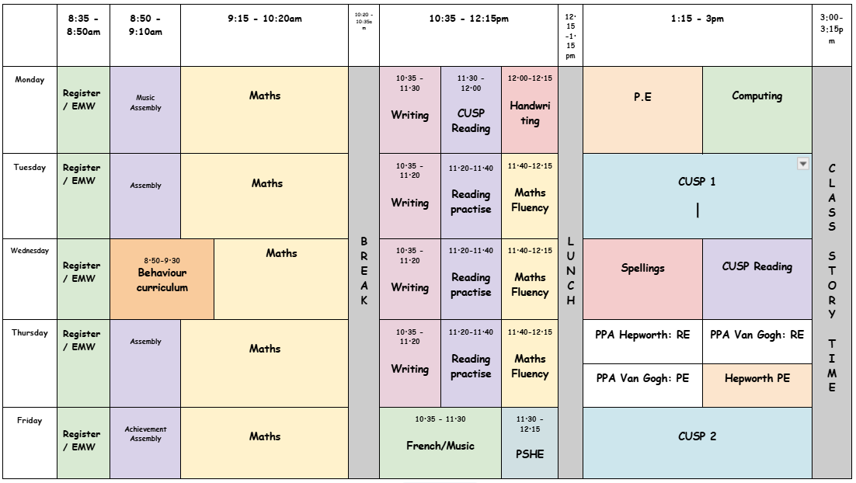

This term we are blocking subjects in the afternoon. Where the timetable shows “CUSP”, this would be either Science, History, Geography, Art, Design Technology or Computing.
(Timetable is subject to change on occasion)
Uniform Expectations:
School Uniform: Red jumper/cardigan / grey trousers, skirts, shorts or pinafore dress / white polo shirts, shirt/blouse / smart, black shoes / white/grey socks / grey/red tights / red /black hair bands/clips/Alice bands only
Black boots are not permitted – black sturdy school shoes only

PE Uniform: White t-shirt (plain or school logo) / plain black shorts / plain black jogging bottoms / plain black hoodie (or school logo) / trainers

OPAL Outside: Wellies and a waterproof coat and trousers / all in one.

Art Shirt/Apron: An old, oversized shirt or T-shirt is ideal (to be kept in locker)
Please ensure all uniform items are labelled with children’s names so items can be returned if lost.

