Year 4 Curriculum Letter - Autumn Term 2026
Welcome to Year 4
We hope you all had a lovely summer.
Now the term is underway we would like to say hello and a warm welcome to all parents and carers of Year 4 children.
English
  Reading:  This term, we are following the CUSP Reading curriculum and exploring a range of engaging and thought-provoking texts. Our reading journey will include:  - ‘The Queen’s Nose’ – A magical story about Harmony, a young girl who discovers a 50p coin that grants wishes, leading her on a journey of self-discovery and reflection.  - ‘What a Waste’ by Jess French – A non-fiction text that introduces children to important environmental issues and shows how small everyday actions can help reduce, reuse, and recycle waste.  - ‘The Girl Who Stole an Elephant’ – Set in Sri Lanka, this exciting adventure follows Chaya, a brave girl with a strong sense of justice. After stealing the Queen’s jewels to help those in need, she finds herself on the run and determined to bring fairness back to her community.  Through our daily reading sessions, children will develop key reading skills such as inference, deduction, and comprehension, while building a deeper understanding of the texts. | Writing:  This term, we are following the ESSENTIALWRITING programme – a carefully sequenced curriculum designed to help children write with purpose and for real audiences. Each unit develops pupils’ understanding of how language choices vary depending on the writing purpose, and this knowledge is built upon year after year.  Our writing focuses this term will include:  - Writing to Entertain – Composing a free verse poem  - Writing to Entertain – Creating a graphic novel  - Writing to Persuade – Writing a persuasive speech  - Writing to Inform – Producing a clear and structured explanation text  - Writing to Entertain – Writing an original narrative  In each unit, children are encouraged to consider their audience carefully and will be given the opportunity to publish and share their work with their intended readers, helping to develop confidence, purpose and pride in their writing.  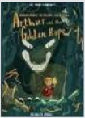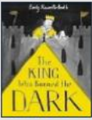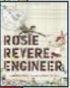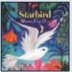
Handwriting:  In Year 4, we continue to use the LetterJoin handwriting programme, with a focus on developing fluency, consistency and legibility. Handwriting lessons take place twice a week, and practice is meaningfully linked to other areas of the curriculum, including English, maths, science, geography and French.  These cross-curricular links allow children to apply their handwriting skills in context, helping to reinforce learning while supporting their written presentation across all subjects. Through regular, structured practice, children build the handwriting stamina and quality needed to prepare them for the demands of upper Key Stage 2. | Spelling:  Each week, we will learn a new spelling rule in class. You will then be set Home Learning to build on this spelling rule ahead of a dictation task the following week, where you will apply the learning from the previous lesson and our Home Learning.  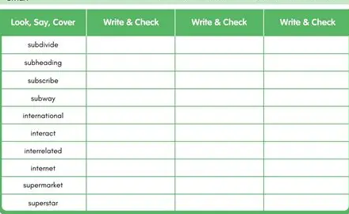
Maths
This term, we will begin by focusing on place value up to 4-digit numbers, before moving on to exploring counting in multiples and mastering times tables up to 12 × 12.

A key focus this year is times tables knowledge. This is not only because children will complete the Multiplication Tables Check (MTC) in June, but because secure times tables fluency is essential for success in upper Key Stage 2 maths. From fractions and division to area, perimeter and problem-solving, quick and accurate recall of multiplication facts underpins a large proportion of the maths curriculum.

We cannot stress enough the importance of regular practice, both in school and at home. We strongly recommend children use Times Tables Rock Stars at least three times a week to build speed and confidence. Additionally, MathsFrame provides an online version of the MTC-style check, helping children become familiar with the format they’ll encounter in June – and it’s a fun way to practise!

By investing time in regular practice now, children will build the fluency and confidence needed to access more complex mathematical concepts later in the year.

https://mathsframe.co.uk/en/resources/resource/477/Multiplication-Tables-Check

Art & Design: | Computing:
 We will begin the year by focusing on ‘Painting’, looking at creating different tints, tones and shades by mixing colours. We will then create our own lino prints and mosaics during Art Week.   | In Autumn 1, we will focus on Online Safety. We will understand how the way we conduct ourselves online can affect others; being a responsible digital citizen and being able to use a search engine accurately.  In Autumn 2, we will be looking at Computing Systems and Networks. We will be learning about how the internet and the World Wide Web work, including how devices connect, how websites are created and shared, and the different services the internet provides. We will also learn how to stay safe online by understanding who creates web content, respecting ownership and copyright, and checking whether information is trustworthy before sharing it.
Design Technology (DT): | Geography:
We follow the CUSP curriculum for Design Technology. We will begin with our first ‘Food’ unit and answer the question ‘What is really in your food?’, looking at the ways food can be processed. As part of the unit, we will be making our own mini bread rolls.  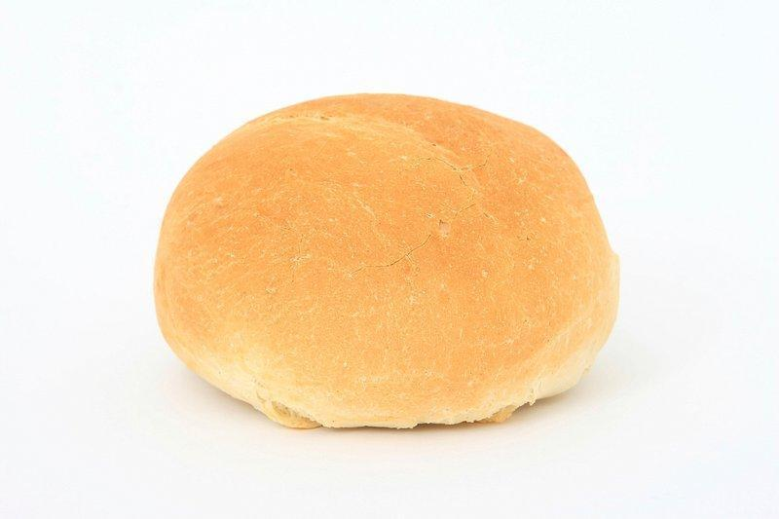 | We follow the CUSP curriculum for Geography. In Autumn 1, we will be learning all about rivers including our local river, The River Lea. We will look at the different courses of rivers and the features found in each of these.  A link to books from Curriculum Visions will be put on Google classroom should the children want to do any extra reading.
History: | Leader in Me & The 8 Habits:
We follow the CUSP curriculum for History. Across the Autumn term, we will be looking at Britain’s settlement with a focus on the Anglo Saxons and Scots. We will understand why the Anglo-Saxons came to Britain and what life was like for them.  A link to books from Curriculum Visions will be put on Google classroom should the children want to do any extra reading. | Across the Autumn term, we will be revising each of the 8 Habits and looking at how we can use the Habits to support learning, personal development and to help create a positive classroom culture. They have a key part to play in the smooth running of the classroom. This year will focus on developing our social, personal and learning behaviours.
Modern Foreign Languages (MFL): | Music:
  We use the ‘Language Angels’ curriculum for MFL. Our unit this term is ‘Je Me Presente’. Across this unit, we will learn how to present ourselves, including basic greetings and giving personal details. We will also learn how to say numbers up to 100. | We follow the CUSP curriculum for Music. In Autumn 1, we will be exploring ‘Untuned Percussion’, looking at Bhangra music and traditional Indian musical instruments to support us in creating our own Chagaal rhythms.  In Autumn 2, we will be exploring Singing. We will learn how to sing parts in an ensemble.
Physical Education (PE): | Personal, Social, Health & Economic Education (PSHE):
We follow the ‘Complete PE’ curriculum. Our PE days are Wednesdays and Fridays. Please ensure you are wearing the correct PE kit to school on both these days.  In Autumn 1, for indoor PE, we will be developing our Gymnastic skills, focusing on Bridges. For outdoor PE, we will be developing our Tag Rugby skills.  In Autumn 2, for indoor PE, we will be developing our Communication and Tactics skills through our OAA lessons. For outdoor PE, we will be developing our Football skills.   | This term, the children will continue to develop important life skills through the EC Publishing PSHE programme.  Respectful Communities: The programme will also explore respecting difference, understanding diverse communities, and recognising prejudice, discrimination and racism.  Respectful Behaviour: Finally, the children will focus on preventing bullying and understanding the impact of hurtful behaviour, developing the skills to contribute positively to their school and wider community.  As part of our PSHE curriculum, we would like to invite parents and carers to share any relevant skills, experiences, or career knowledge that could help bring our learning to life. If your job or personal experience links to any of the themes we will be exploring, please speak to a member of the Year 4 team.
Religious Education (RE) & Worldviews: | Science
During the Autumn term, Year 4 will be learning about Christianity. The children will be learning about harvest and exploring worship. We will be exploring the idea of the Holy Trinity and Holy Spirit. Towards the end of the term we will be looking at the Nativity and Christmas celebrations. A link to books from Curriculum Visions has been put on Google classroom should the children want to do any extra reading.   | We follow the CUSP curriculum for Science. In Autumn 1, we will be looking at ‘Living Things and Their Habitats’, focusing on what makes something a living thing and how different living things are classified based on their characteristics.  In Autumn 2, we will be looking at ‘States of Matter’, focusing on different solids, liquids and gases. We will also learn about the processes of melting, evaporating and condensing through various experiments.  A link to books from Curriculum Visions will be put on Google classroom should the children want to do any extra reading.
Attendance & Punctuality:
Registration takes place promptly at 8:45am and the school day runs until 3.15pm. Children should arrive from 8:35am for a ‘soft start’. Punctuality is important: children arriving in class after 8:45am will be marked as late in the register. If your child is absent, please inform the school office as soon as possible. Children are expected to attend school every day, unless they are unwell.

96+% = good attendance.

Behaviour & Discipline:
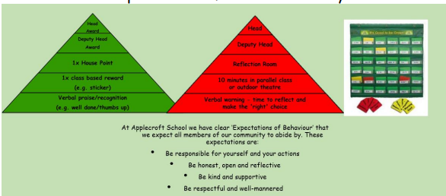
Our behaviour & discipline policy encourages positive, helpful and socially acceptable behaviour and children are aware of the school’s behaviour expectations: to be responsible for yourself and your actions; to be honest, open and reflective; to be kind and supportive; to be respectful and well-mannered. In addition, both classes have created their own class mission statement to support this behaviour and their learning. The green triangle is used to recognise and reward positive behaviour and this system includes stickers, class rewards, house tokens and certificates. There are warnings and consequences for unsocial or anti-social behaviour which does not meet the behaviour expectations.

Home Learning:
Home Learning will continue to be set on a Friday and due the following Friday.

Key Dates:
Autumn Term 2026:
Thursday 3rd September - Friday 18th December
Monday 14th Sept - Clubs start this week
Friday 18th Sept - 8:50 -9:50am - small hall - Volunteer Safeguarding Training
Monday 21st Sept - 2:10-3:10pm - small hall - Volunteer Safeguarding Training
Wednesday 23rd Sept – 9:20am - School Photos (individual & sibling)
Monday 28th Sept - Monday 1st - Book Fair
Monday 5th October - Y4 Whole Class Indoor Athletics (please wear PE kits)
Thursday 22nd October - 3:30-6:00pm - Years 1-6 Parent Consultations - face-to-face at school
Friday 23rd Oct - last day of half term
Half Term: Monday 26th October - Friday 30th
Wednesday 4th November - 3:30-6:00pm - Years 1-6 Parent Consultations - face-to-face at school
Friday 6th November - PTA Fireworks
Tuesday 10th November - Y4 Tag Rugby 1:15pm - 2:45pm
Friday 20th November - 8:50am - Y4 Assembly
Friday 27th November - INSET Day - School Closed
Monday 30th November - Occasional Day - School Closed
Saturday 5th and Sunday 6th December - PTA Christmas Wreath Workshop
Tuesday 8th December - 1:30pm - Y1-6 - Christmas Show Matinee Performance & 5:30pm - Y1-6 Christmas Show Performance
Thursday 10th - 5:30pm - Y1-6 Christmas Show Performance
Friday 11th December - PTA KS2 Disco
Wednesday 16th December - PANTO Day!
Thursday 17th December - Christmas Jumper Day & Christmas Lunch
Friday 18th - 2pm finish last day of term
Christmas Break: Monday 21st December - Friday 1st January

Safeguarding:
Should you have any concerns over a child’s welfare please contact any of our Designated Safeguarding Leaders (DSL) via the school office:

Mrs Ruth Johnson (Lead DSL)
Mrs Lisa Withe (DSL)
Mr Paul Wyatt (DSL)
Ms Jale Apicella (DSL)
Mrs Carey O'Connor (DSL)
Miss Eloise Yates (DSL)

They can also be contacted via safeguarding@applecroft.herts.sch.uk. If urgent please contact the school office.

Staffing in the Year Group:
Miss Theo (Year Group Leader and Year 4 Picasso Class Teacher Mon-Wed & Fri)
Miss Bird (Riley Class Teacher)
Mrs Buck (Year 4 Learning Support Assistant)
Mr Passade (PPA Lead & Sports Coach)
Mrs Wake (PPA Lead & Joint RE Leader)

Timetable:
Picasso

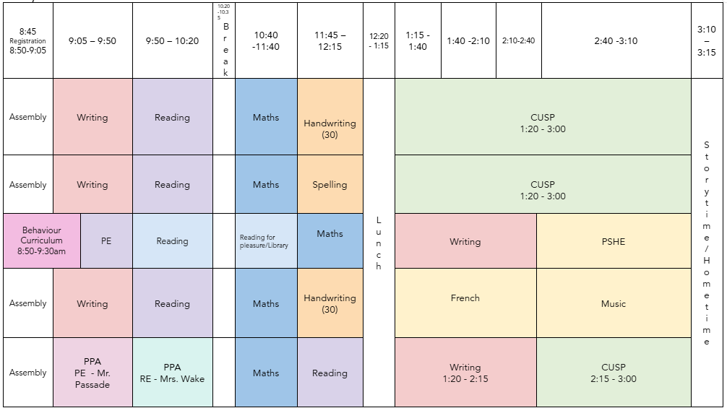

Riley
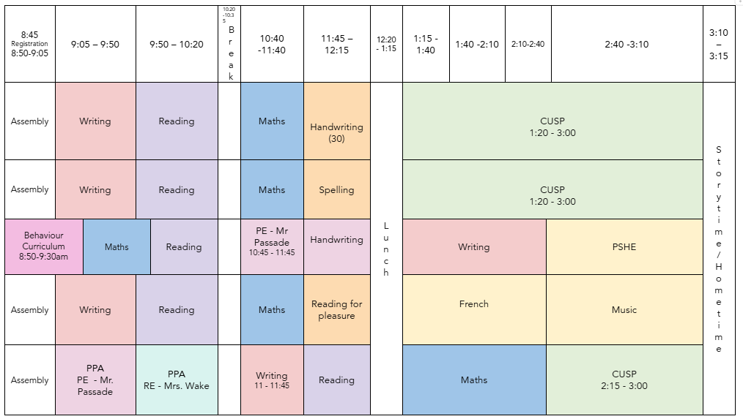

P.E is Wednesday and Friday

Uniform and Equipment Expectations:
School Uniform should be worn daily and all items must be labelled. Long hair should be tied back using hair ties in school colours (red & black). Black school shoes must be worn, not trainers or boots. No nail varnish or jewellery is allowed other than a pair of small stud earrings.

Our PE kit consists of a white T-shirt and black shorts (no branded items). A plain black sweatshirt or joggers may be worn if the weather is cold. Trainers should be in school every day for the Daily Mile. PE kits should be worn to school on Tuesdays and Fridays.

A small pencil case containing a black writing pen (not a ballpoint or a biro), pencil, eraser, sharpener, scissors, glue stick and a small selection of coloured pencils should be in school daily, however children will be provided with any resources they will require. Any reading book from school or home should also be in school daily.
All stationary items are available in the school shop which is open each morning.

Communication:
If you wish to speak with us in person regarding your child, we will be holding a weekly surgery on Tuesdays between 3:20pm and 3:40pm.
We also communicate home learning to the children via Google Classroom, so please ensure they regularly log on to check for assignments and messages.

