Year 5 Curriculum Letter - Autumn Term 2026
Welcome to Year 5
We hope you all had a lovely summer.
Now the term is underway we would like to say hello and a warm welcome to all parents and carers of Year 5 children. Here is an outline of our plans and expectations for this term.
We love to invite parents/carers in to help, particularly with some of the practical aspects of DT and to hear readers. If you would like to help, please attend one of the parent volunteer meetings:
- Friday 18th September (8:50-9:50am)
- Monday 21st September (2:10-3:10pm)
English
  Reading:  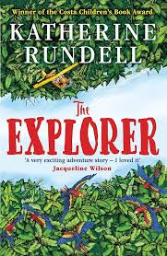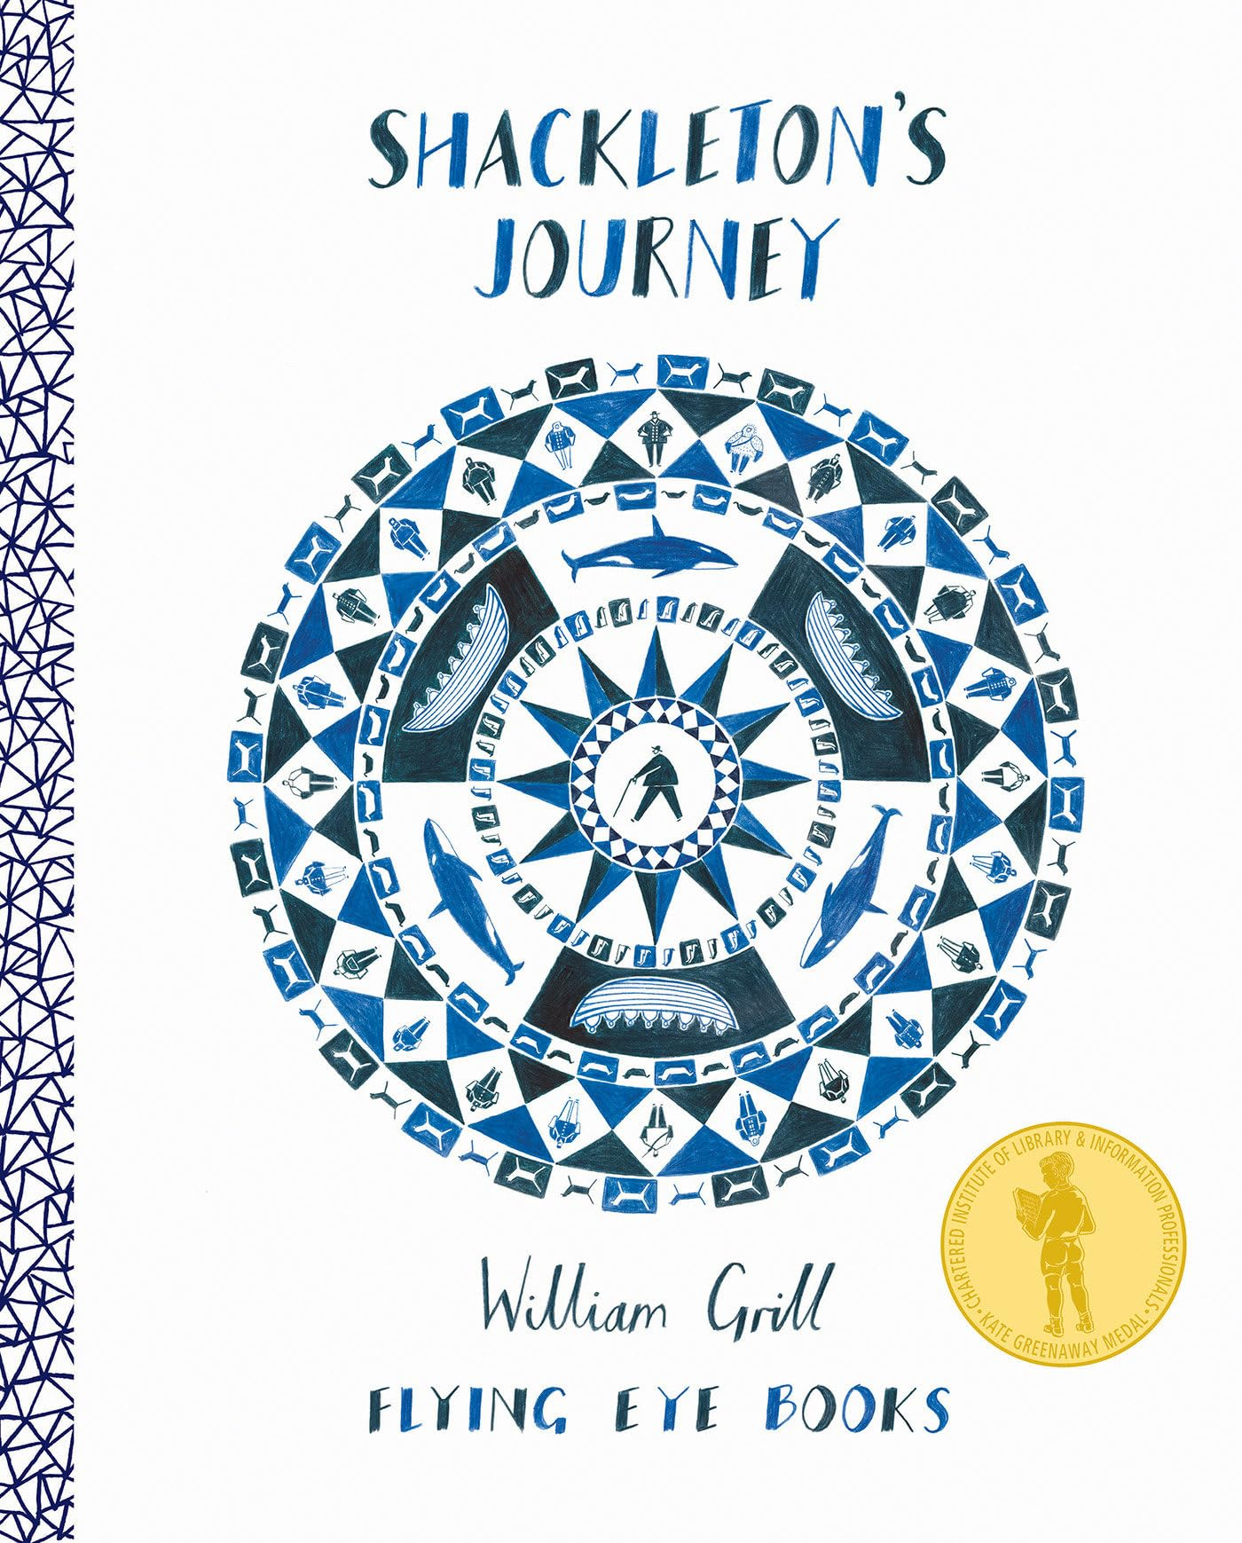  The first book that we will be looking at in our reading lessons is ‘The Explorer’ by Katherine Rundell. This is an exciting story about four children who find themselves lost in the Amazon rainforest after a plane crash. The next book is ‘Shackleton’s Journey’, about Ernest Shackleton’s expedition across the Antarctic on his ship, ‘Endurance’.  Children will ‘self-register’ their name (on an image of an open book) if they have read the previous night. Reading Society members will add up the scores daily and at the end of the week, totals for each class will be displayed in the main corridor. Please listen to your child read at home as often as possible - we really appreciate your support. | 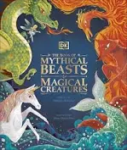  Writing:  In writing, we will be covering a variety of topics such as:  - Non-chronological reports  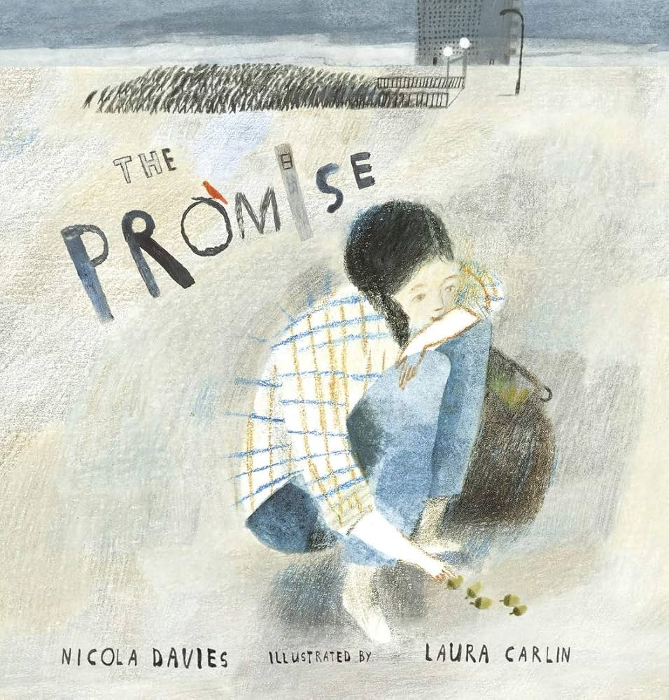  - Descriptive scenes  - Cinquain poetry  - Narratives  We will use a range of exciting books as inspiration.
Handwriting:
A weekly handwriting lesson will be used to extend and polish learning that has taken place previously.
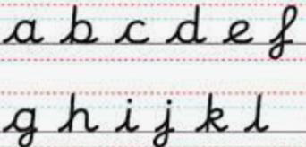
Some children may have additional practice if this is helpful.
Spelling:
Investigations will be a regular feature of our spelling lessons and home learning. We will have weekly dictations to assess the spelling rules learned in school and practised at home.

Maths

We will be following the Essential Maths programme which has a strong focus on number sense in the first term, starting with a topic on place value. We will cover work on negative numbers, decimals and the four operations in the coming weeks. Later in the term, we will be looking at fractions.
Mental Maths: Please help your child to practise their multiplication tables on a regular basis. This will help in so many areas of maths, including division and fractions. There are many interactive on-line games you can use such as: Times Tables Rock Stars, Number Club and BBC Bitesize.
Art & Design: | Computing:
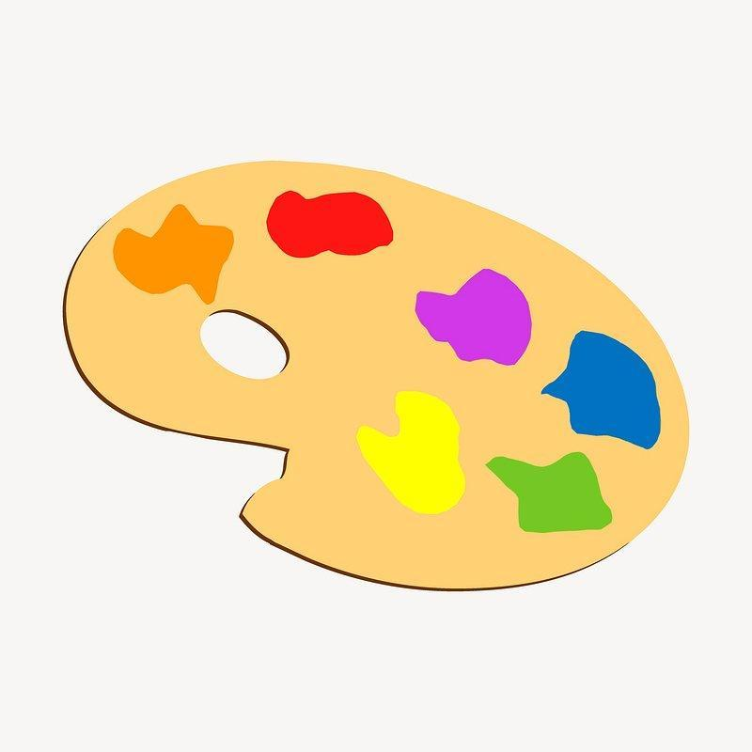  In Art and Design, we will begin with a painting topic, exploring the use of colour. We will look at how artists, including David Hockney, have used colour to create mood.  The children will learn to mix colours accurately and understand the properties of a range of different paint types. |   This term, we will be learning about online safety and our digital footprints. We will also have discussions on how to make healthy media choices.  Later in the term, we will be learning about vector drawings and how to use different drawing tools to help create images.
Design Technology (DT): | Geography:
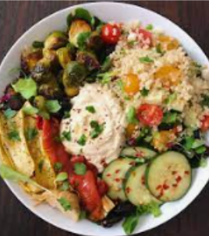  The first DT topic for the Autumn Term is ‘Food and Nutrition’, looking at why our diets are different around the world. In this block, pupils will look to Middle Eastern and Danish foods for inspiration. They will learn how to make a nutritious mezze bowl and use a range of techniques for preparing ingredients. Later in the term, pupils will design and make shelters, focusing on how to reinforce structures to provide strength and stability. |   Our Geography lessons begin with ‘World Countries and Biomes’, where we will learn to locate countries across the world through identifying the seven continents, lines of longitude and latitude and the equator. We will use these concepts to notice how and why conditions and vegetation change across the world, classifying similar areas into biomes. Looking even more closely, we will then identify major cities and capitals across the world and consider both the human and physical features by which these are defined.
History: | Leader in Me & The 8 Habits:
  The History topic for this term is the Ancient Greeks. We will be learning all about who the Ancient Greeks were, when they ruled, their beliefs, democracy, why theatres were so important to them, as well as the Olympic Games. |   We will continue to develop leadership in all our pupils and explore how the 8 Habits can support us to be proactive and effective learners and leaders. Leadership roles are an important part of daily life at Applecroft, and children enjoy the responsibility and independence that they are given. They have a key part to play in the smooth running of the classroom. This year will focus on developing our social, personal and learning behaviours.
Modern Foreign Languages (MFL): | Music:
In French, we will begin the year working on our pronunciation, particularly the phonemes ‘eau’, ‘eux’ and ‘e’. We will then start our first topic ‘As-tu un animal?’ (Do You Have A Pet?), which covers a wide range of vocabulary for common pets alongside introducing the conjunctions ‘et’ (and) and ‘mais’ (but). We will be working towards being able to confidently say, (in French), our name, age, whether we do or don’t have a pet - if we do, what animals these are, their names, and being able to join these sentences with simple conjunctions. | Our first CUSP music unit will have a focus on untuned percussion and will be based on ‘Musical Stories’.  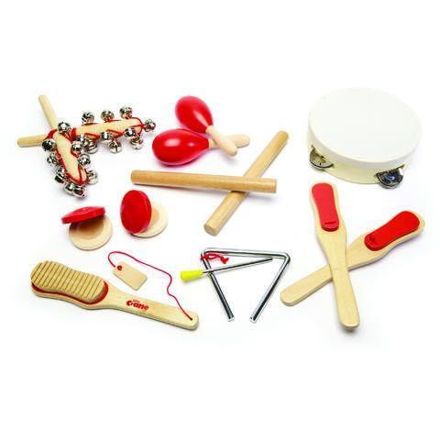  Children will be composing rhythmic pieces using a combination of choral chanting, body percussion and untuned percussion instruments.
Physical Education (PE): | Personal, Social, Health & Economic Education (PSHE):
P.E. lessons will take place every Tuesday and Thursday. This term we will cover gymnastics, netball, football and health-related fitness. Children will need to wear their P.E. kits to school on both of these days and must have warm clothing to wear when the weather turns cold. A pair of trainers should remain in school every day for other sporting activities such as the Daily Mile. |   Our first PSHE topic is ‘Understanding Ourselves and Others’, covering areas such as friendship and peer pressure. In the second half of the term, our topic will be ‘Safe Relationships’. This will focus on positive relationships and stranger safety.
Religious Education (RE) & Worldviews: | Science
  In the Autumn Term we will be learning about Islam. We will be using our history skills to discover the Golden Age of Islam and delving deeper into the 5 Pillars of Islam. We will also explore what happens during Hajj and Ramadan. | 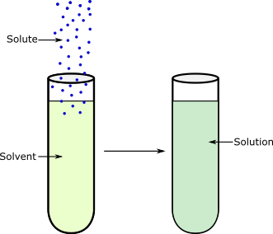  Science this term will focus on ‘Properties and Changes of Materials’.  We will be separating mixtures and solutions as well as identifying physical and chemical changes. Our curriculum has an emphasis on vocabulary and retrieval of knowledge and the children will be asked to think like a scientist, finding links and conducting investigations and experiments.
Attendance & Punctuality:
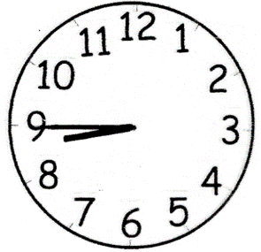
Registration takes place promptly at 8:45am and the school day runs until 3:15pm. Children should arrive from 8:35am for a ‘soft start’. Punctuality is important: children arriving in class after 8:45am will be marked as late in the register. If your child is absent, please inform the school office as soon as possible. Children are expected to attend school every day, unless they are unwell.
96+% = good attendance.

Behaviour & Discipline:
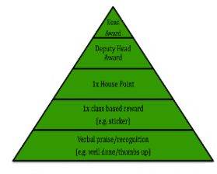
Our behaviour & discipline policy encourages positive, helpful and socially acceptable behaviour and children are aware of the school’s behaviour expectations: to be responsible for yourself and your actions; to be honest, open and reflective; to be kind and supportive; to be respectful and well-mannered. In addition, both classes have created their own class mission statement to support this behaviour and their learning. The green triangle is used to recognise and reward valued behaviour and this system includes class rewards, house tokens and certificates. There are warnings and consequences for detrimental behaviour which does not meet the behaviour expectations.

Home Learning:
Home Learning tasks will be set as Google Classroom assignments, where appropriate. Children are expected to spend between 30 and 45 minutes on most tasks. All home learning will be set on a Friday and will be due the following Friday.

Key Dates:
Monday 14th September: Welcome meeting recordings sent to parents
Friday 18th September at 8:50am and Monday 21st September at 2:10pm: Volunteer Meeting & Safeguarding Training
Wednesday 23rd September: School individual and sibling photos
W/C Monday 28th September: Book Fair
Wednesday 30th September: 1:00-2.45pm: Y5 Fun Run/Cross Country heats, Stanborough Lakes
Thursday 8th October: 3:45-5.00pm: Cross Country Finals, Stanborough Lakes
Friday 16th October: Y5 Assembly
W/C 19th October: Arts Week
Thursday 22nd October: 3:30-6.00pm: Parent consultations in school
W/C Monday 26th October: Half Term Break
Wednesday 4th November: 3:30-6:00pm: Parent consultations in school
Friday 6th November: PTA Fireworks
Tuesday 17th November: The Young Shakespeare Company (Macbeth)
Friday 27th November: INSET day, school closed
Monday 30th November: Occasional day, school closed
Tuesday 8th December: 1:30pm and 5:30pm: Christmas Show Performance x2
Thursday 10th December: 5:30pm: Christmas Show Performance
Friday 11th December: PTA KS2 Disco
Tuesday 15th December: 3:00pm: Carols on the Playground
Wednesday 16th December: Gordon Craig Theatre Panto Trip
Thursday 17th December: Christmas Lunch/Christmas Jumper Day
Friday 18th December 2:00pm: End of Term

Tuesday 27th April - Thursday 29th April 2027: Residential Aylmerton Trip
Safeguarding:
Should you have any concerns over a child’s welfare please contact any of our DSLs via the school office.
Our DSLs are Mrs Lisa Withe, Mr Paul Wyatt, Ms Ruth Johnson, Ms Jale Apicella, Mrs Carey O’Connor, Miss Eloise Yates and Mrs Natalie Clementson.
They can also be contacted via safeguarding@applecroft.herts.sch.uk.
If urgent, please contact the school office.

Staffing in the Year Group:
Mrs Juliet Keefe – Hockney Class (Monday-Wednesday)
Mrs Sharon Boulton – Hockney Class (Thursday-Friday)
Mr Ben Chemelal – Gormley Class
Ms Donna Syrett – LSA
Mrs Vikki Wake – PPA Teacher (Tuesday/Thursday morning)
Mr Bradley Passade - Sports Coach (Tuesday morning)
Phase Leader - Mrs Carey O’Connor

Timetables:
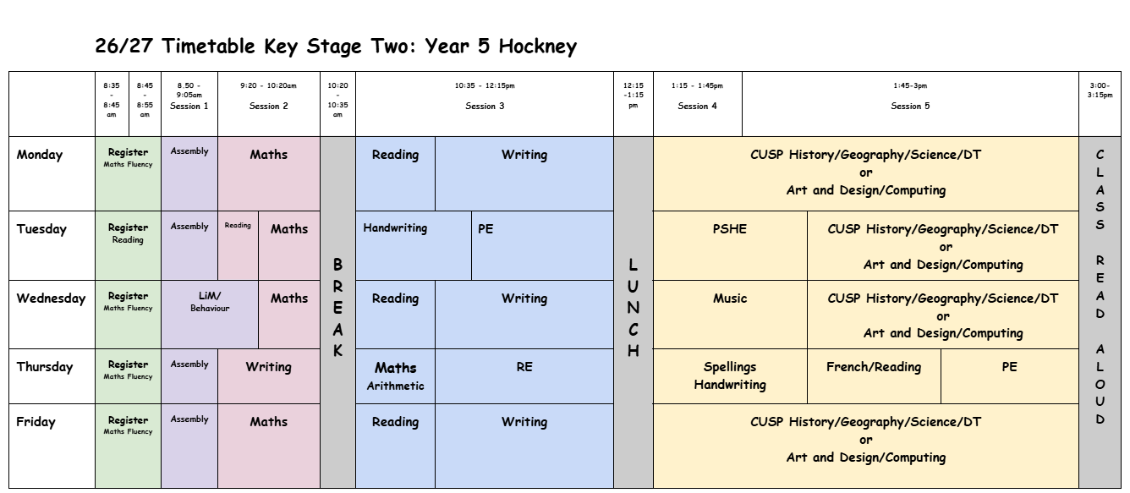
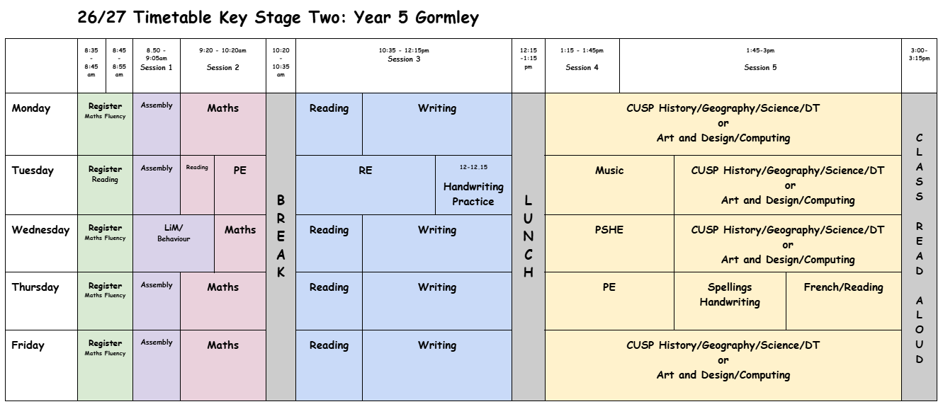
We will be blocking subjects in the afternoon. The order is as follows:
Autumn 1: Art and Design, Science, Computing, Design Technology, Geography, Arts Week
Autumn 2: Science, History, Design Technology, Computing

Uniform Expectations:
School Uniform should be worn daily and all items must be labelled. Long hair should be tied back using hair ties in school colours (red, black or grey). Black school shoes must be worn, not trainers or boots. No nail varnish or jewellery is allowed other than a pair of small stud earrings.
Our P.E. kit consists of a white T-shirt and black shorts (no branded items). A plain black sweatshirt and joggers may be worn if the weather is cold. Trainers should be in school every day for the Daily Mile.
PE kits should be worn to school on Tuesday and Thursday.
A small pencil case is useful, containing a black writing pen (not a ballpoint), pencils, a sharpener, scissors and a glue stick. All stationary items are available in the school shop which is open each morning. A reading book from school or home should also be in school daily.
Communication:
We will be communicating with the children via Google Classroom, so please ensure they regularly log on to check for assignments and messages. We will also be updating the Year 5 page of the school website and using Instagram for school events.
As always, please feel free to contact us if you have any queries. If it is a non-urgent matter, we are usually available on Mondays and Thursdays after school. If you would like to talk to us, please book an appointment via the school admin email.
If you require an urgent response, please contact us by phone, via the school office.

