Year 6 Curriculum Letter - Autumn Term 2026

Welcome to Year 6

We are looking forward to enjoying a fantastic final year at Applecroft as we prepare children to transition to the next exciting stage of their learning journey. We expect children to work hard and develop their independence and confidence, supporting the wider school community as excellent leaders and role models.

English
  Reading:  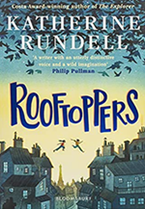  In our whole class reading we will begin the term with a beautiful book called ‘Rooftoppers’. The children will develop their reading comprehension skills with this and other related texts in a daily reading lesson.  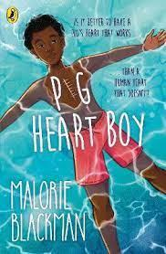  Our main text in the second half of term is ‘Pig Heart Boy’. All children will have their own copy of the text and home learning may include reading preparation for future lessons. Daily reading at home is expected and should be recorded on Boom Reader. | Writing:  We start the year by writing short stories for a whole class book, under the theme ‘Writing to Entertain’, and based around the texts ‘Uncle Montague’s Tales of Terror’ by Chris Priestly and ‘Short Too!’ by Kevin Crossly-Holland. We will then move onto Non-Chronological Reports using the beautiful book ‘Planetarium’ before returning to Narrative using ‘Wisp: A Story of Hope’ by Zana Fraillon and Graham Baker-Smith  We then finish the Autumn Term writing persuasive speeches based on ‘Talking History’.  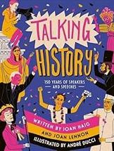  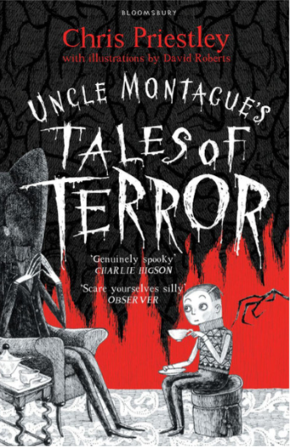  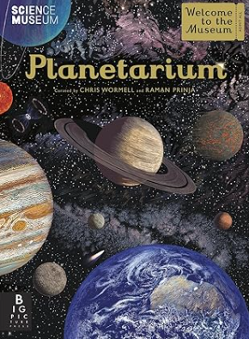  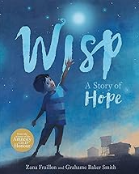  We will develop composition and grammar skills in these lessons. Grammar knowledge will also be consolidated alongside our spelling learning.
Handwriting:  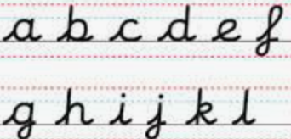  A weekly handwriting lesson will be used to extend and polish learning that has taken place previously. Some children may have additional practice if this is helpful. | Spelling:  Direct teaching of spelling takes place weekly and includes spelling rules, phonetic, morphemic and etymological exploration. Investigations will be a regular feature of our spelling lessons and home learning. We will be benefitting from a new subscription to Spelling Shed and the children will complete weekly homework tasks.
Maths
We will be following the ESSENTIALMATHS programme with a strong focus on number this term and will also cover shape, measures and statistics. Please help your child to practice their multiplication tables on a regular basis. This will help in so many areas of Maths, including division and fractions. Using Maths at home in everyday situations such as cooking and shopping will also help mathematical confidence and agility. There are many interactive on-line games you can use such as: Times Tables Rock Stars and BBC Bitesize.
Art & Design: | Computing:
    Our Art lessons this year will include studies of both the class artists.  In this term’s unit on painting, we will look at how artists such as Cezanne use composition and how Andy Warhol uses different colour schemes. We will also learn about printing in our art week and use a silk screen. |   We will be looking closely at Online Safety in the first part of this term, including learning how to identify secure websites and encouraging pupils to apply their internet safety knowledge both in school and at home.  During the second half of the term, we will be creating Webpages to use as our Leadership Portfolios to link with Leader in Me, before constructing and manipulating 3D digital models using Tinkercad in our ‘Creating Media’ topic.
Design Technology (DT): | Geography:
  In DT, the children will undertake a food and nutrition topic focused around eating ethically.  We will also link with our Science topic on Electricity by testing the uses of switches.  Later in the term, we will explore how we can use mechanisms and gears, ahead of the STEMPoint (Herts) Challenge next year. |   This term, Year 6 will be exploring the physical geography and processes of earthquakes, mountains, and volcanoes.  This will include investigating how tectonic plates create and influence the physical geography of Earth.
History: | Leader in Me & The 8 Habits:
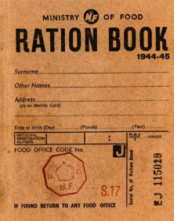  Our history topic is ‘The Battle of Britain’. We will be learning about the causes of conflict in the second world war and how this impacted on people between 1939 and 1945.  In particular, we will learn about evacuation, rationing, the Battle of Britain and the Blitz. This will prepare children to build on their knowledge as we explore other aspects of 20th century history in the Spring. | 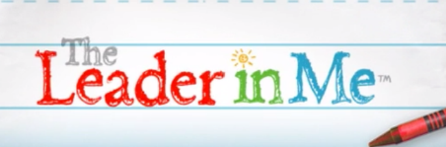  We will continue to develop leadership in all our pupils and explore how the 8 habits can support us to be proactive and effective learners and leaders.  Year 6 children will have new roles such as play leading, running the school shop and assembly support to further develop their independence and leadership across the school.
Modern Foreign Languages (MFL): | Music:
  This term in French we will be covering the ‘At School’ (A L’Ecole) topic.  This topic covers learning about the school day and the names of the school subjects. We will be learning how to say simple phrases including telling someone which subjects we like and dislike. | 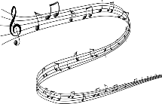  This half term’s topic is ‘Sing Musical Stories’. We will be listening and responding to a variety of songs and the meaning of their cultural and social lyrics, learning to sing in harmony and with descant parts, creating our own song lyrics, and performing as an ensemble.  In the second half of the term, we will develop composition skills using music technology.
Physical Education (PE): | Personal, Social, Health & Economic Education (PSHE):
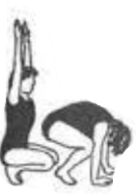  PE lessons will take place on Wednesdays and Fridays for both classes and will cover gymnastics and invasion games (netball).  Children should wear their PE kits to school on these days and must have warm clothing to wear when the weather turns cold. | We will start our term by combining PSHE and Computing to consider Online Safety, looking at topics such as cyberbullying, online gaming danger, group chats and online privacy.  We then move to physical health and well-being, looking at medicine and product safety, habits, addiction, and the effects of alcohol and drugs, aligning with our Science topic.
Religious Education (RE) & Worldviews: | Science
This term we will be learning about Judaism. We will explore many different Jewish celebrations including Bar and Bat Mitzvahs. We will link to our History topic of WWII and learn about the Holocaust. Linked to the Holocaust, we will also visit our local synagogue which was founded by Jewish refugees during WWII. | The Science topics this term are Electricity and Animals Including Humans. We will look at the human circulatory system and the functions of the heart, blood vessels and blood. We will explore and recognise the impact of diet, exercise, drugs and lifestyle on the way our bodies function.
Attendance & Punctuality:
Registration takes place promptly at 8:45am and the school day runs until 3:15pm. Children should arrive from 8:35am for a ‘soft start’. Children complete early morning work during this period before assembly. Punctuality is important: children arriving in class after 8:45am will be marked as late in the register. If your child is absent, please inform the school office as soon as possible. Children are expected to attend school every day, unless they are unwell.
96%+ = good attendance.
Behaviour & Discipline:
Our Behaviour Policy encourages positive, helpful and socially acceptable behaviour and children are aware of the school’s behaviour expectations: to be responsible for yourself and your actions; to be honest, open and reflective; to be kind and supportive; to be respectful and well-mannered. In addition, both classes have created their own class mission statement to support this behaviour and their learning. The green triangle is used to recognise and reward positive behaviour, and this system includes class rewards, house tokens and certificates. There are warnings and consequences for detrimental behaviour which do not meet the behaviour expectations.
Home Learning:
Home learning will be set on Google Classroom on a Friday in line with the rest of the school and will be due the following Friday. We will discuss with the children how they can be proactive and organise their week to complete tasks on time. Please support your child to develop good habits by managing their home learning over the course of the week. Home learning is set for Maths, Reading and Spelling, as well as pre-reading for foundation subjects using Curriculum Visions.
Key Dates:
Y6 Welcome Meeting - slides to be made available. Note that there is no face-to-face meeting.
Individual/Sibling School Photographs - Wednesday 23rd September
Young Shakespeare Performance (in school) - Tuesday 17th November
Art & Design Themed Week - Monday 19th - Friday 23rd October *Parent helpers welcome!
Parent Consultations 1/2 - Thursday 22nd October 3:30-6:00pm (in school)
Half term - Monday 26th - Friday 30th October
Bikeability - Monday 2nd to Friday 6th November
Parent Consultations 2/2 - Wednesday 4th November 3:30 -6:00pm (in school)
PTA Fireworks - Friday 6th November
Inset day - Friday 27th November (school closed)
Occasional day - Monday 30th November (school closed)
Christmas Show - Tuesday 8th December - 1:30pm and 5:30pm; Thursday 10th December – 5:30pm
PTA KS2 Christmas Disco - Friday 11th December
Carols after school - Tuesday 15th December
Pantomime Visit - Wednesday 16th December
Christmas Jumper & Lunch Day - Thursday 17th December
Last Day of Autumn Term - Friday 18th December - School finishes at 2pm

Y6 SATs Week - Monday 10th - Thursday 13th May 2027
Residential Trip PGL - Monday 14th - Friday 18th June 2027

Safeguarding:
Should you have any concerns over a child’s welfare please contact any of our Designated Safeguarding Leads via the school office.
Our DSLs are Mrs Ruth Johnson, Mrs Lisa Withe, Mr Paul Wyatt, Ms Jale Apicella, Mrs Carey O’Connor, Mrs Natalie Clementson and Miss Eloise Yates. They can also be contacted via safeguarding@applecroft.herts.sch.uk. If urgent please contact the school office.
Staffing in the Year Group:
Mrs O’Connor – Y6 Lead, Warhol Class Teacher and Upper KS2 Phase Leader
Mr House - Moore Class teacher
Mrs Parnham and Mrs Slee – Y6 LSAs
Mrs Wake/Mr Passade – PPA Teachers (Wednesday pm)
Timetable:
The timetable for the Autumn term in Year 6 includes PE on Tuesday and Thursday.
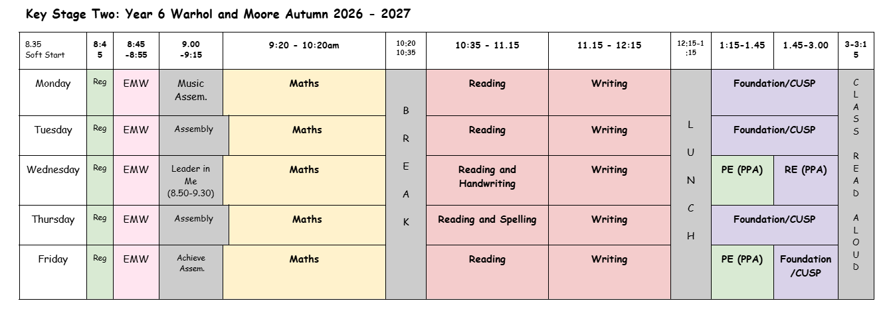
There may be occasional variations to the timetable, for example when outside visitors attend.
Uniform Expectations:
School uniform, PE uniform, shoes – not books, accessories,
School Uniform should be worn daily, and all items must be labelled. Long hair should be tied back and hair ties in school colours (red,black). Black school shoes, no trainers or boots. No nail varnish or jewellery is allowed other than a pair of small stud earrings.
P.E kit: White T-shirt and black shorts (no branded items). A plain black sweatshirt or joggers may be worn if the weather is cold. Trainers should be in school every day for the Daily Mile. PE kits should be worn to school on Wednesday and Friday (both classes).

A small pencil case containing black writing pen (not ball point), pencil, eraser, sharpener, scissors, glue stick and protractor should be in school daily. Children will also need a small selection of coloured pencils and a set of highlighters. A reading book from school or home should also be in school daily. Watercolour palettes, a brush and art pencils may be brought in optionally. All stationery items are available in the school shop which is open each morning.
Art shirts: Please ensure your child has their own art shirt in school - to be kept in their locker.
Communication:
Please contact us via email for non-urgent matters: admin@applecroft.herts.sch.uk
For urgent matters, please contact the school office.

