History of Applecroft School

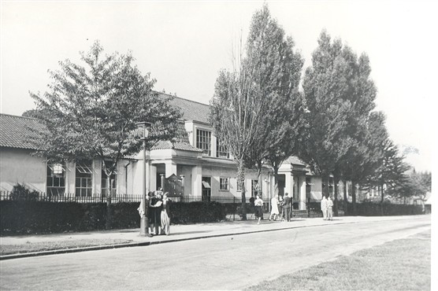
At the heart of Welwyn Garden City stands a school with a rich heritage that stretches back more than a century. Designed by the renowned town architect and planner, Louis de Soissons, Applecroft School began life as Handside School, becoming the first permanent county-run school in Welwyn Garden City.
The school opened in two phases, with the first buildings welcoming pupils in 1923, followed by the completion of the remaining school buildings in 1927. At the time, Handside School was considered innovative and forward-thinking. Its design featured light and airy classrooms, promoting a positive learning environment, while a quarter of an acre of school grounds allowed children to learn through growing their own vegetables and flowers.
As the community grew and evolved, so too did the school. In 1953, Handside School adopted the name Applecroft School, reflecting a new chapter in its history. The school continued to develop and, in 1986, amalgamated with Parkway Infants School,
Further expansion came in 1999 with the addition of a nursery, strengthening Applecroft's commitment to providing high-quality education and care from the earliest years.
Today, Applecroft School proudly combines its historic foundations with a modern approach to learning, maintaining the vision of nurturing children, inspiring curiosity, and serving the community at the heart of Welwyn Garden City.
In 2023, Applecroft School proudly celebrated its 100th anniversary, marking a century of education at the heart of the community. Throughout the year, the school hosted a range of special events, including open days, an historical exhibition, community tea party, and a 1923-themed Sports Day, giving pupils and visitors a glimpse into school life as it would have been a century ago.
As part of the celebrations, pupils and staff also created a commemorative school song, which captured the spirit, history and values of Applecroft School. You can listen to the song via the link provided.
Celebrating over 100 years of learning, growth and community.

